**Adv. Java Lab Assignment**

**Collections 20 Programs**

**Name-Milind Bajaj**

**M.Tech(5th Sem)**

**Roll No.:- IT-2k17-35**

**1.Program of adding elements in ArrayList .**

**Solution:-**

import java.util.*;

class Student{

int rollno;

String name;

int age;

Student(int rollno,String name,int age){

this.rollno=rollno;

this.name=name;

this.age=age;

}

}

class ArrayListClass{

public static void main(String args[]){

Student s1=new Student(1,"marvel",21);

Student s2=new Student(2,”hulk",22);

Student s3=new Student(3,"thor",23);

ArrayList<Student> al=new ArrayList<Student>();

al.add(s1);

al.add(s2);

al.add(s3);

Iterator itr=al.iterator;

while(itr.hasNext()){

Student st=(Student)itr.next();

System.out.println(st.rollno+" "+st.name+" "+st.age);

}

}

}

**Output 1:-**

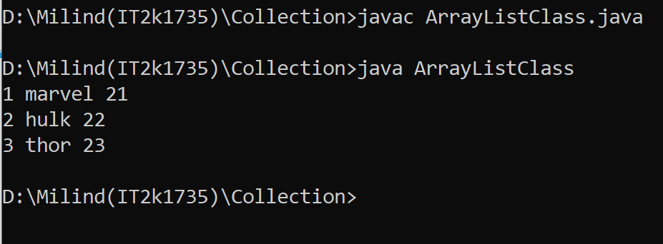

**2.Program of ArrayList (getting elements with all methods).**

**Solution:-**

import java.util.*;

class ArrayListAll{

public static void main(String args[]){

ArrayList<String> list=new ArrayList<String>();

list.add("Thor");

list.add("Ironman");

list.add("hulk");

list.add("marvel”);

System.out.println("Traversing list through List Iterator:");

ListIterator<String> list1=list.listIterator(list.size());

while(list1.hasPrevious())

{

String str=list1.previous();

System.out.println(str);

}

System.out.println("Traversing list through for loop:");

for(int i=0;i<list.size();i++)

{

System.out.println(list.get(i));

}

System.out.println("Traversing list through forEach() method:");

list.forEach(a->System.out.println(a);

});

System.out.println("Traversing list through forEachRemaining() method:");

Iterator<String> itr=list.iterator();

itr.forEachRemaining(a-> (

{

System.out.println(a);

});

}

}

**Output 2:-**

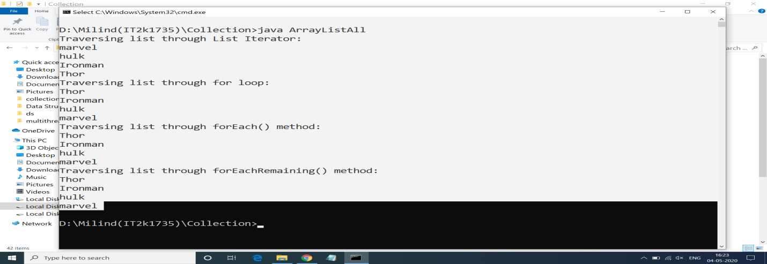

**3.Comapring Elements with compareTo() Method.**

**Solution:-**

import java.util.*;

public class compareto {

public static void main(String[] args) {

String s1 = "Hello";

String s2 = "World!";

String s3 = "";

System.out.println("s1 compareto s2: " + s1.compareTo(s2));

System.out.println("s1 compareto s3: " + s1.compareTo(s3));

System.out.println("s2 compareto s3: " + s2.compareTo(s3));

}

}

**Output 3:-**

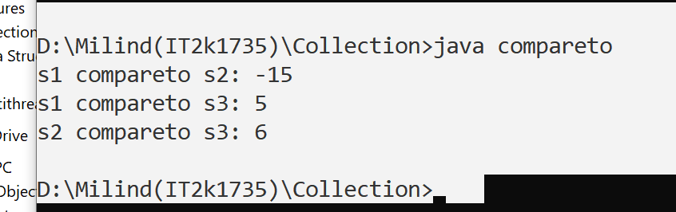

**4.Program of Enumeration in Collection.**

**Solution:-**

public class Enum {

public enum Season {WINTER, SPRING, SUMMER, FALL}

public static void main(String[] args)

{

System.out.println("Getting season with enum:");

for (Season s : Season.values()) {

System.out.println(s);

}

}

}

**Output 4:-**

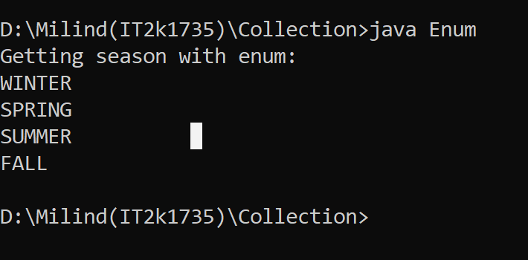

**5.Program of making LinkedList using Collection.**

**Solution:-**

import java.util.Iterator;

import java.util.LinkedList;

import java.util.List;

public class Linkedlst {

public static void main(String[] args) {

List<String> lst = new LinkedList<String>();

lst.add("Thor");

lst.add("hulk");

lst.add("Ironman");

lst.add("Marvel");

Iterator itr = lst.iterator();

Object First = itr.next();

Object Second = itr.next();

Object third = itr.next();

Object fourth = itr.next();

System.out.println("First:"+First+",Second:"+Second+",third:"+third+",fourth:"+fourth);

}

}

**Output 5:-**

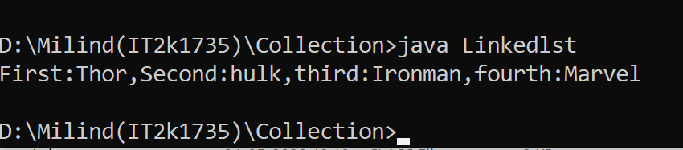

**6.Program of Removing elements from linkedlist.**

**Solution:-**

import java.util.LinkedList;

public class Linkedlst1 {

public static void main(String[] args) {

LinkedList<String> lst = new LinkedList<String>();

lst.add("xmen");

lst.add("hulk");

lst.add("thor");

lst.add("ironman");

System.out.println(lst);

System.out.println("remove :" + lst.remove(0));

System.out.println(lst);

System.out.println("remove:" + lst.remove(1));

System.out.println("After Removing ,remaining list:");

System.out.println(lst);

}

}

**Output 6:-**

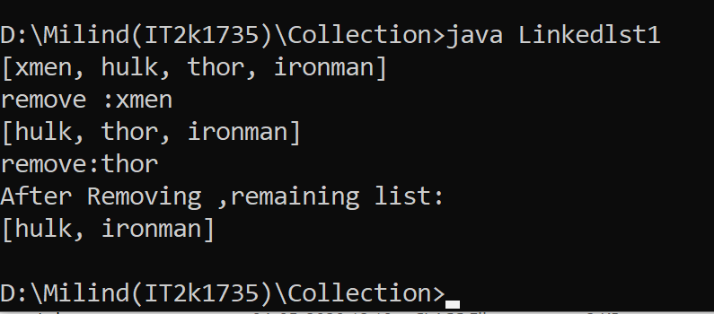

**7.Program of making Queue using Collection.**

**Solution:-**

import java.util.LinkedList;

import java.util.Queue;

public class Queue1 {

public static void main(String[] args) {

Queue<Integer> qu = new LinkedList<>();

for (int i = 0; i < 5; i++) {

qu.add(i);

}

System.out.println("Queue Element:" + qu);

Integer remo = qu.remove();

System.out.println("removed Element:" + remo);

Integer head = qu.peek();

System.out.println("Head of queue:" + head);

int size = qu.size();

System.out.println("Size of queue:" + size);

}

}

**Output 7:-**

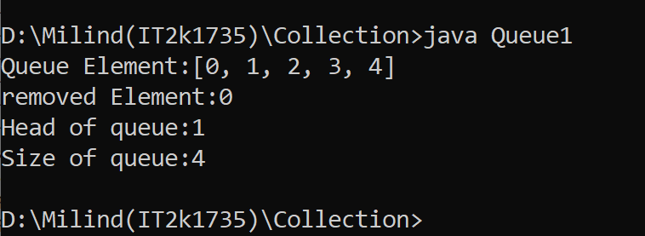

**8.Program of creating Priority Queue using Collection.**

**Solution:-**

import java.util.Iterator;

import java.util.PriorityQueue;

class Pqueue {

public static void main(String[] args) {

PriorityQueue<String> q = new PriorityQueue<>();

q.add("navlakha");

q.add("palasiya");

q.add("56 dukan");

System.out.println("head" + q.peek());

System.out.println("head:" + q.element());

System.out.println("iterating the queue Element");

Iterator itr = q.iterator();

while (itr.hasNext()) {

System.out.println(itr.next());

}

System.out.println("after removing two Element");

q.remove();

q.poll();

Iterator itr1 = q.iterator();

while (itr1.hasNext()) {

System.out.println(itr1.next());

}

}

}

**Output 8:-**

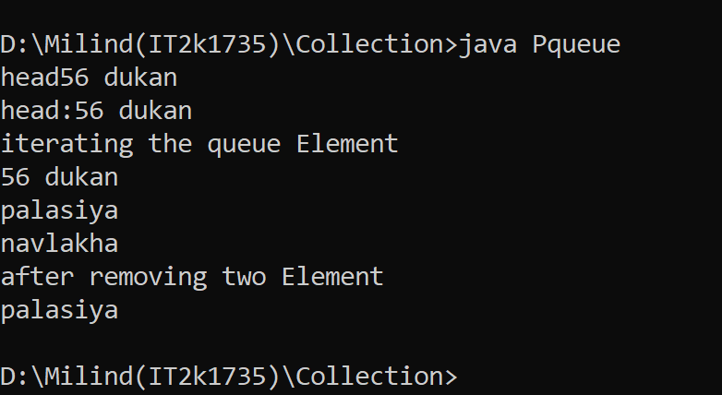

**9.Program of creating Stack using Collection.**

**Solution:-**

import java.io.*;

import java.util.*;

class StackDemo

{

static void stack_push(Stack<Integer> stack)

{

for(int i = 0; i < 5; i++)

{

stack.push(i);

}

}

static void stack_pop(Stack<Integer> stack)

{

System.out.println("Pop :");

for(int i = 0; i < 5; i++)

{

Integer y = (Integer) stack.pop();

System.out.println(y);

}

}

static void stack_peek(Stack<Integer> stack)

{

Integer element = (Integer) stack.peek();

System.out.println("Element on stack top : " + element);

}

static void stack_search(Stack<Integer> stack, int element)

{

Integer pos = (Integer) stack.search(element);

if(pos == -1)

System.out.println("Element not found");

else

System.out.println("Element is found at position " + pos);

}

public static void main (String[] args)

{

Stack<Integer> stack = new Stack<Integer>();

stack_push(stack);

stack_pop(stack);

stack_push(stack);

stack_peek(stack);

stack_search(stack, 2);

stack_search(stack, 6);

}

}

**Output 9:-**

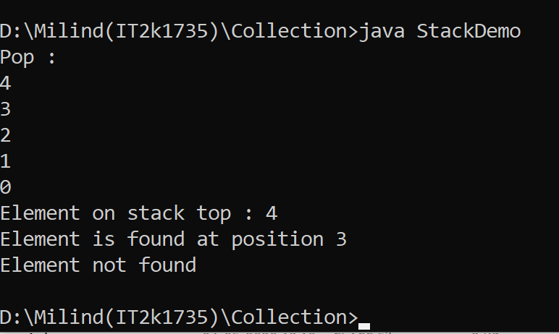

**10.Program of Map in Collection interface.**

**Solution:-**

import java.util.HashMap;

import java.util.Iterator;

import java.util.Map;

import java.util.Set;

public class MyMap {

public static void main(String[] args) {

Map m = new HashMap();

m.put(1, "dhoni");

m.put(7, "Rahul");

m.put(9, "ram");

m.put(6, "pant");

Set set = m.entrySet();

Iterator itr = set.iterator();

while (itr.hasNext()) {

Map.Entry entry = (Map.Entry) itr.next();

System.out.println(entry.getKey() + " " + entry.getValue());

}

}}

**Output 10:-**

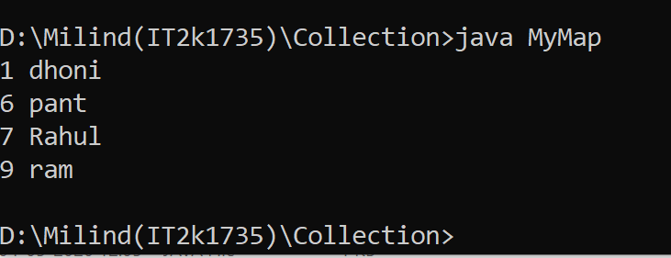

**11.Program of Sorted Map with Collection.**

**Solution:-**

import java.util.SortedMap;

import java.util.TreeMap;

public class SortedMap1 {

public static void main(String[] args) {

SortedMap<Integer, String> sm = new TreeMap<Integer, String>();

sm.put(107, "Dhoni");

sm.put(102, "Rohit Sharma");

sm.put(106, "Virat");

System.out.println("HeadMap:" + sm.headMap(107));

System.out.println("tailMap:" + sm.tailMap(107));

System.out.println("subMap" + sm.subMap(102, 107));

}

}

**Output 11:-**

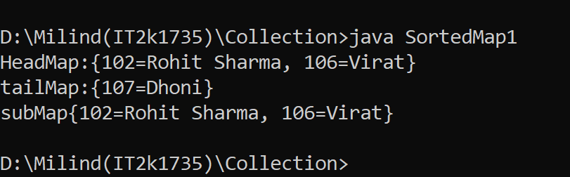

**12.Program Of Identity Hash Map.**

**Solution:-**

import java.util.HashMap;

import java.util.IdentityHashMap;

import java.util.Map;

public class Identityhashmap {

public static void main(String[] args) {

Map h = new HashMap();

Map hm = new IdentityHashMap();

h.put("hkey", "hvalue");

hm.put("hmkey", "hmvalue");

System.out.println("Size of HashMap: " + h.size());

System.out.println("Size of IdentityHashMap: " + hm.size());

}

}

**Output 12:-**

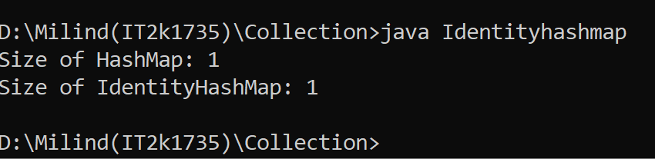

**13.Program of Hash Set in Collection.**

**Solution:-**

import java.util.HashSet;

public class Hashset1 {

public static void main(String[] args) {

HashSet<String> hs = new HashSet<>();

hs.add("Virat kohli");

hs.add("Rohit sharma");

hs.add("Rishabh pant");

hs.add("Ms Dhoni");

System.out.println(hs);

System.out.println("List contains Ms Dhoni or not :" + hs.contains("Ms Dhoni"));

hs.remove("Virat kohli");

System.out.println(hs);

}

}

**Output 13:-**

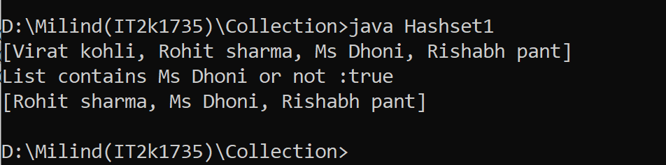

**14.Program of LinkedHash Set in Collection.**

**Solution:-**

import java.util.LinkedHashSet;

public class Linkedhashset {

public static void main(String[] args) {

LinkedHashSet<String> a = new LinkedHashSet<>();

a.add("kalu");

a.add("ram");

a.add("lakhan");

System.out.println("linkedhashset size:" + a.size());

System.out.println("Original Linkedhashset:" + a);

System.out.println("Removing Ram from Linkedhashset: " + a.remove("ram"));

System.out.println("update Linkedhashset:" + a);

}

}

**Output 14:-**

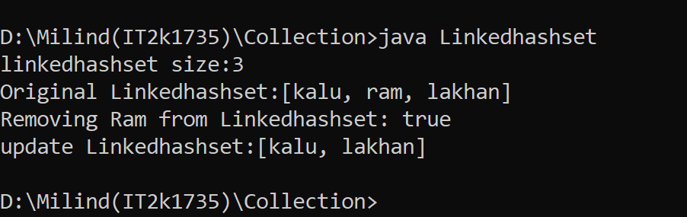

**15.Program of Tree in Collection.**

**Solution:-**

import java.util.SortedSet;

import java.util.TreeSet;

public class Tree1 {

public static void main(String[] args) {

SortedSet<String> str = new TreeSet<>();

str.add("mumbai");

str.add("delhi");

str.add("chennai");

str.add("kolkata");

str.add("hyderabad");

System.out.println("getting elements in tree");

for (String s : str) {

System.out.println(s);

}

}

}

**Output 15:-**

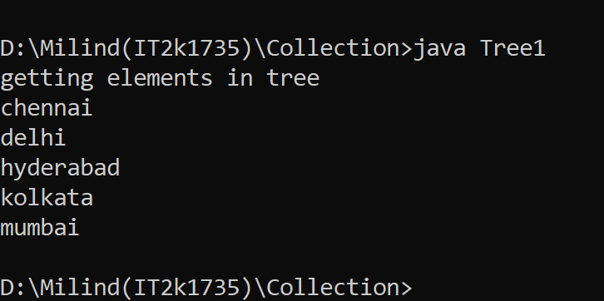

**16. Program of TreeMap in Collection Framework.**

**Solution:-**

import java.util.Map;

import java.util.TreeMap;

public class TreeMap1 {

public static void main(String[] args) {

TreeMap<Integer, String> tr = new TreeMap<>();

tr.put(1, "Virat kohli");

tr.put(2, "Pant");

tr.put(3, "Dhoni");

tr.put(4, "Rohit");

for (Map.Entry a : tr.entrySet()) {

System.out.println(a.getKey() + " " + a.getValue());

}

}

}

**Output 16:-**

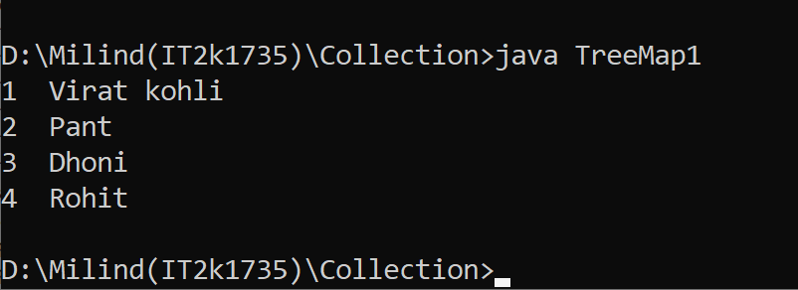

**17.Program of TreeSet with Collection.**

**Solution:-**

import java.util.TreeSet;

public class TreeSet1 {

public static void main(String[] args) {

TreeSet<String> set = new TreeSet<String>();

set.add("A");

set.add("B");

set.add("C");

set.add("D");

set.add("E");

System.out.println("Initial Set: " + set);

System.out.println("Reverse Set: " + set.descendingSet());

System.out.println("Head Set: " + set.headSet("C", true));

System.out.println("SubSet: " + set.subSet("A", false, "E", true));

System.out.println("TailSet: " + set.tailSet("C", false));

}

}

**Output 17:-**

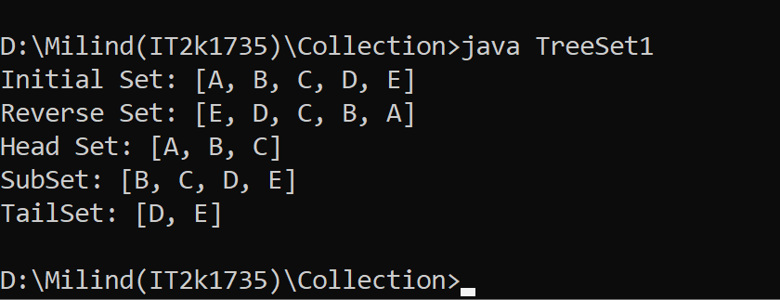

**18.Program of Vector in Collection.**

**Solution:-**

import java.util.Iterator;

import java.util.Vector;

public class Vector1 {

public static void main(String[] args) {

Vector<String> a = new Vector<>();

a.add("modi");

a.add("trump");

a.add("imran");

Iterator itr = a.iterator();

while (itr.hasNext()) {

System.out.println(itr.next())

}

}}

**Output 18:-**

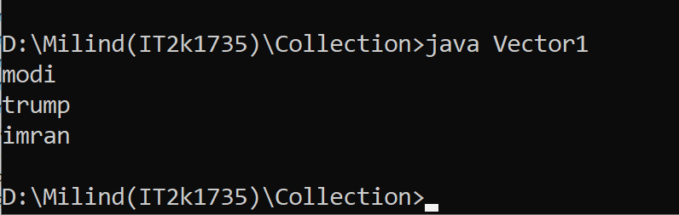

**19.Program of WeakHashMap in Collection.**

**Solution:-**

import java.util.HashMap;

import java.util.Map;

import java.util.Set;

public class WeakhashMap1 {

public static void main(String[] args) {

Map<Number, String> a = new HashMap<>();

a.put(1, "thor");

a.put(2, "hulk");

a.put(3, "iornman");

Set set = a.entrySet();

System.out.println(set);

Set keySet = a.keySet();

System.out.println("keyset is:" + keySet);

}

}

**Output 19:-**

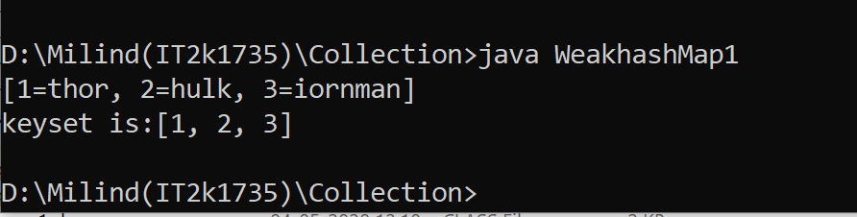

**20.Program of WeakHashMap in Collection.**

**Solution:-**

import java.util.HashMap;

import java.util.Map;

public class WeakhashMap2 {

public static void main(String[] args) {

Map<Number, String> a = new HashMap<>();

a.put(1, "marvel");

a.put(2, "antman");

a.put(3, "nat");

Map<Number, String> a1 = new HashMap<>();

a1.putAll(a);

System.out.println("getting second element:"+a1.get(2));

System.out.println("Size of map is:" + a1.size());

System.out.println("removing second element:");

a1.remove(2);

System.out.println("New Size of map is:" + a1.size());

}

}

**Output 20:-**

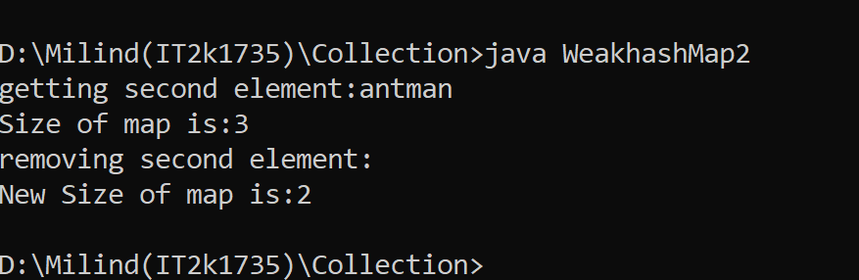

**END**

**Adv. Java Lab Assignment**

**Data Structures 10 Programs**

**Name:-Milind Bajaj**

**M.Tech(5th Sem)**

**Rollno.:-IT-2k17-35**

**1.Program of Array in Java.**

**Solution:-**

class Myarray{

public static void main(String args[]){

int a[]=new int[5];

a[0]=10;

a[1]=20;

a[2]=70;

a[3]=40;

for(int i=0;i<a.length;i++)

System.out.println(a[i]);

}

}

**Output 1:-**

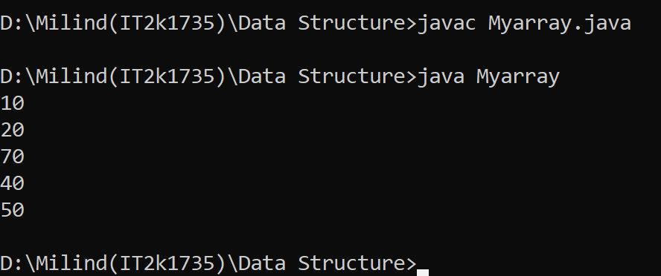

**2.Program of Stack Implement in Java.**

**Solution:-**

public class MyStackImpl {

private int stackSize;

private int[] stackArr;

private int top;

public MyStackImpl(int size) {

this.stackSize = size;

this.stackArr = new int[stackSize];

this.top = -1;

}

public void push(int entry) throws Exception {

if(this.isStackFull()){

throw new Exception("Stack is already full. Can not add element.");

}

System.out.println("Adding: "+entry);

this.stackArr[++top] = entry;

}

public int pop() throws Exception {

if(this.isStackEmpty()){

throw new Exception("Stack is empty. Can not remove element.");

}

int entry = this.stackArr[top--];

System.out.println("Removed entry: "+entry);

return entry;

}

public int peek() {

return stackArr[top];

}

public boolean isStackEmpty() {

return (top == -1);

}

public boolean isStackFull() {

return (top == stackSize - 1);

}

public static void main(String[] args) {

MyStackImpl stack = new MyStackImpl(5);

try {

stack.push(4);

stack.push(8);

stack.push(3);

stack.push(89);

stack.pop();

stack.push(34);

stack.push(45);

stack.push(78);

} catch (Exception e) {

System.out.println(e.getMessage());

}

try {

stack.pop();

stack.pop();

stack.pop();

stack.pop();

stack.pop();

stack.pop();

} catch (Exception e) {

System.out.println(e.getMessage());

}

}

}

**Output 2:-**

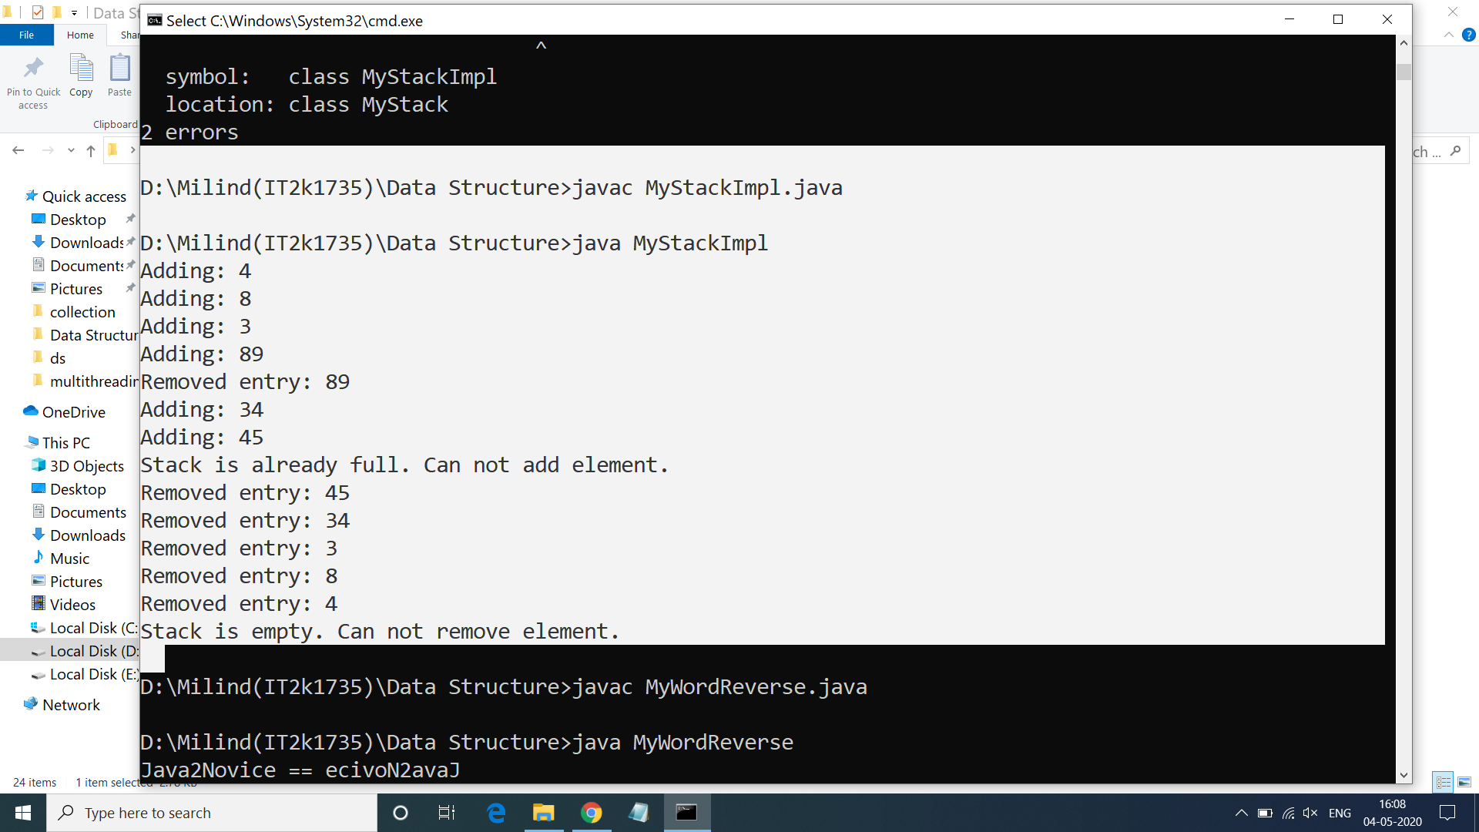

**3.Program of Queue Implement in Java.**

**Solution:-**

public class QueueImpl {

private int capacity;

int queueArr[];

int front = 0;

int rear = -1;

int currentSize = 0;

public QueueImpl(int queueSize){

this.capacity = queueSize;

queueArr = new int[this.capacity];

}

public void enqueue(int item) {

if (isQueueFull()) {

System.out.println("Overflow ! Unable to add element: "+item);

} else {

rear++;

if(rear == capacity-1){

rear = 0;

}

queueArr[rear] = item;

currentSize++;

System.out.println("Element " + item+ " is pushed to Queue !");

}

}

public void dequeue() {

if (isQueueEmpty()) {

System.out.println("Underflow ! Unable to remove element from Queue");

} else {

front++;

if(front == capacity-1){

System.out.println("Pop operation done ! removed: "+queueArr[front-1]);

front = 0;

} else {

System.out.println("Pop operation done ! removed: "+queueArr[front-1]);

}

currentSize--;

}

}

public boolean isQueueFull(){

boolean status = false;

if (currentSize == capacity){

status = true;

}

return status;

}

public boolean isQueueEmpty(){

boolean status = false;

if (currentSize == 0){

status = true;

}

return status;

}

public static void main(String a[]){

QueueImpl queue = new QueueImpl(4);

queue.enqueue(4);

queue.dequeue();

queue.enqueue(56);

queue.enqueue(2);

queue.enqueue(67);

queue.dequeue();

queue.dequeue();

queue.enqueue(24);

queue.dequeue();

queue.enqueue(98);

queue.enqueue(45);

queue.enqueue(23);

queue.enqueue(435);

}

}

**Output 3:-**

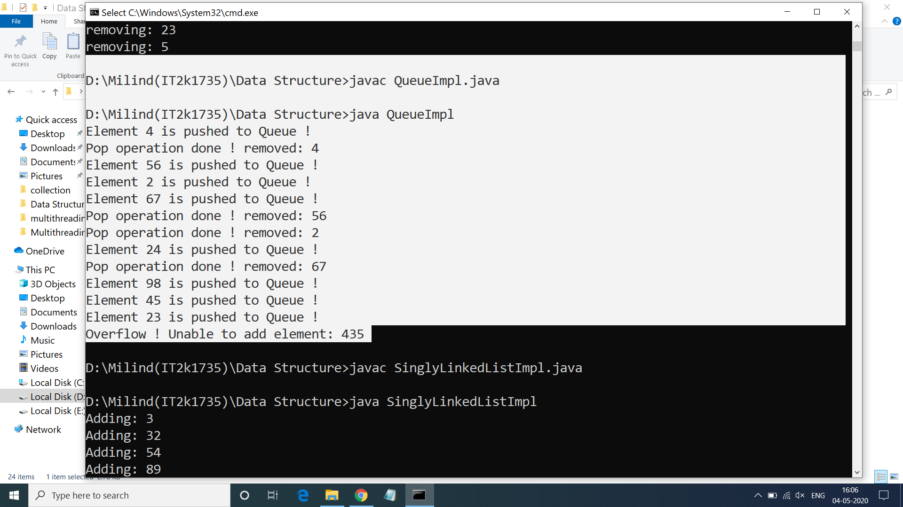

**4.Program of Single LinkedList In Java.**

**Solution:-**

public class SinglyLinkedListImpl<T> {

private Node<T> head;

private Node<T> tail;

public void add(T element){

Node<T> nd = new Node<T>();

nd.setValue(element);

System.out.println("Adding: "+element);

if(head == null){

head = nd;

tail = nd;

} else {

tail.setNextRef(nd);

tail = nd;

}

}

public void addAfter(T element, T after){

Node<T> tmp = head;

Node<T> refNode = null;

System.out.println("Traversing to all nodes..");

while(true){

if(tmp == null){

break;

}

if(tmp.compareTo(after) == 0){

refNode = tmp;

break;

}

tmp = tmp.getNextRef();

}

if(refNode != null){

Node<T> nd = new Node<T>();

nd.setValue(element);

nd.setNextRef(tmp.getNextRef());

if(tmp == tail){

tail = nd;

}

tmp.setNextRef(nd);

} else {

System.out.println("Unable to find the given element...");

}

}

public void deleteFront(){

if(head == null){

System.out.println("Underflow...");

}

Node<T> tmp = head;

head = tmp.getNextRef();

if(head == null){

tail = null;

}

System.out.println("Deleted: "+tmp.getValue());

public void traverse(){

Node<T> tmp = head;

while(true){

if(tmp == null){

break;

}

System.out.println(tmp.getValue());

tmp = tmp.getNextRef();

}

}

public static void main(String a[]){

SinglyLinkedListImpl<Integer> sl = new SinglyLinkedListImpl<Integer>();

sl.add(3);

sl.add(32);

sl.add(54);

sl.add(89);

sl.addAfter(76, 54);

sl.deleteFront();

sl.deleteAfter(76);

sl.traverse();

}

}

}

**Output 4:-**

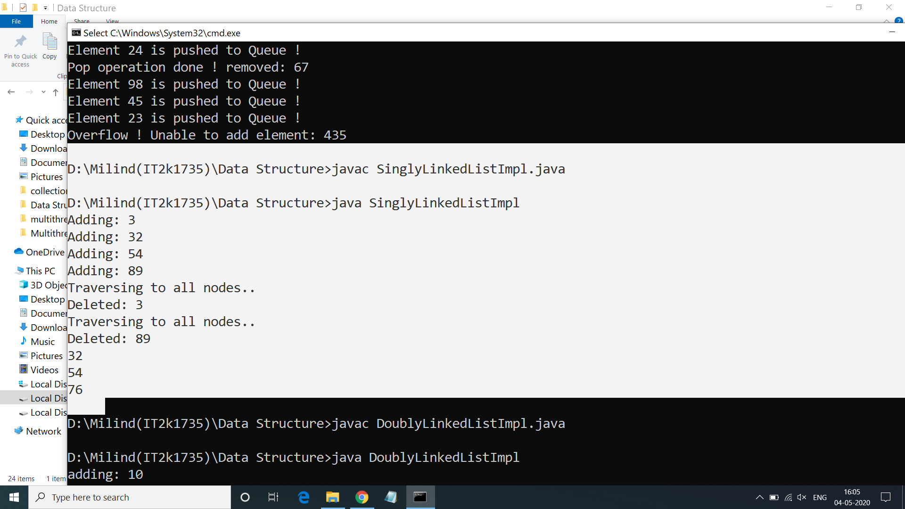

**5.Program of Matrix in Java**

**Solution:-**

import java.util.Scanner;

public class CreateMatrix {

public static void main(String[] args) {

Scanner scan = new Scanner(System.in);

System.out.println("Enter The Number Of Matrix Rows");

int matrixRow = scan.nextInt();

System.out.println("Enter The Number Of Matrix Columns");

int matrixCol = scan.nextInt();

int[][] matrix = new int[matrixRow][matrixCol];

enterMatrixData(scan, matrix, matrixRow, matrixCol);

printMatrix(matrix, matrixRow, matrixCol);

}

public static void enterMatrixData(Scanner scan, int[][] matrix, int matrixRow, int matrixCol){

System.out.println("Enter Matrix Data");

for (int i = 0; i < matrixRow; i++)

{

for (int j = 0; j < matrixCol; j++)

{

matrix[i][j] = scan.nextInt();

}

}

}

public static void printMatrix(int[][] matrix, int matrixRow, int matrixCol){

System.out.println("Your Matrix is : ");

for (int i = 0; i < matrixRow; i++)

{

for (int j = 0; j < matrixCol; j++)

{

System.out.print(matrix[i][j]+"\t");

}

System.out.println();

}

}

}

**Output 5:-**

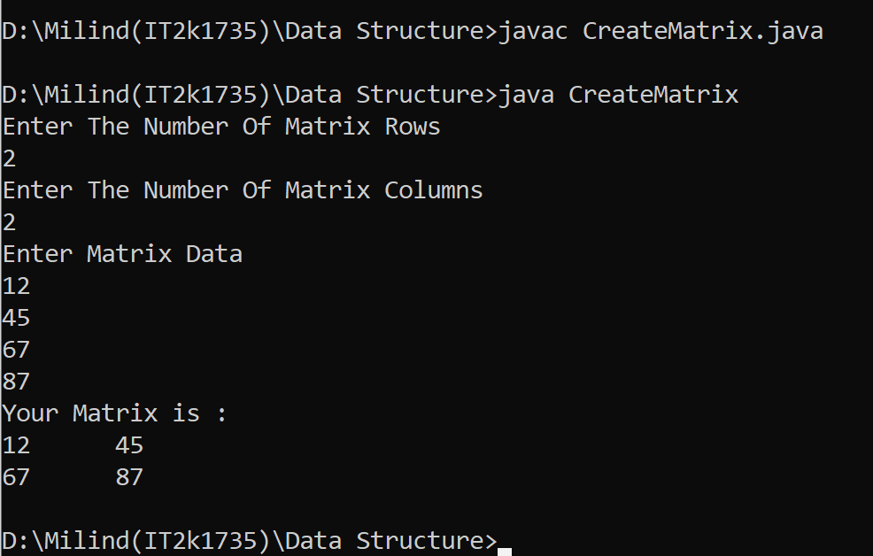

**6.Program of Binary Tree in Java.**

**Solution:-**

public class Tree {

static class Node {

int value;

Node left, right;

Node(int value){

this.value = value;

left = null;

right = null;

}

}

public void insert(Node node, int value) {

if (value < node.value) {

if (node.left != null) {

insert(node.left, value);

} else {

System.out.println(" Inserted " + value + " to left of " + node.value);

node.left = new Node(value); }

} else if (value > node.value) {

if (node.right != null) {

insert(node.right, value);

} else {

System.out.println(" Inserted " + value + " to right of "

+ node.value);

node.right = new Node(value);

}

}

}

public void traverseInOrder(Node node) {

if (node != null) {

traverseInOrder(node.left);

System.out.print(" " + node.value);

traverseInOrder(node.right);

}

}

public static void main(String args[])

{

Tree tree = new Tree();

Node root = new Node(5);

System.out.println("Binary Tree Example");

System.out.println("Building tree with root value " + root.value);

tree.insert(root, 2);

tree.insert(root, 4);

tree.insert(root, 8);

tree.insert(root, 6);

tree.insert(root, 7);

tree.insert(root, 3);

tree.insert(root, 9);

}

}

**Output 6:-**

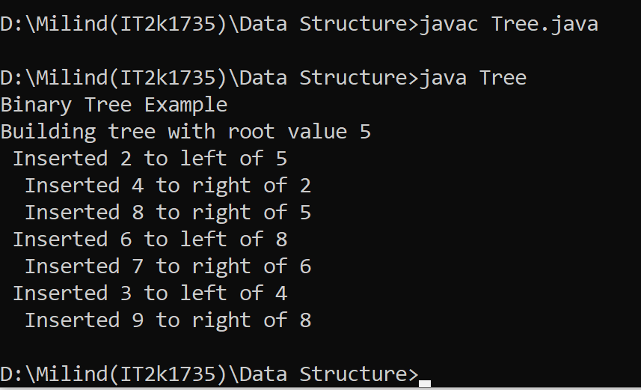

**7.Program of Binary Search Tree in Java.**

**Solution:-**

public class Binary {

private BstNode root;

public boolean isEmpty() {

return (this.root == null);

}

public void insert(Integer data) {

System.out.print("[input: "+data+"]");

if(root == null) {

this.root = new BstNode(data);

System.out.println(" -> inserted: "+data);

return;

}

insertNode(this.root, data);

System.out.print(" -> inserted: "+data);

System.out.println();

}

private BstNode insertNode(BstNode root, Integer data) {

BstNode tmpNode = null;

System.out.print(" ->"+root.getData());

if(root.getData() >= data) {

System.out.print(" [L]");

if(root.getLeft() == null) {

root.setLeft(new BstNode(data));

return root.getLeft();

} else {

tmpNode = root.getLeft();

}

} else {

System.out.print(" [R]");

if(root.getRight() == null) {

root.setRight(new BstNode(data));

return root.getRight();

} else {

tmpNode = root.getRight();

}

}

return insertNode(tmpNode, data);

}

public static void main(String a[]) {

Binary bst = new Binary();

bst.insert(10);

bst.insert(20);

bst.insert(21);

bst.insert(8);

bst.insert(6);

bst.insert(16);

bst.insert(23);

}

}

**Output 7:-**

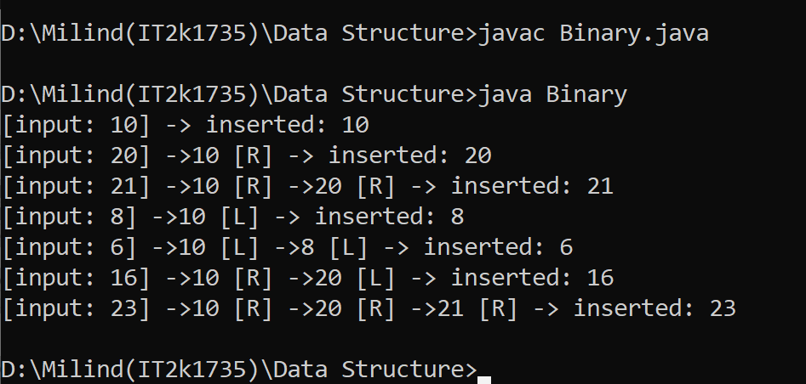

**8.Program of Hash Table in Java.**

**Solution:-**

import java.util.*;

class Hash {

public static void main(String args[])

{

Hashtable<Integer, String>

hm = new Hashtable<Integer, String>();

hm.put(1, "marvel");

hm.put(84, "hulk");

hm.put(48, "thor");

hm.put(2, "Ironman");

System.out.println(hm);

}

}

**Output 8:-**

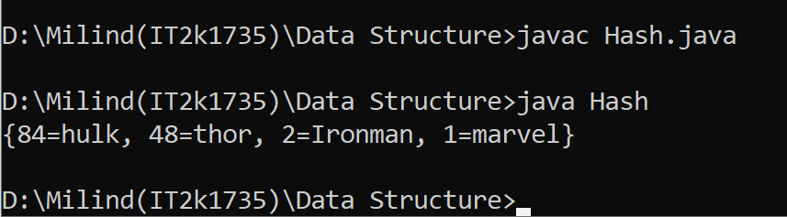

**9.Program of Heap in Java.**

**Solution:-**

public class MinHeap {

private int[] Heap;

private int size;

private int maxsize;

private static final int FRONT = 1;

public MinHeap(int maxsize)

{

this.maxsize = maxsize;

this.size = 0;

Heap = new int[this.maxsize + 1];

Heap[0] = Integer.MIN_VALUE;

}

private int parent(int pos)

{

return pos / 2;

}

private int leftChild(int pos)

{

return (2 * pos);

}

private int rightChild(int pos)

{

return (2 * pos) + 1;

}

private boolean isLeaf(int pos)

{

if (pos >= (size / 2) && pos <= size) {

return true;

}

return false;

}

private void swap(int fpos, int spos)

{

int tmp;

tmp = Heap[fpos];

Heap[fpos] = Heap[spos];

Heap[spos] = tmp;

}

private void minHeapify(int pos)

{

if (!isLeaf(pos)) {

if (Heap[pos] > Heap[leftChild(pos)]

|| Heap[pos] > Heap[rightChild(pos)]) {

if (Heap[leftChild(pos)] < Heap[rightChild(pos)]) {

swap(pos, leftChild(pos));

minHeapify(leftChild(pos));

}

else {

swap(pos, rightChild(pos));

minHeapify(rightChild(pos));

}

}

}

}

public void insert(int element)

{

if (size >= maxsize) {

return;

}

Heap[++size] = element;

int current = size;

while (Heap[current] < Heap[parent(current)]) {

swap(current, parent(current));

current = parent(current);

}

}

public void print()

{

for (int i = 1; i <= size / 2; i++) {

System.out.print(" PARENT : " + Heap[i]

+ " LEFT CHILD : " + Heap[2 * i]

+ " RIGHT CHILD :" + Heap[2 * i + 1]);

System.out.println();

}

}

public void minHeap()

{

for (int pos = (size / 2); pos >= 1; pos--) {

minHeapify(pos);

}

}

public int remove()

{

int popped = Heap[FRONT];

Heap[FRONT] = Heap[size--];

minHeapify(FRONT);

return popped;

}

public static void main(String[] arg)

{

System.out.println("The Min Heap is ");

MinHeap minHeap = new MinHeap(15);

minHeap.insert(5);

minHeap.insert(3);

minHeap.insert(17);

minHeap.insert(10);

minHeap.insert(84);

minHeap.insert(19);

minHeap.insert(6);

minHeap.insert(22);

minHeap.insert(9);

minHeap.minHeap();

minHeap.print();

System.out.println("The Min val is " + minHeap.remove());

}

}

**Output 9:-**

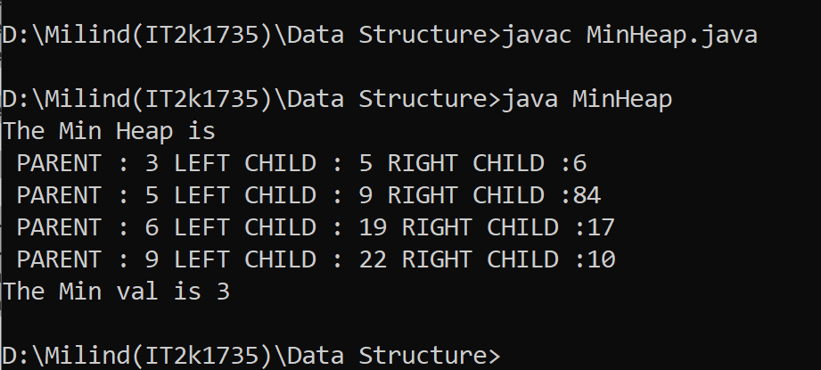

**10.Program of Graph in Java.**

**Solution:-**

import java.util.*;

class Graph<T> {

private Map<T, List<T> > map = new HashMap<>();

public void addVertex(T s)

{

map.put(s, new LinkedList<T>());

}

public void addEdge(T source,

T destination,

boolean bidirectional)

{

if (!map.containsKey(source))

addVertex(source);

if (!map.containsKey(destination))

addVertex(destination);

map.get(source).add(destination);

if (bidirectional == true) {

map.get(destination).add(source);

}

}

public void getVertexCount()

{

System.out.println("The graph has "

+ map.keySet().size()

+ " vertex");

}

public void getEdgesCount(boolean bidirection)

{

int count = 0;

for (T v : map.keySet()) {

count += map.get(v).size();

}

if (bidirection == true) {

count = count / 2;

}

System.out.println("The graph has “ + count

+ " edges.");

} public void hasVertex(T s)

{

if (map.containsKey(s)) {

System.out.println("The graph contains "

+ s + " as a vertex.");

}

else {

System.out.println("The graph does not contain "

+ s + " as a vertex.");

}

}

public void hasEdge(T s, T d)

{

if (map.get(s).contains(d)) {

System.out.println("The graph has an edge between "

+ s + " and " + d + ".");

}

else {

System.out.println("The graph has no edge between "

+ s + " and " + d + ".");

}

}

@Override

public String toString()

{

StringBuilder builder = new StringBuilder();

for (T v : map.keySet()) {

builder.append(v.toString() + ": ");

for (T w : map.get(v)) {

builder.append(w.toString() + " ");

}

builder.append("\n");

}

return (builder.toString());

}

}

public class Main {

public static void main(String args[])

{ Graph<Integer> g = new Graph<Integer>();

g.addEdge(0, 1, true);

g.addEdge(0, 4, true);

g.addEdge(1, 2, true);

g.addEdge(1, 3, true);

g.addEdge(1, 4, true);

g.addEdge(2, 3, true);

g.addEdge(3, 4, true);

System.out.println("Graph:\n"

+ g.toString());

g.getVertexCount();

g.getEdgesCount(true);

g.hasEdge(3, 4);

g.hasVertex(5); } }

**Output 10:-**

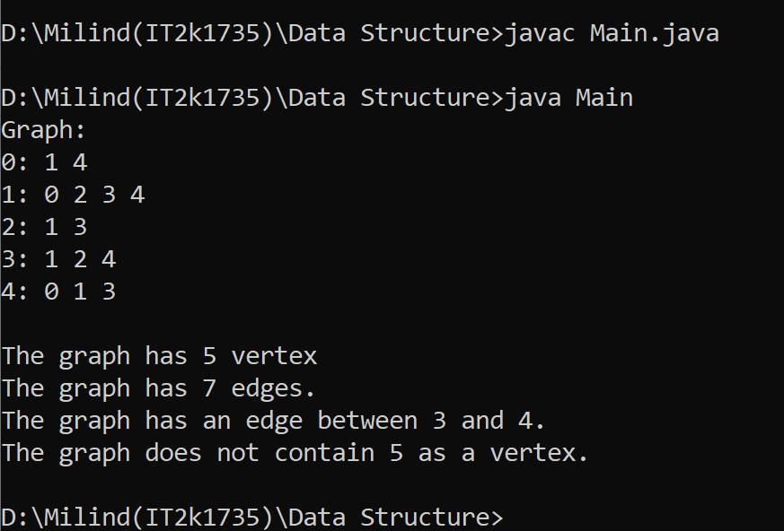

**END**

**Adv. Java Lab Assignment**

**MultiThreading 20 Programs**

**Name:-Milind Bajaj**

**M.Tech(5th Sem)**

**Rollno.:-IT-2k17-35**

**1.Program of Create Thread by implementing Runnable Interface.**

**Solution:-**

import java.util.*;

class subTh implements Runnable

{

void get() {

System.out.println("WelCome in threading");

}

public void run()

{

System.out.println("Hello world!");

}

}

class FirstThread {

public static void main(String[] args) {

subTh st=new subTh();

Thread ThreadEx=new Thread(st);

ThreadEx.start();

st.get();

}}

**Output 1:-**

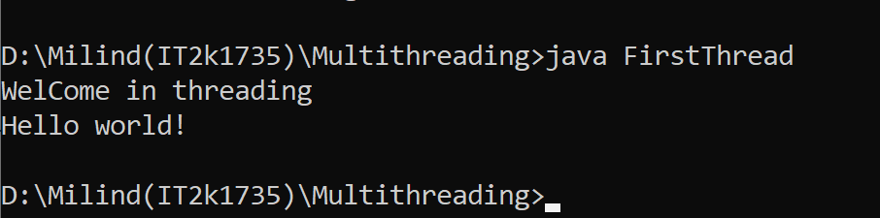

**2.Program of Creating Thread by Thread Class.**

**Solution:-**

class ThreadDemo extends Thread {

private Thread t;

private String threadName;

ThreadDemo( String name){

threadName = name;

System .out.println("Creating " + threadName );

}

public ThreadDemo() {

}

public void run() {

System .out.println("Running " + threadName );

try {

for(int i = 4; i > 0; i--) {

System .out.println("Thread: " + threadName + ", " + i);

Thread.sleep(50);

}

} catch (InterruptedException e) {

System .out.println("Thread " + threadName + " interrupted.");

}

System .out.println("Thread " + threadName + " exiting.");

}

public void start ()

{

System .out.println("Starting " + threadName );

if (t == null)

{

t = new Thread (this, threadName);

t.start ();

}}}

class ExtendThread {

public static void main(String args[]) {

ThreadDemo T1 = new ThreadDemo( "Thread-1");

T1.start();

ThreadDemo T2 = new ThreadDemo( "Thread-2");

T2.start(); }}

**Output 2:-**

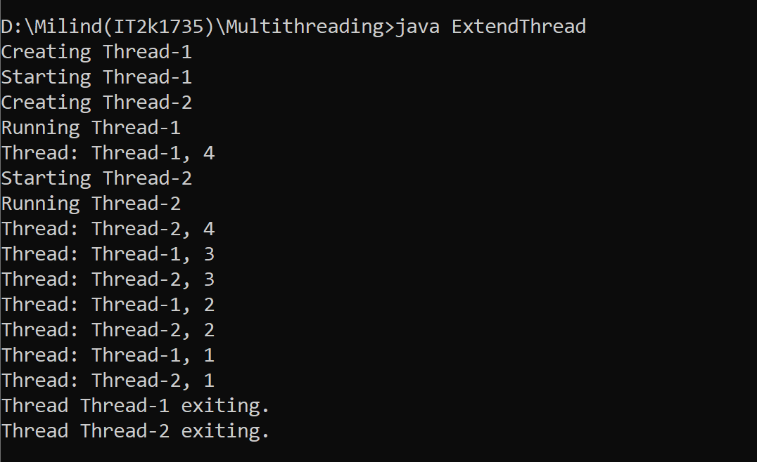

**3.Program of Extending Thread and Creating its Child.**

**Solution:-**

class Count extends Thread

{

Count()

{

super("my extending thread");

System.out.println("my thread created" + this);

start();

}

public void run()

{

try

{

for (int i=0 ;i<10;i++)

{

System.out.println("Printing the count " + i);

Thread.sleep(1000);

}

}

catch(InterruptedException e)

{

System.out.println("my thread interrupted");

}

System.out.println("My thread run is over" );

}

}

class ExtendingExample

{

public static void main(String args[])

{

Count cnt = new Count();

try

{

while(cnt.isAlive())

{

System.out.println("Main thread will be alive till the child thread is live");

Thread.sleep(1500); } }

catch(InterruptedException e)

{

System.out.println("Main thread interrupted");

}

System.out.println("Main thread's run is over" );

}}

**Output 3:-**

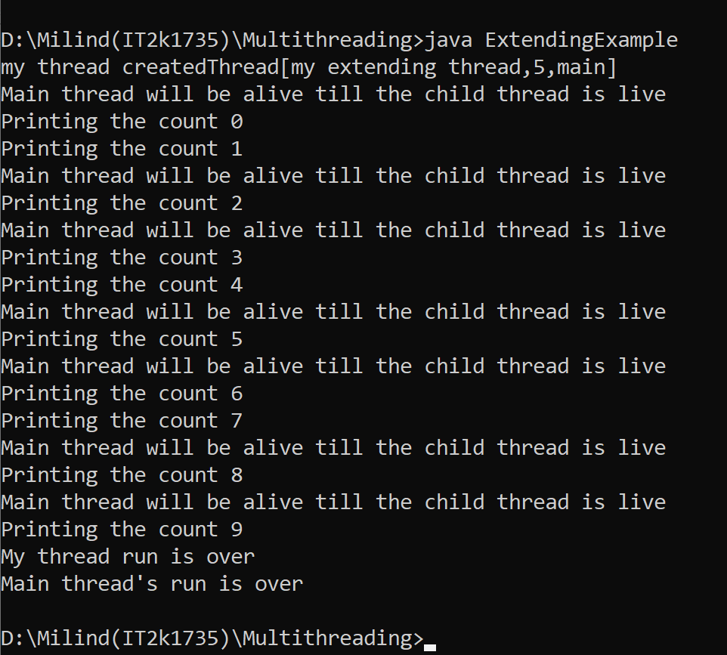

**4.Program of Creating Thread and Using sleep() method and Terminate it.**

**Solution:-**

public class MainThread {

public static void main(String[] args) {

for (int i = 0; i < 5; i++) {

try {

System.out.println(Thread.currentThread() + " " + i);

Thread.sleep(1010);

} catch (InterruptedException e) {

System.out.println("Interrupted");

}

}

System.out.println("Terminated"); }}

**Output 4:-**

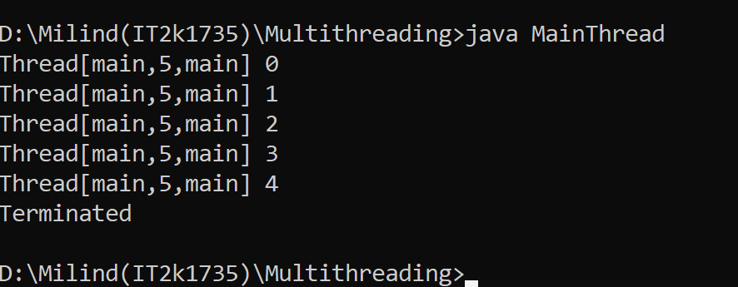

**5.Program of Creating Thread and Exiting From Main Thread.**

**Solution:-**

public class Main {

static volatile boolean exit = false;

public static void main(String[] args)

{

System.out.println("started main thread..");

new Thread() {

public void run()

{

System.out.println("started inside thread..");

while (!exit) {

}

System.out.println("exiting inside thread..");

}

}

try {

Thread.sleep(500);

}

catch (InterruptedException e) {

System.out.println("Caught :" + e);

}

exit = true;

System.out.println("exiting main thread..");

}

}

**Output 5:-**

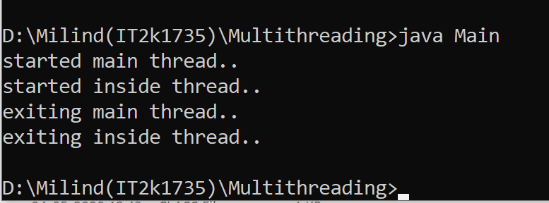

**6.Program of Guessing A Number with the help of Thread.**

**Solution:-**

public class GuessANumber extends Thread {

private int number;

public GuessANumber(int number) {

this.number = number; }

public static void main(String[] args) {

GuessANumber t=new GuessANumber(12);

t.start(); }

public void run() {

int counter = 0;

int guess = 0

do { guess = (int) (Math.random() * 50 + 1);

System.out.println(this.getName() + " guesses " + guess);

counter++;

} while(guess != number);

System.out.println("** Correct!" + this.getName() + "in" + counter + "guesses.**");

}

}

**Output 6:-**

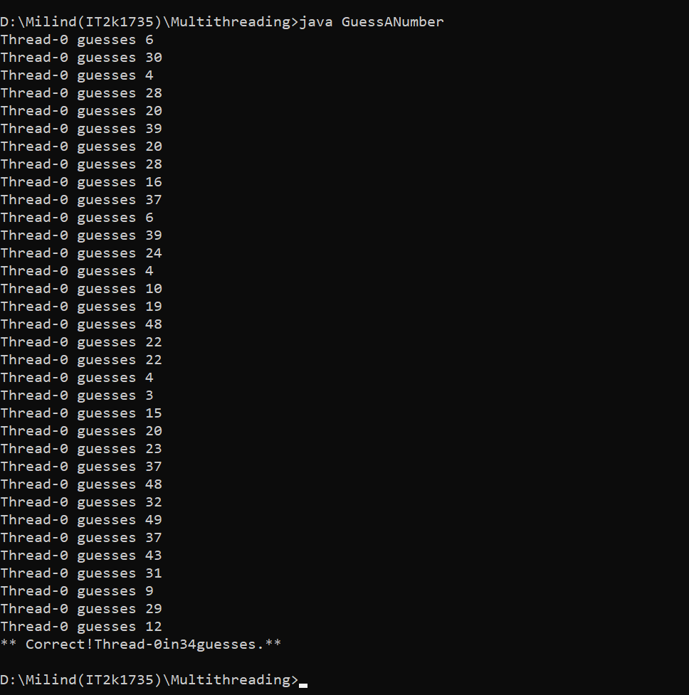

**7.Program of GetName and SetName of Thread.**

**Solution:-**

public class GetNameandSetName implements Runnable {

public static void main(String[] args) {

GetNameandSetName s1 = new GetNameandSetName();

Thread t1 = new Thread(s1);

t1.start();

System.out.println(t1.getId());

Thread t2 = new Thread(s1);

System.out.println(t2.getId());

t2.start();

t2.setName("Dhoni");

t1.setName("pant");

}

public void run() {

for (int i = 0; i < 5; i++) {

try {

Thread.sleep(500);

} catch (InterruptedException e) {

System.out.println("error");

}

System.out.println("Name of the thread is " + Thread.currentThread().getName() + " " + i); }}}

**Output 7:-**

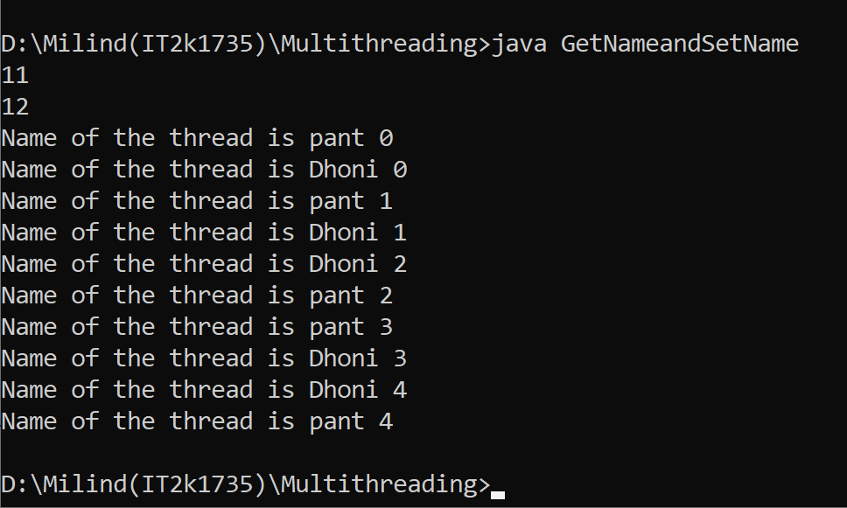

**8.Program of Creating Daemon Thread.**

**Solution:-**

class DaemonThreadDemo

{

public static void main (String [] args)

{

MyThread5 mt = new MyThread5 ();

mt.setDaemon (true);

mt.start ();

try

{

Thread.sleep (100);

}

catch (InterruptedException e)

{

}

}

}

class MyThread5 extends Thread

{

public void run ()

{

System.out.println ("Daemon is " + isDaemon ());

}

}

**Output 8:-**

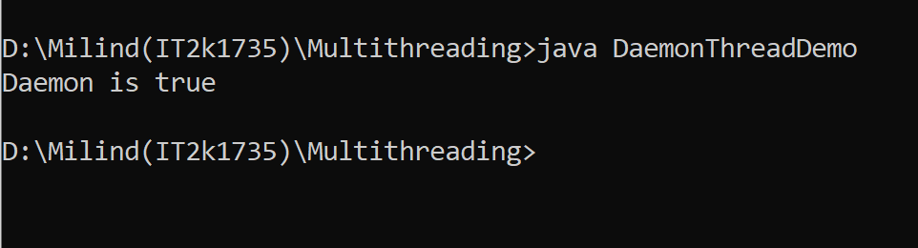

**9.Program of Creating Table with Thread.**

**Solution:-**

class Table {

synchronized void printTable(int n) {

for (int i = 1; i <= 5; i++) {

System.out.println(n * i);

try {

Thread.sleep(400);

} catch (Exception e) {

System.out.println(e);

}

}

}

}

class MyThread1 extends Thread{

Table t;

MyThread1(Table t){

this.t=t;

}

public void run(){

t.printTable(5);

}

}

class MyThread2 extends Thread{

Table t;

MyThread2(Table t){

this.t=t;

}

public void run(){

t.printTable(100);

}}

class Table1{

public static void main(String args[]){

Table obj = new Table();//only one object

MyThread1 t1=new MyThread1(obj);

MyThread2 t2=new MyThread2(obj);

t1.start();

t2.start(); }}

**Output 9:-**

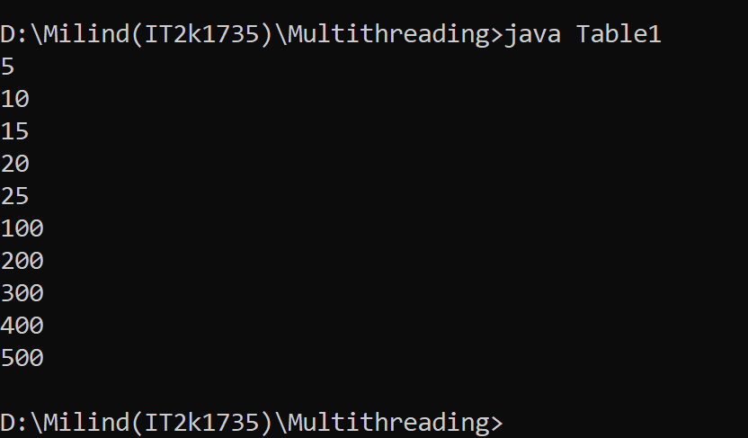

**10.Program of Naming my thread.**

**Solution:-**

class NameMyThread

{

public static void main (String [] args)

{

MyThread4 mt;

if (args.length == 0)

mt = new MyThread4 ();

else

mt = new MyThread4(args [0]);

mt.start ();

}

}

class MyThread4 extends Thread {

MyThread4() {

}

MyThread4(String name) {

setName(name);

}

public void run() {

System.out.println("My name is: " + getName());

}

}

**Output 10:-**

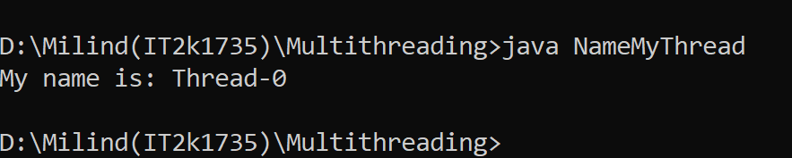

**11.Program of Testing Daemon Thread.**

**Solution:-**

class TestDaemonThread1 extends Thread{

public void run(){

if(Thread.currentThread().isDaemon()){//checking for daemon thread

System.out.println("daemon thread work");

}

else{

System.out.println("user thread work");

}

}

public static void main(String[] args){

TestDaemonThread1 t1=new TestDaemonThread1();

TestDaemonThread1 t2=new TestDaemonThread1();

TestDaemonThread1 t3=new TestDaemonThread1();

t1.setDaemon(true);

t1.start();

t2.start();

t3.start();

}

}

**Output 11:-**

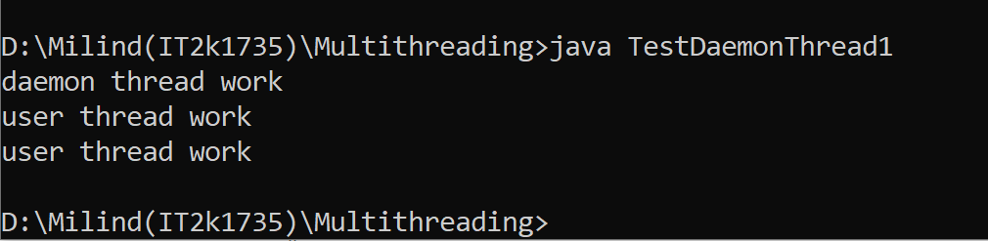

**12.Program of checking Thread Priority and Count Active Thread.**

**Solution:-**

public class ThreadDemo2 {

public static void main(String[] args) {

Thread t = Thread.currentThread();

t.setName("Admin Thread");

t.setPriority(1);

System.out.println("Thread = " + t);

int priority= t.getPriority();

System.out.println("Thread priority= " + priority);

int count = Thread.activeCount();

System.out.println("currently active threads = " + count);

}

}

**Output 12:-**

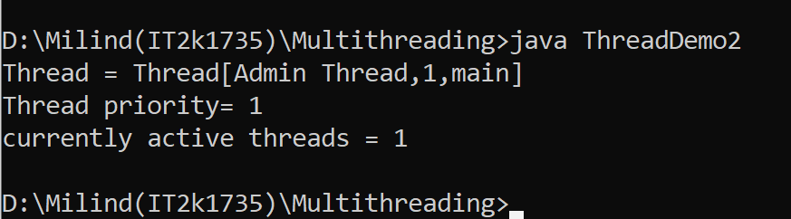

**13.Program of checking Thread whether it is running or not.**

**Solution:-**

class ThreadTest1 extends Thread

{

public void run()

{

System.out.println("In run");

yield();

System.out.println("Leaving run");

}

public static void main(String []argv)

{

(new ThreadTest1()).start();

}

}

**Output 13:-**

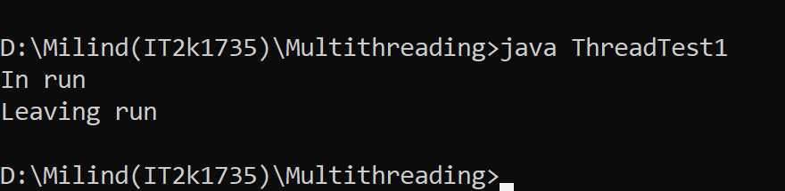

**14.Program of Multithreading.**

**Solution:-**

class MultithreadingDemo extends Thread

{

public void run()

{

try{

System.out.println("Thread:"+Thread.currentThread().getId()+"\tis running");

}

catch(Exception e)

{

System.out.println("Exception is caught");

}

}

}

public class Mthread1 {

public static void main(String[] args) {

int n = 5;

for (int i = 0; i <= 5; i++) {

MultithreadingDemo object = new MultithreadingDemo();

object.start();

}

}

}

**Output 14:-**

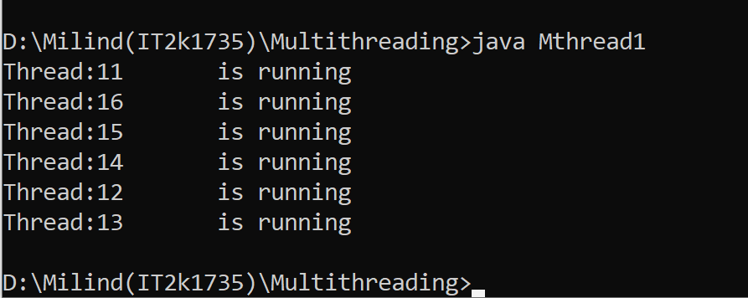

**15.Program of Multithreading Using Runnable.**

**Solution:-**

public class MultiThreadingusingRunnable {

public static void main(String[] args) {

StrtThread st = new StrtThread();

Thread thread = new Thread(st);

thread.start();

}

}

class StrtThread implements Runnable {

public void run() {

System.out.println("Thread is working");

}

}

**Output 15:-**

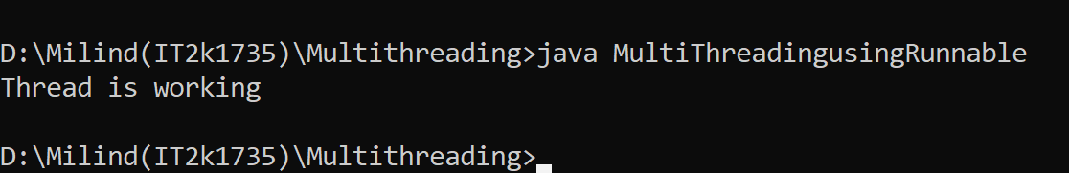

**16.Program of Multithreading Using Thread Class.**

**Solution:-**

public class MultiThreadingusingThread {

public static void main(String[] args) {

StartThread st1 = new StartThread();

st1.start();

}

}

class StartThread extends Thread {

public void run() {

System.out.println("thread is working");

}

}

**Output 16:-**

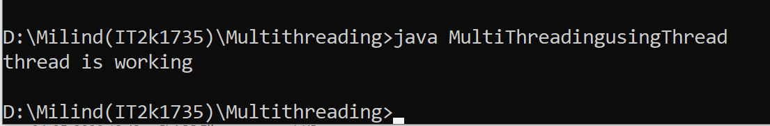

**17.Program of Getting Priority of Multithreading.**

**Solution:-**

public class MultithreadgetPriority extends Thread {

public static void main(String[] args) {

MultithreadgetPriority m1 = new MultithreadgetPriority();

MultithreadgetPriority m2 = new MultithreadgetPriority();

m1.start();

m2.start();

m1.setPriority(MIN_PRIORITY);

System.out.println(m1.getPriority());

System.out.println(m2.getPriority());

System.out.println(m1.getId());

}

public void run() {

System.out.println("Current thread is -" + Thread.currentThread().getName());

}

}

**Output 17:-**

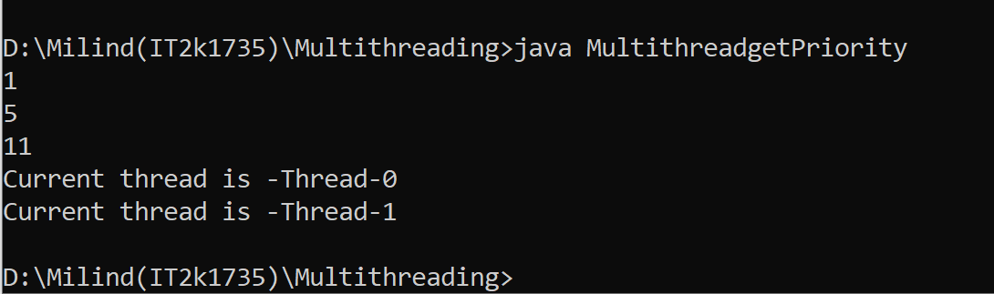

**18.Program of Multihtreading Using sleep Method.**

**Solution:-**

class Starthread implements Runnable {

public void run() {

for (int i = 1; i < 6; i++) {

try {

Thread.sleep(5000);

} catch (InterruptedException e) {

System.out.println(e);

}

System.out.print(i + " ");

System.out.println(Thread.currentThread().getName());

}

}

}

class MultiThreadSleepMethod {

public static void main(String[] args) {

Starthread t1 = new Starthread();

Starthread t2 = new Starthread();

Thread th1 = new Thread(t1);

Thread th2 = new Thread(t2);

th1.start();

th2.start();

}

}

**Output 18:-**

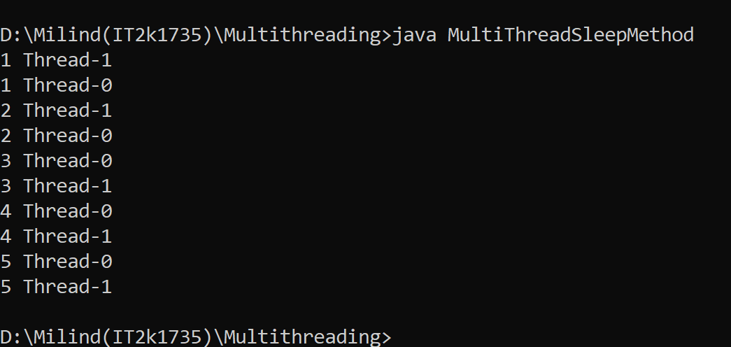

**19.Program of creating thread Using join Method.**

**Solution:-**

class UsingjoinMethod {

public static void main(String[] args) {

strt t1 = new strt();

strt t2 = new strt();

strt t3 = new strt();

t1.start();

try {

t1.join(1500);

} catch (Exception e) {

System.out.println(e);

}

t2.start();

t3.start();

}

}

class strt extends Thread {

public void run() {

for (int i = 1; i < 6; i++) {

try {

Thread.sleep(500);

} catch (InterruptedException e) {

System.out.println(e);

}

System.out.println(i + " " + Thread.currentThread().getName());

}

}

}

**Output 19:-**

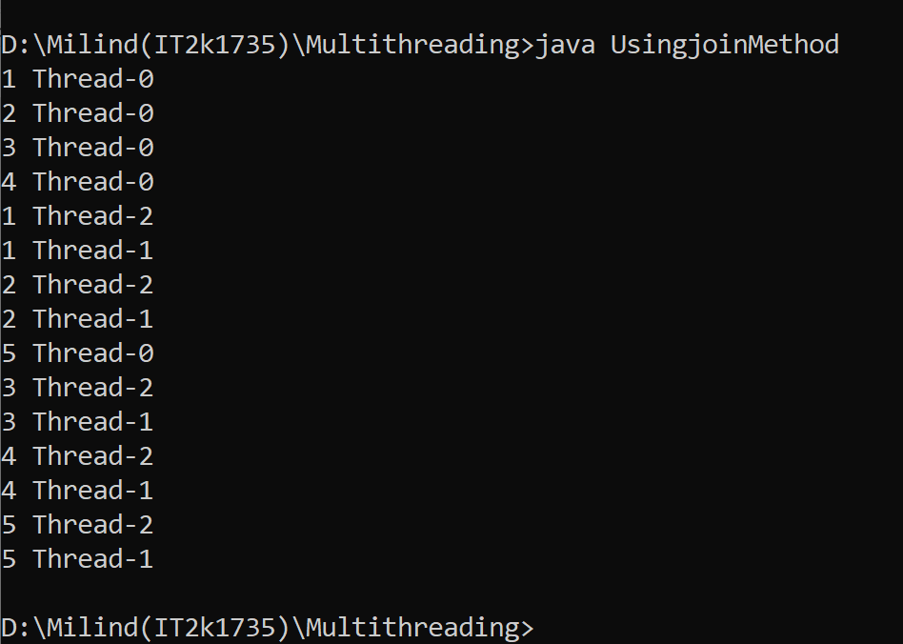

**20.Program of creating thread using Yield Method.**

**Solution:-**

public class YieldMethod extends Thread {

public static void main(String[] args) {

YieldMethod m1 = new YieldMethod();

YieldMethod m2 = new YieldMethod();

YieldMethod m3 = new YieldMethod();

m1.setName("Rohit");

m2.setName("kohli");

m3.setName("pant");

m1.start();

m2.start();

m2.suspend();

m3.start();

for (int i = 0; i < 3; i++) {

System.out.println(Thread.currentThread().getName() + " in control");

}

}

public void run() {

for (int i = 0; i < 5; i++) {

try {

Thread.sleep(500);

} catch (InterruptedException e) {

System.out.println("error");

}

System.out.println("Name of the thread is " + Thread.currentThread().getName() + " " + i);

}}}

**Output 20:-**

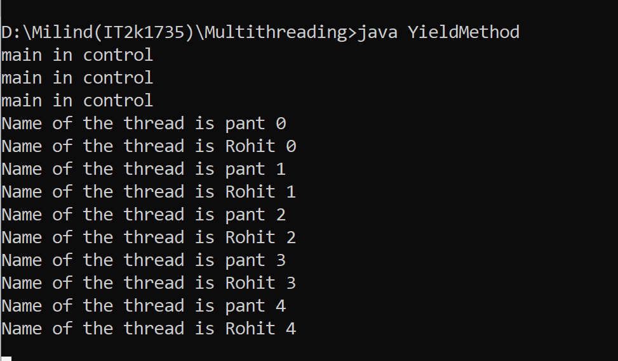

**END**

**Adv. Java Lab Assignment**

**JDBC 20 Programs**

**Name:-Root Bajaj**

**M.Tech(5th Sem)**

**Rollno.:-IT-2k17-35**

**1.Program for mysql connection with JDBC.**

**Solution:-**

import java.sql.Connection;

import java.sql.DriverManager;

import java.sql.SQLException;

import java.sql.Statement;

public class JdbcConnection {

public static void main(String a[]){

try {

Class.forName("com.mysql.jdbc.Driver");

Connection con = DriverManager.

getConnection("jdbc:mysql://localhost:3306/firstdb","root","root");

Statement stmt = con.createStatement();

System.out.println("Created DB Connection....");

} catch (ClassNotFoundException e) {

e.printStackTrace();

} catch (SQLException e) {

e.printStackTrace();

}

}

}

**Output 1:-**

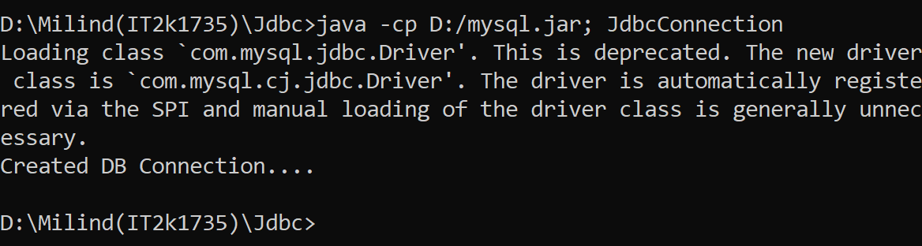

**2.Program of CREATE table in jdbc.**

**Solution:-**

import java.sql.*;

public class CreateTable{

Connection con;

CreateTable()

{

try

{

Class.forName("com.mysql.jdbc.Driver");

con=DriverManager.getConnection("jdbc:mysql://localhost:3306/firstdb","root","root");

PreparedStatement ps=con.prepareStatement("create table Student(sId int primary key,sName VARCHAR(30) not null )");

int count=ps.executeUpdate();

System.out.println(count);

System.out.println("Table created successfully!!");

}

catch (Exception e)

{

e.printStackTrace();

}

}

public static void main(String s[])

{

new CreateTable();

}

}

**Output 2:-**

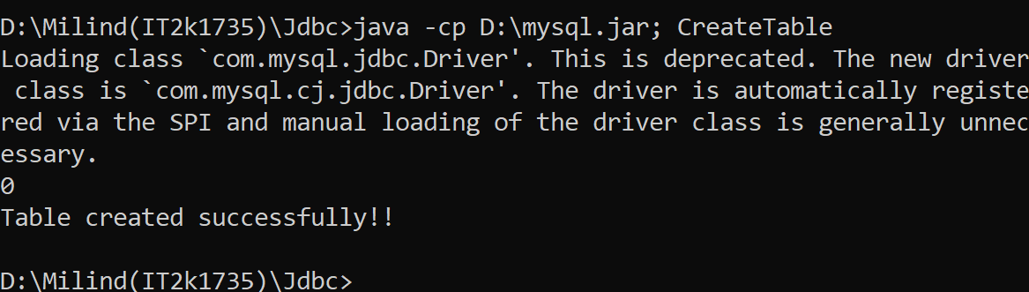

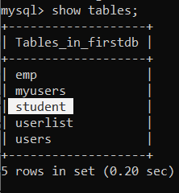

**3.Program of INSERT query in jdbc.**

**Solution:-**

import java.sql.*;

class Sinsert

{

public static final String DBURL = "jdbc:mysql://localhost:3306/firstdb";

public static final String DBUSER = "root";

public static final String DBPASS = "root";

public static void main(String args[])

{

try

{

Class.forName("com.mysql.jdbc.Driver");

Connection con = DriverManager.getConnection(DBURL, DBUSER, DBPASS);

String sql = "INSERT INTO Student(sId,sName) VALUES (?, ?)";

PreparedStatement statement = con.prepareStatement(sql);

statement.setInt(1, 3);

statement.setString(2, "mahesh");

int rowsInserted = statement.executeUpdate();

if (rowsInserted > 0)

{

System.out.println("A new employee was inserted successfully!\n");

}

}

catch(Exception e)

{

System.out.println(e);

}

}

}

**Output 3:-**

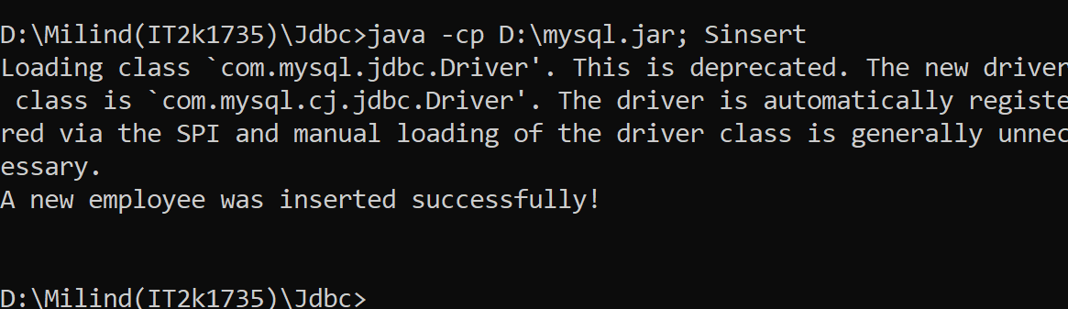

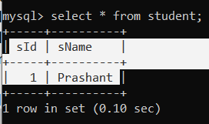

**4.Program of SELECT query.**

**Solution:-**

import java.sql.*;

class Sselect

{

public static final String DBURL = "jdbc:mysql://localhost:3306/firstdb";

public static final String DBUSER = "root";

public static final String DBPASS = "root";

public static void main(String args[])

{

try

{

Class.forName("com.mysql.jdbc.Driver");

Connection con = DriverManager.getConnection(DBURL, DBUSER, DBPASS);

String sql1 = "SELECT * FROM Student";

Statement stmt = con.createStatement();

ResultSet result = stmt.executeQuery(sql1);

while (result.next())

{

System.out.println (result.getInt(1)+" "+

result.getString(2));

}

}

catch(Exception e)

{

System.out.println(e);

}

}

}

**Output 4:-**

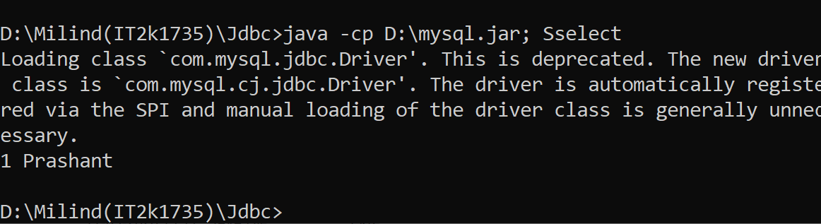

**5.Program of Update Query in jdbc.**

**Solution:-**

import java.sql.*;

class Supdate

{

public static final String DBURL = "jdbc:mysql://localhost:3306/firstdb";

public static final String DBUSER = "root";

public static final String DBPASS = "root";

public static void main(String args[])

{

try

{

Class.forName("com.mysql.jdbc.Driver");

Connection con = DriverManager.getConnection(DBURL, DBUSER, DBPASS);

String sql2 = "Update Student set sName = ? where sId = ?";

PreparedStatement pstmt = con.prepareStatement(sql2);

pstmt.setString(1, "Ramesh");

pstmt.setInt(2,1);

int rowUpdate = pstmt.executeUpdate();

if (rowUpdate > 0)

{

System.out.println("\nRecord updated successfully!!\n");

}

}

catch(Exception e)

{

System.out.println(e);

}

}

}

**Output 5:-**

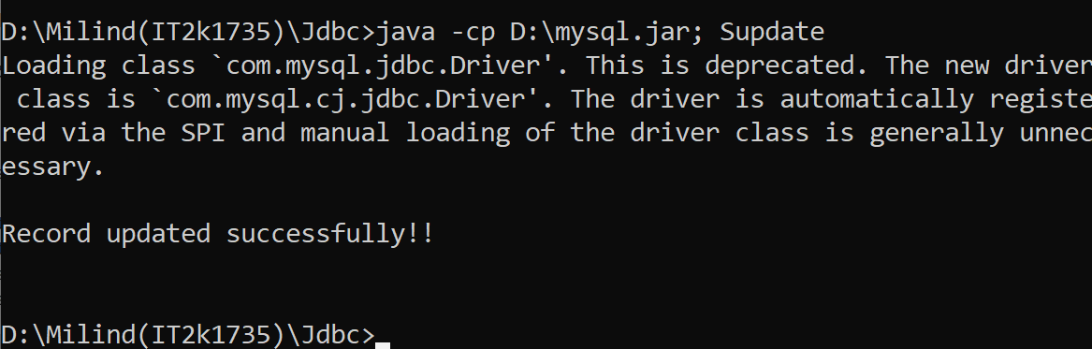

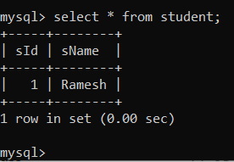

**6.Program of DELETE query in jdbc.**

**Solution:-**

import java.sql.*;

class Sdelete

{

public static final String DBURL = "jdbc:mysql://localhost:3306/firstdb";

public static final String DBUSER = "root";

public static final String DBPASS = "root";

public static void main(String args[])

{

try

{

Class.forName("com.mysql.jdbc.Driver");

Connection con = DriverManager.getConnection(DBURL, DBUSER, DBPASS);

String sql3 = "DELETE FROM Student WHERE sName=?";

PreparedStatement statement1 = con.prepareStatement(sql3);

statement1.setString(1, "Suresh");

int rowsDeleted = statement1.executeUpdate();

if (rowsDeleted > 0)

{

System.out.println("A Employee was deleted successfully!\n");

}

}

catch(Exception e)

{

System.out.println(e);

}}}

**Output 6:-**

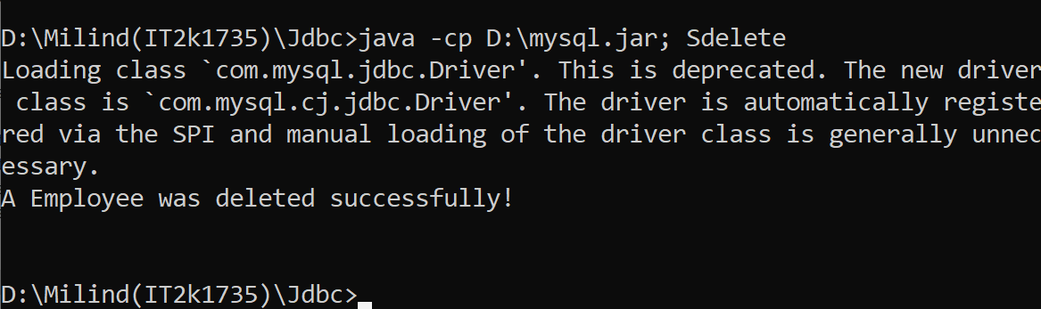

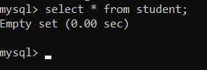

**7.Program of deleting more than one record at a time.**

**Solution:-**

import java.sql.*;

import java.util.Scanner;

class DeleteTest

{

public static final String DBURL = "jdbc:mysql://localhost:3306/firstdb";

public static final String DBUSER = "root";

public static final String DBPASS = "root";

public static void main(String[] args) throws Exception

{

Scanner sc = new Scanner(System.in);

System.out.print("Enter record number which you want to delete: ");

int stno = sc.nextInt();

Class.forName("com.mysql.jdbc.Driver");

Connection con = DriverManager.getConnection(DBURL, DBUSER, DBPASS);

String qry = "delete from Student where sId=(select max(sId) from Student where sName<=?)

PreparedStatement pst=con.prepareStatement(qry);

pst.setInt(1,stno);

int count = pst.executeUpdate();

if(count != 0)

System.out.println(count+" Record deleted successfully\n");

else

System.out.println("Record deletion failed\n");

pst.close();

con.close();

}

}

**Output 7:-**

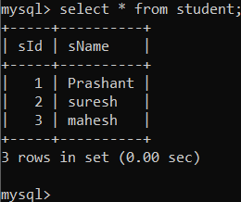

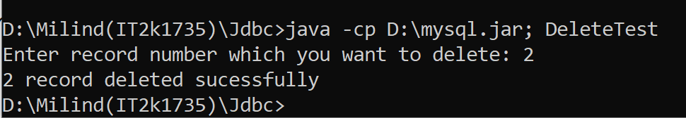



**8.Program of Auto Generated Keys.**

**Solution:-**

import java.sql.Connection;

import java.sql.DriverManager;

import java.sql.PreparedStatement;

import java.sql.ResultSet;

import java.sql.SQLException;

import java.sql.Statement;

import java.util.logging.Level;

import java.util.logging.Logger;

public class AutoGenKey {

public static void main(String[] args) {

String url = "jdbc:mysql://localhost:3306/firstdb?useSSL=false";

String user = "root";

String password = "root";

String sName = "lakhan";

int rn=19;

String sql = "INSERT INTO users(name,rollno) VALUES(?,?)";

try (Connection con = DriverManager.getConnection(url, user, password);

PreparedStatement preparedStatement = con.prepareStatement(sql,Statement.RETURN_GENERATED_KEYS))

{

preparedStatement.setString(1, sName);

preparedStatement.setInt(2,rn);

preparedStatement.executeUpdate();

try (ResultSet resultSet = preparedStatement.getGeneratedKeys()) {

if (resultSet.first()) {

System.out.printf("The ID of new student : %d", resultSet.getLong(1));

}

}

System.out.println("record inserted");

System.out.println("The ID of new student:");

} catch (SQLException ex) {

Logger lgr = Logger.getLogger(AutoGenKey.class.getName());

lgr.log(Level.SEVERE, ex.getMessage(), ex);

}

}

}

**Output 8:-**

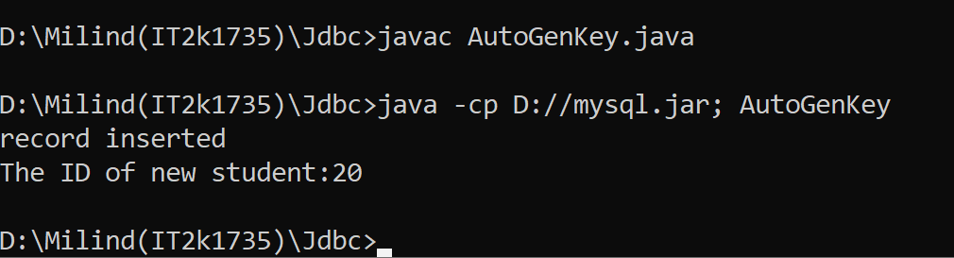

**9.Program of joining two tables in jdbc.**

**Solution:-**

import java.sql.*;

class JoinExample

{

public static final String DBURL = "jdbc:mysql://localhost:3306/firstdb";

public static final String DBUSER = "root";

public static final String DBPASS = "root";

public static void main(String args[])

{

try

{

Class.forName("com.mysql.jdbc.Driver");

Connection con = DriverManager.getConnection(DBURL, DBUSER, DBPASS);

String sql = "select rollno,id from emp inner join users ON users.name = emp.name";

Statement stmt = con.createStatement();

ResultSet result = stmt.executeQuery(sql);

System.out.println("Two table join successfully");

System.out.println("Id Rollno ");

System.out.println("**===========**==========**");

while (result.next())

{

System.out.println (

result.getInt(1)+" "+

result.getInt(2));

}

System.out.println("**===========**==========**\n");

}

catch(Exception ex)

{

ex.printStackTrace();

}}}

**Output 9:-**

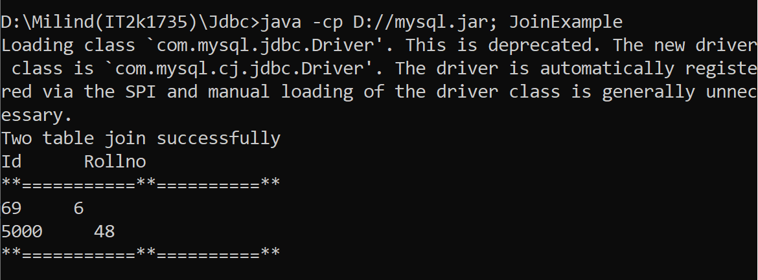

**10.Program of Query update in jdbc.**

**Solution:-**

import java.sql.Connection;

import java.sql.DriverManager;

import java.sql.SQLException;

import java.sql.Statement;

public class MyQueryUpdate {

public static void main(String[] args) {

Connection con = null;

Statement stmt = null;

try {

Class.forName("com.mysql.jdbc.Driver");

con = DriverManager.

getConnection("jdbc:mysql://localhost:3306/firstdb","root","root");

stmt = con.createStatement();

String query = "UPDATE users SET name=name WHERE rollno=1";

int count = stmt.executeUpdate(query);

System.out.println("Updated queries: count");

} catch (ClassNotFoundException e) {

e.printStackTrace();

} catch (SQLException e) {

e.printStackTrace();

} finally{

try{

if(stmt != null) stmt.close();

if(con != null) con.close();

} catch(Exception ex){}

}

}

}

**Output 10:-**

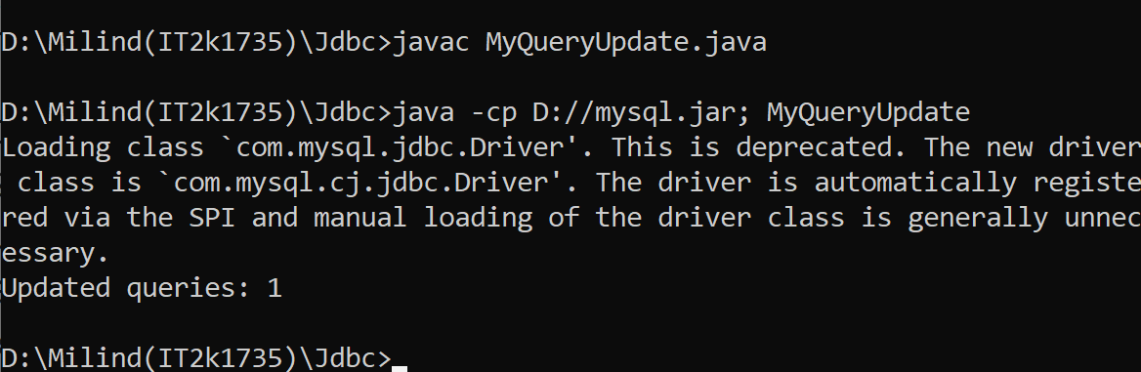

**11.Program of sinple callable Statement with stored procedue.**

**Solution:-**

import java.sql.CallableStatement;

import java.sql.Connection;

import java.sql.DriverManager;

import java.sql.SQLException;

public class MySimpleCallableStatement {

public static void main(String a[]){

Connection con = null;

CallableStatement callSt = null;

try {

Class.forName("com.mysql.jdbc.Driver");

con = DriverManager.

getConnection("jdbc:mysql://localhost:3306/firstdb","root","root");

callSt = con.prepareCall("{call hello(?,?)}");

callSt.setString(1,"drak");

callSt.setInt(2,10);

callSt.execute();

System.out.println("Executed stored procedure!!!");

} catch (ClassNotFoundException e) {

e.printStackTrace();

} catch (SQLException {

e.printStackTrace();

} finally{

try{

if(callSt != null) callSt.close();

if(con != null) con.close();

} catch(Exception ex){}

}

}

}

**Output 11:-**

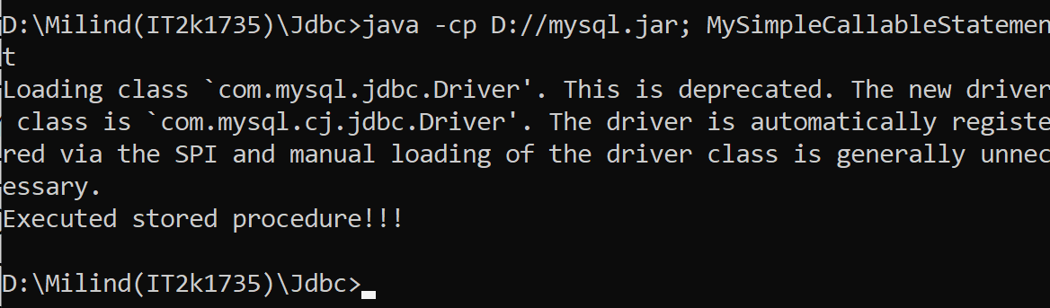

**12. Program of Simple Prepared Statement.**

**Solution:-**

import java.sql.Connection;

import java.sql.DriverManager;

import java.sql.PreparedStatement;

import java.sql.SQLException;

public class MyPreparedStatement {

public static void main(String a[]){

Connection con = null;

PreparedStatement prSt = null;

try {

Class.forName("com.mysql.jdbc.Driver");

con = DriverManager.

getConnection("jdbc:mysql://localhost:3306/firstdb","root","root");

String query = "insert into users(name,rollno) values(?,?)";

prSt = con.prepareStatement(query);

prSt.setString(1, "ebun");

prSt.setInt(2, 13);

int count = prSt.executeUpdate();

prSt.setString(1, "fagun");

prSt.setInt(2, 14);

count = prSt.executeUpdate();

System.out.println("records Successfully inserted");

} catch (ClassNotFoundException e) {

e.printStackTrace();

} catch (SQLException e) {

e.printStackTrace();

} finally{

try{

if(prSt != null) prSt.close();

if(con != null) con.close();

} catch(Exception ex){}

}

}}

**Output 12:-**

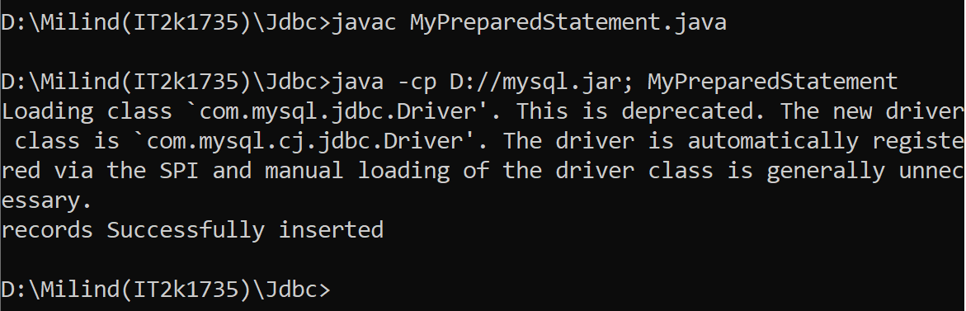

**13.Program of Batch Callable Statement with Stored Procedure.**

**Solution:-**

import java.sql.CallableStatement;

import java.sql.Connection;

import java.sql.DriverManager;

import java.sql.SQLException;

public class MyBatchCallableStatement {

public static void main(String a[]){

Connection con = null;

CallableStatement callSt = null;

try {

Class.forName("com.mysql.jdbc.Driver");

con = DriverManager.

getConnection("jdbc:mysql://localhost:3306/firstdb","root","root");

callSt = con.prepareCall("{call hello(?,?)}");

callSt.setString(1,"bajaj");

callSt.setInt(2,9);

callSt.addBatch();

callSt.setString(1,"bmw");

callSt.setInt(2,15);

callSt.addBatch();

int[] updateCounts = callSt.executeBatch();

System.out.println("all batch added!!!");

} catch (ClassNotFoundException e) {

e.printStackTrace();

} catch (SQLException e) {

e.printStackTrace();

} finally{

try{

if(callSt != null) callSt.close();

if(con != null) con.close();

} catch(Exception ex){}

}

}}

**Output 13:-**

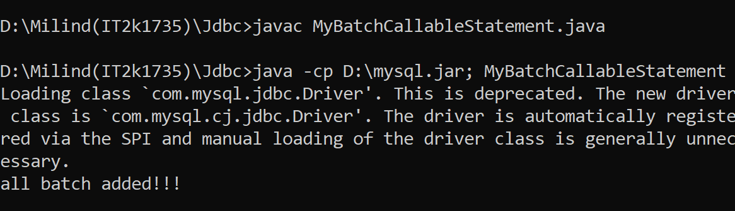

**14.Program of Batch Prepared Statement with Stored Procedure.**

**Solution:-**

import java.sql.Connection;

import java.sql.DriverManager;

import java.sql.PreparedStatement;

import java.sql.SQLException;

public class MyBatchPreparedStmt {

public static void main(String a[]){

Connection con = null;

PreparedStatement pst = null;

try {

Class.forName("com.mysql.jdbc.Driver");

con = DriverManager.

getConnection("jdbc:mysql://localhost:3306/firstdb","root","root");

con.setAutoCommit(false);

pst = con.prepareStatement("update users set rollno=? where name=?");

pst.setInt(1,68);

pst.setString(2,"mohan");

pst.addBatch();

pst.setInt(1, 100);

pst.setString(2,"police");

pst.addBatch();

int count[] = pst.executeBatch();

for(int i=1;i<=count.length;i++){

System.out.println("Query "+i+" has effected "+count[i]+" times");

}

con.commit();

} catch (ClassNotFoundException e) {

try {

con.rollback();

} catch (SQLException e1) {

e1.printStackTrace();

}

e.printStackTrace();

} catch (SQLException e) {

try {

con.rollback();

} catch (SQLException e1) {

e1.printStackTrace();

}

e.printStackTrace();

} finally{

try{

if(pst != null) pst.close();

if(con != null) con.close();

} catch(Exception ex){}

}}}

**Output 15:-**

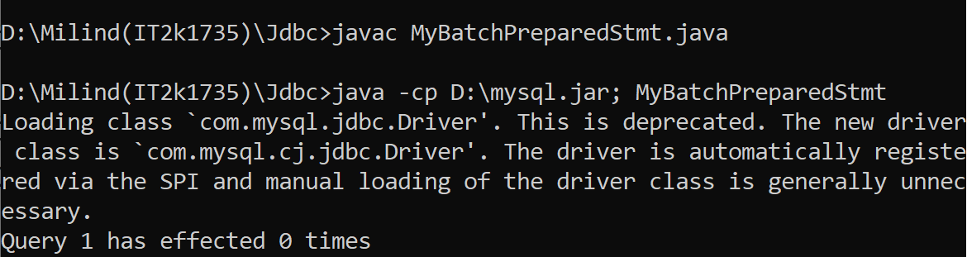

**16.Program of Statement Batch Update.**

**Solution:-**

import java.sql.Connection;

import java.sql.DriverManager;

import java.sql.SQLException;

import java.sql.Statement;

public class MyStatementBatchUpdate {

public static void main(String a[]){

Connection con = null;

Statement st = null;

try {

Class.forName("com.mysql.jdbc.Driver");

con = DriverManager.

getConnection("jdbc:mysql://localhost:3306/firstdb","root","root");

con.setAutoCommit(false);

st = con.createStatement();

st.addBatch("update users set rollno=5 where name='kalu'");

st.addBatch("insert into users values ('thor',12)");

st.addBatch("update users set name='Ram' where rollno=5");

int count[] = st.executeBatch();

for(int i=1;i<=count.length;i++){

System.out.println("Query "+i+" has effected "+count[i]+" times");}

con.commit();

} catch (ClassNotFoundException e) {

try {

con.rollback();

} catch (SQLException e1) {

e1.printStackTrace();

}

e.printStackTrace();

} catch (SQLException e) {

try {

con.rollback();

} catch (SQLException e1) {

e1.printStackTrace();

}

e.printStackTrace();

} finally{

try{

if(st != null) st.close();

if(con != null) con.close();

} catch(Exception ex){}

}}}

**Output 16:-**

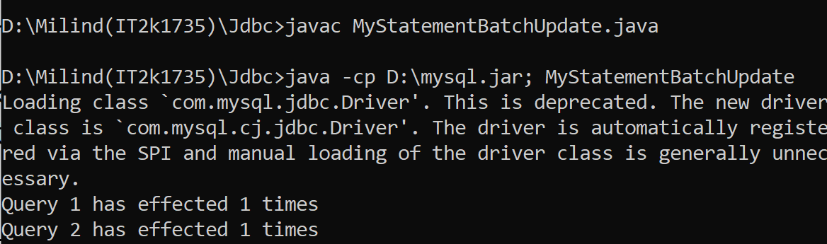

**17.Program of Prepared Statement Result Set.**

**Solution:-**

import java.sql.Connection;

import java.sql.DriverManager;

import java.sql.PreparedStatement;

import java.sql.ResultSet;

import java.sql.SQLException;

public class MyPrepStmtResltSet {

public static void main(String a[]){

Connection con = null;

PreparedStatement prSt = null;

ResultSet rs = null;

try {

Class.forName("com.mysql.jdbc.Driver");

con = DriverManager.

getConnection("jdbc:mysql://localhost:3306/firstdb","root","root");

String query = "select * from users where rollno=?";

prSt = con.prepareStatement(query);

prSt.setInt(1,69);

rs = prSt.executeQuery();

while(rs.next()){

System.out.println(rs.getString("name")+" -- "+rs.getInt("rollno"));

}

rs.close();

prSt.setInt(1,5000);

rs = prSt.executeQuery();

while(rs.next()){

System.out.println(rs.getString("name")+" -- "+rs.getInt("rollno"));

}

} catch (ClassNotFoundException e) {

e.printStackTrace();

} catch (SQLException e) {

e.printStackTrace();

} finally{

try{

if(rs != null) rs.close();

if(prSt != null) prSt.close();

if(con != null) con.close();

} catch(Exception ex){}

}

}

}

**Output 17:-**

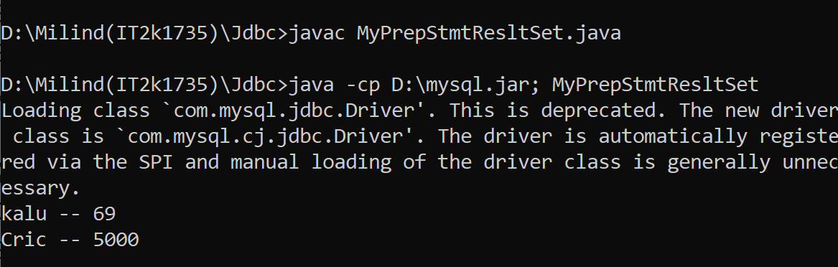

**18.Program of Read Database Structure in jdbc.**

**Solution:-**

import java.sql.*;

public class ReadDatabaseStructureExample {

public static void main(String[] args) {

String url = "jdbc:mysql://localhost:3306/firstdb";

String username = "root";

String password = "root";

try (Connection conn = DriverManager.getConnection(url, username, password)) {

DatabaseMetaData meta = conn.getMetaData();

String catalog = null, schemaPattern = null, tableNamePattern = null;

String[] types = {"TABLE"};

ResultSet rsTables = meta.getTables(catalog, schemaPattern, tableNamePattern, types);

while (rsTables.next()) {

String tableName = rsTables.getString(3);

System.out.println("\n=== TABLE: " + tableName);

String columnNamePattern = null;

ResultSet rsColumns = meta.getColumns(catalog, schemaPattern, tableName, columnNamePattern);

ResultSet rsPK = meta.getPrimaryKeys(catalog, schemaPattern, tableName);

while (rsColumns.next()) {

String columnName = rsColumns.getString("COLUMN_NAME");

String columnType = rsColumns.getString("TYPE_NAME");

int columnSize = rsColumns.getInt("COLUMN_SIZE");

System.out.println("\t" + columnName + " - " + columnType + "(" + columnSize + ")"); }

while (rsPK.next()) {

String primaryKeyColumn = rsPK.getString("COLUMN_NAME");

System.out.println("\tPrimary Key Column: " + primaryKeyColumn);

}

}

} catch (SQLException ex) {

System.out.println(ex.getMessage());

ex.printStackTrace();

}}}

**Output 18:-**

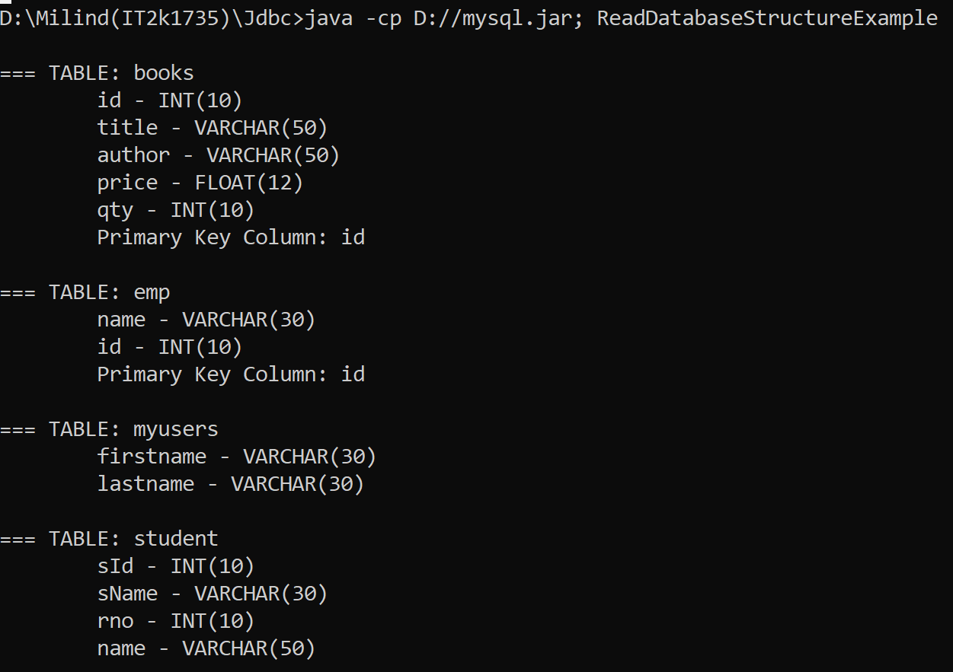

**19.Program of Simple Transction Management in jdbc.**

**Solution:-**

import java.sql.*;

class Mytranction{

public static void main(String args[])throws Exception{

Class.forName("com.mysql.jdbc.Driver");

Connection con=DriverManager.getConnection("jdbc:mysql://localhost:3306/firstdb","root","root");

con.setAutoCommit(false);

Statement stmt=con.createStatement();

stmt.executeUpdate("insert into users values('hari',16)");

stmt.executeUpdate("insert into users values('irish',17)");

con.commit();

System.out.print("record sucessfully inserted");

con.close();

}

}

**Output 19:-**

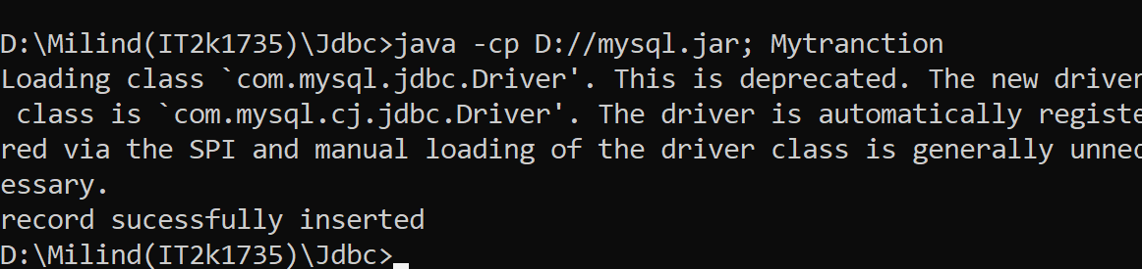

**20.Program of Transction Management.**

**Solution:-**

import java.sql.*;

import java.io.*;

class TM{

public static void main(String args[]){

try{

Class.forName("com.mysql.jdbc.Driver");

Connection con=DriverManager.getConnection("jdbc:mysql://localhost:3306/firstdb","root","root");

con.setAutoCommit(false);

PreparedStatement ps=con.prepareStatement("insert into users values(?,?)");

BufferedReader br=new BufferedReader(new InputStreamReader(System.in));

while(true){

System.out.println("enter name");

String name=br.readLine();

System.out.println("enter rollno");

String s1=br.readLine();

int rollno=Integer.parseInt(s1);

ps.setString(1,name);

ps.setInt(2,rollno);

ps.executeUpdate();

System.out.println("commit/rollback");

String answer=br.readLine();

if(answer.equals("commit")){

con.commit();

}

if(answer.equals("rollback")){

con.rollback();

}

System.out.println("Want to add more records y/n");

String ans=br.readLine();

if(ans.equals("n")){

break;

}

}

con.commit();

System.out.println("record successfully saved");

con.close();

}catch(Exception e){System.out.println(e);}

}}

**Output 20:-**

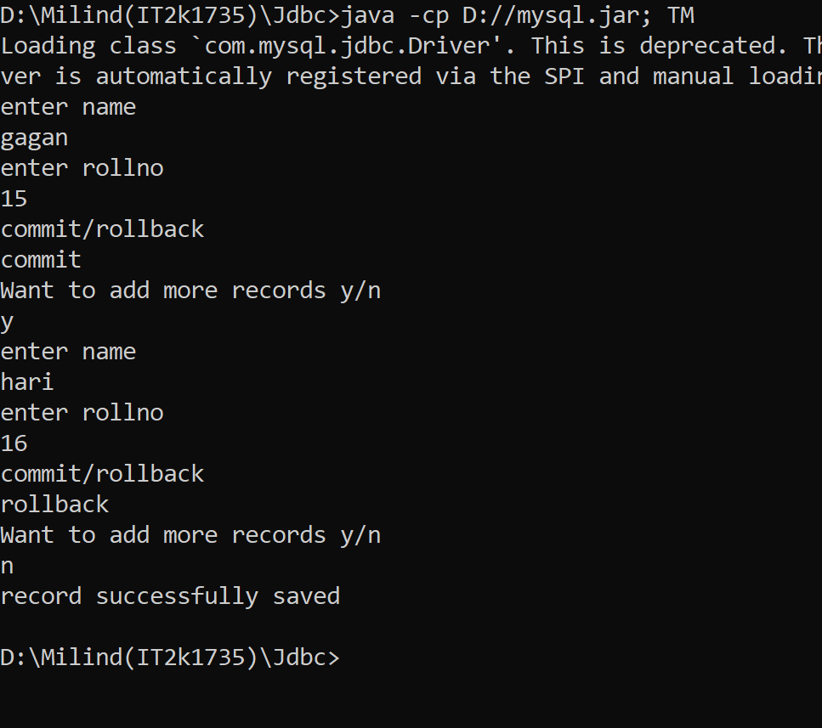

**END**

**Adv. Java Lab Assignment**

**JSP 20 Programs**

**Name:-Milind Bajaj**

**M.Tech(5th Sem)**

**Rollno.:-IT-2k17-35**

**1.Program of Getting Current Date and Time In JSP.**

**Solution:-**

**Index.jsp:-**

<html>

<head><title>JSPApp</title></head>

<body>

<form>

<fieldset style="width:20%; background-color: #ccffeb;">

<legend><b><i>JSP Application<i><b></legend>

<h3>Current Date and Time is :</h3>

<% java.util.Date d = new java.util.Date();

out.println(d.toString()); %>

</fieldset></form>

</body>

</html>

**Output 1:-**

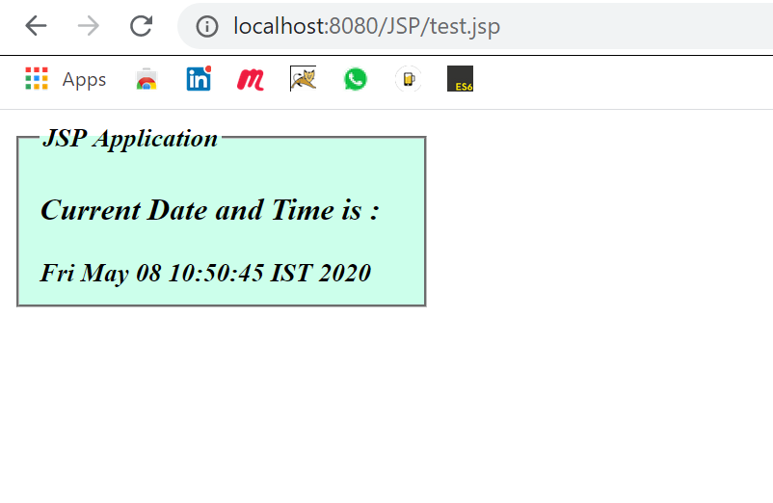

**2.Program of file Uploading in JSP.**

**Solution:-**

**Index.html:-**

<html>

<head>

<title>File Uploading Form</title>

</head>

<body>

<form action="upload.jsp" method="post" enctype="multipart/form-data">

<fieldset style="width:20%; background-color: #e6ff99">

<h2>File Upload Example</h2>

<hr>

Select a file to upload: <br /><br />

<input type="file" name="file" size="50" />

<br /><br />

<input type="submit" value="Upload File" />

</fieldset>

</form>

</body>

</html>

**Upload.jsp:-**

<%@ page import="java.io.*,java.util.*, javax.servlet.*" %>

<%@ page import="javax.servlet.http.*" %>

<%@ page import="org.apache.commons.fileupload.*" %>

<%@ page import="org.apache.commons.fileupload.disk.*" %>

<%@ page import="org.apache.commons.fileupload.servlet.*" %>

<%@ page import="org.apache.commons.io.output.*" %>

<%File file ;

int maxFileSize = 5000 * 1024;

int maxMemSize = 5000 * 1024;

ServletContext context = pageContext.getServletContext();

String filePath = context.getInitParameter("file-upload");

String contentType = request.getContentType();

if ((contentType.indexOf("multipart/form-data") >= 0))

{

DiskFileItemFactory factory = new DiskFileItemFactory();

factory.setSizeThreshold(maxMemSize);

factory.setRepository(new File("D:\\temp"));

ServletFileUpload upload = new ServletFileUpload(factory);

upload.setSizeMax( maxFileSize );

try

{

List fileItems = upload.parseRequest(request);

Iterator i = fileItems.iterator();

out.println("<html>");

out.println("<head>");

out.println("<title>JSP File upload</title>");

out.println("</head>");

out.println("<body>");

while ( i.hasNext () )

{

FileItem fi = (FileItem)i.next();

if ( !fi.isFormField () )

{

String fieldName = fi.getFieldName();

String fileName = fi.getName();

boolean isInMemory = fi.isInMemory();

long sizeInBytes = fi.getSize();

if( fileName.lastIndexOf("\\") >= 0 )

{

file = new File( filePath +

fileName.substring( fileName.lastIndexOf("\\"))) ;

}

else

{

file = new File( filePath +

fileName.substring(fileName.lastIndexOf("\\")+1)) ;

}

fi.write( file ) ;

out.println("Uploaded Filename: " + filePath +

fileName + "<br>");

}

}

out.println("</body>");

out.println("</html>");

}

catch(Exception ex)

{

System.out.println(ex);

}

}

else

{

out.println("<html>");

out.println("<head>");

out.println("<title>Servlet upload</title>");

out.println("</head>");

out.println("<body>");

out.println("<p>No file uploaded</p>");

out.println("</body>");

out.println("</html>");

}

%>

**Output 2:-**

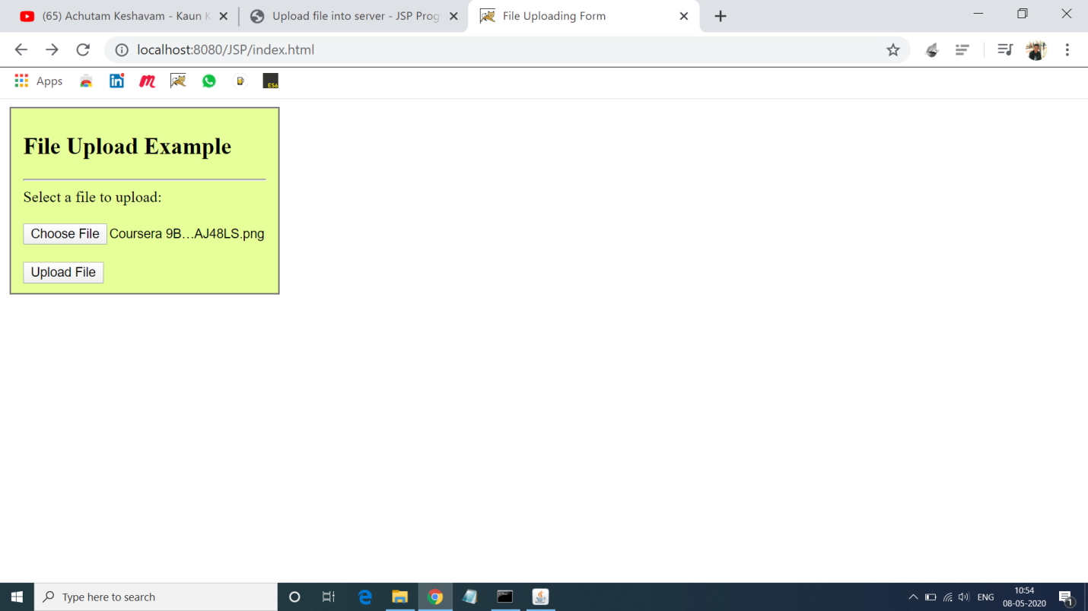

**3.Program of Auto Refreshing Page in JSP.**

**Solution:-**

**Autorefesh.jsp:-**

<%@ page import="java.io.*,java.util.*" %>

<html>

<head>

<title>Auto Refresh</title>

</head>

<body>

<center>

<form>

<fieldset style="width:20%; background-color:#e6ffe6;">

<legend>Auto refresh</legend>

<h2>Auto Refresh Example</h2>

<%

response.setIntHeader("Refresh", 1);

Calendar calendar = new GregorianCalendar();

String am_pm;

int hour = calendar.get(Calendar.HOUR);

int minute = calendar.get(Calendar.MINUTE);

int second = calendar.get(Calendar.SECOND);

if(calendar.get(Calendar.AM_PM) == 0)

am_pm = "AM";

else

am_pm = "PM";

String CT = hour+":"+ minute +":"+ second +" "+ am_pm;

out.println("Crrent Time: " + CT + "\n");

%>

</fieldset>

</form>

</center>

</body>

</html>

**Output 3:-**

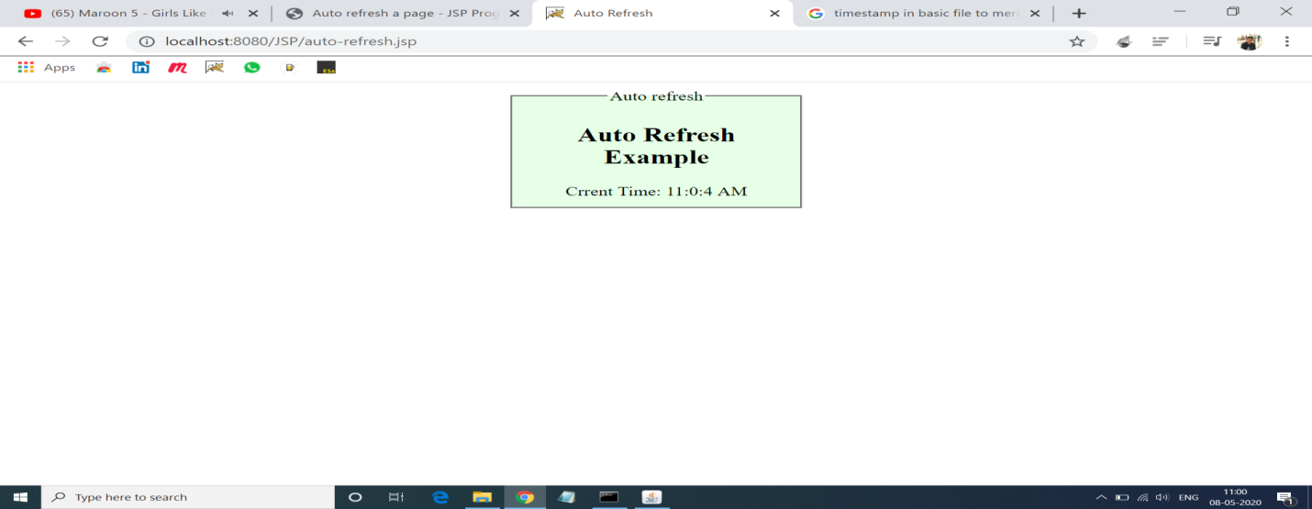

**4.Program to Count no. of visitor in website.**

**Solution:-**

**Count.jsp:-**

<%@ page import="java.io.*,java.util.*" %>

<html>

<head>

<title>Count visitor</title>

</head>

<body>

<form>

<fieldset style="width:20%; background-color:#e6ffe6;">

<legend>Count visitor</legend>

<%

Integer hitsCount =

(Integer)application.getAttribute("hitCounter");

if( hitsCount ==null || hitsCount == 0 )

{

out.println("Welcome to my website!!");

hitsCount = 1;

}

else

{

out.println("Welcome to my website!!");

hitsCount += 1;

}

application.setAttribute("hitCounter", hitsCount);

%>

<p>You are visitor number: <%= hitsCount%></p>

</fieldset>

</form>

</body>

</html>

**Output 4:-**

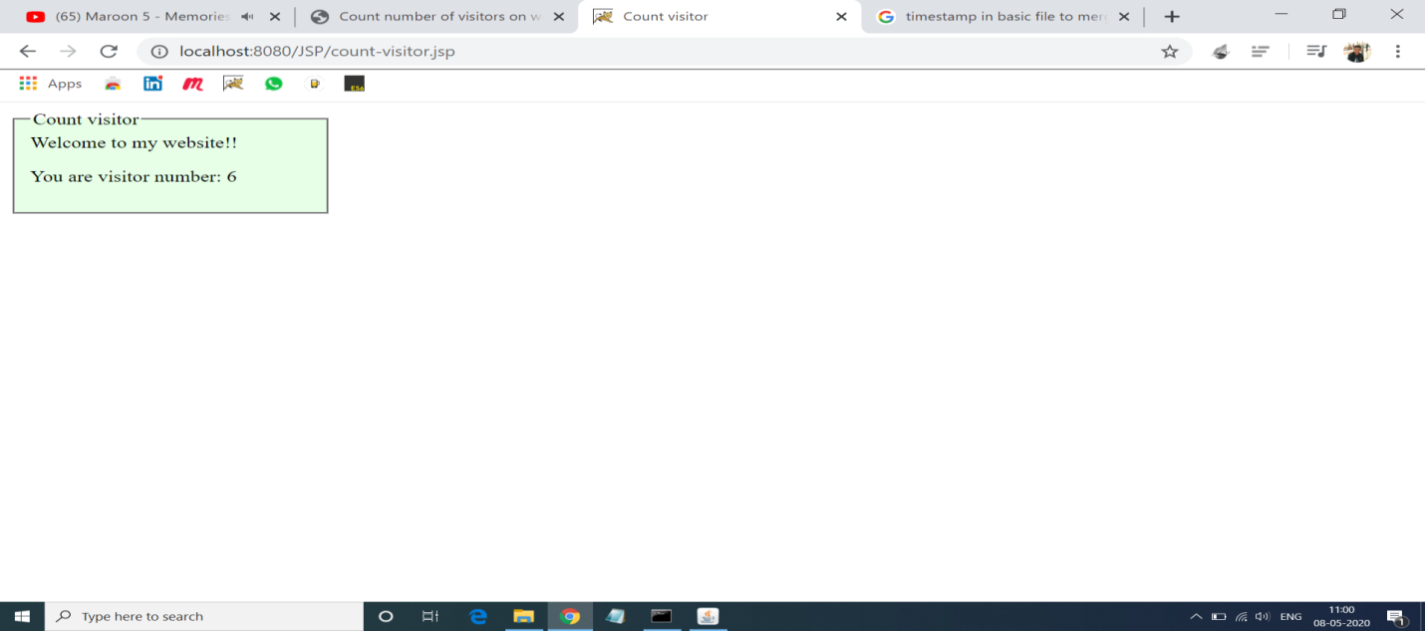

**5.Program of Session Tracking in JSP.**

**Solution:-**

**Session.jsp:-**

<%@ page import="java.io.*,java.util.*" %>

<%.

Date createTime = new Date(session.getCreationTime());

Date lastAccessTime = new Date(session.getLastAccessedTime());

String title = "Welcome Back to my website";

Integer visitCount = new Integer(0);

String visitCountKey = new String("visitCount");

String userIDKey = new String("userID");

String userID = new String("Surendra");

if (session.isNew())

{

title = "Welcome to my website";

session.setAttribute(userIDKey, userID);

session.setAttribute(visitCountKey, visitCount);

}

%>

<html>

<head>

<title>Session Tracking</title>

</head>

<body>

<center>

<h1>Session Tracking Example</h1>

</center>

<table border="1" align="center">

<tr bgcolor="#ffcccc">

<th>Session info</th>

<th>Value</th>

</tr>

<tr >

<td>id</td>

<td><% out.print( session.getId()); %></td>

</tr>

<tr>

<td>Creation Time</td>

<td><% out.print(createTime); %></td>

</tr>

<tr>

<td>Time of Last Access</td>

<td><% out.print(lastAccessTime); %></td>

</tr>

<tr>

<td>User ID</td>

<td><% out.print(userID); %></td>

</tr>

<tr>

<td>Number of visits</td>

<td><% out.print(visitCount); %></td>

</tr>

</table>

</body>

</html>

**Output 5:-**

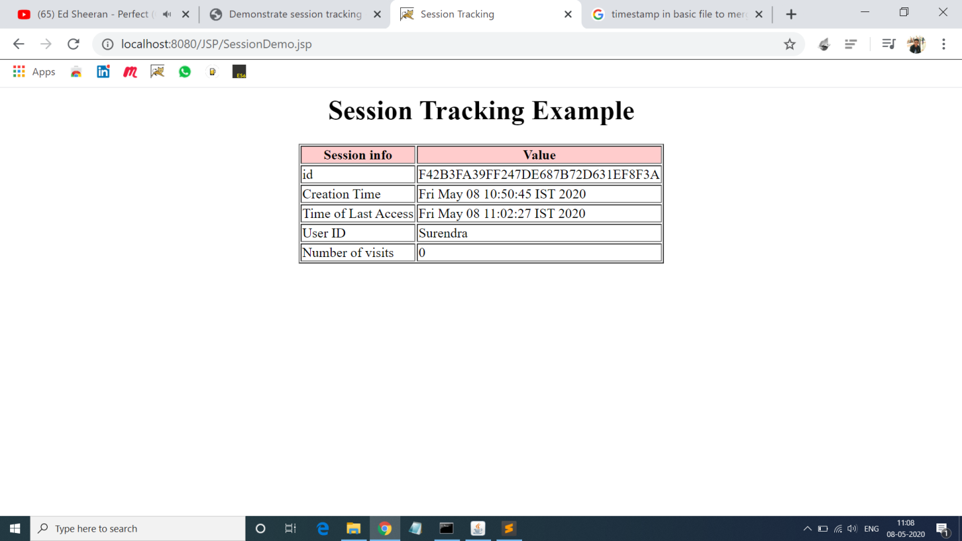

**6.Program of error Handling in JSP.**

**Solution:-**

**Index.html:-**

<html>

<head>

<title>Exception Example</title>

</head>

<body>

<form action="process.jsp">

<fieldset style="width:20%; background-color:#e6ffe6;">

<center>

<h3>Exception Example</h3>

Enter number: <input type="text" name="n1" /><br/><br/>

Enter number: <input type="text" name="n2" /><br/><br/>

<input type="submit" value="Divide"/>

</center>

</fieldset>

</form>

</body>

</html>

**Process.jsp:-**

<%@ page errorPage="error.jsp" %>

<%

String num1=request.getParameter("n1");

String num2=request.getParameter("n2");

int a=Integer.parseInt(num1);

int b=Integer.parseInt(num2);

int c=a/b;

out.print("Division of numbers is: "+c);

%>

**Error.jsp:-**

<%@ page isErrorPage="true" %>

<h3>Sorry an exception occured!</h3>

Exception is: <%= exception %>

**Output 6:-**

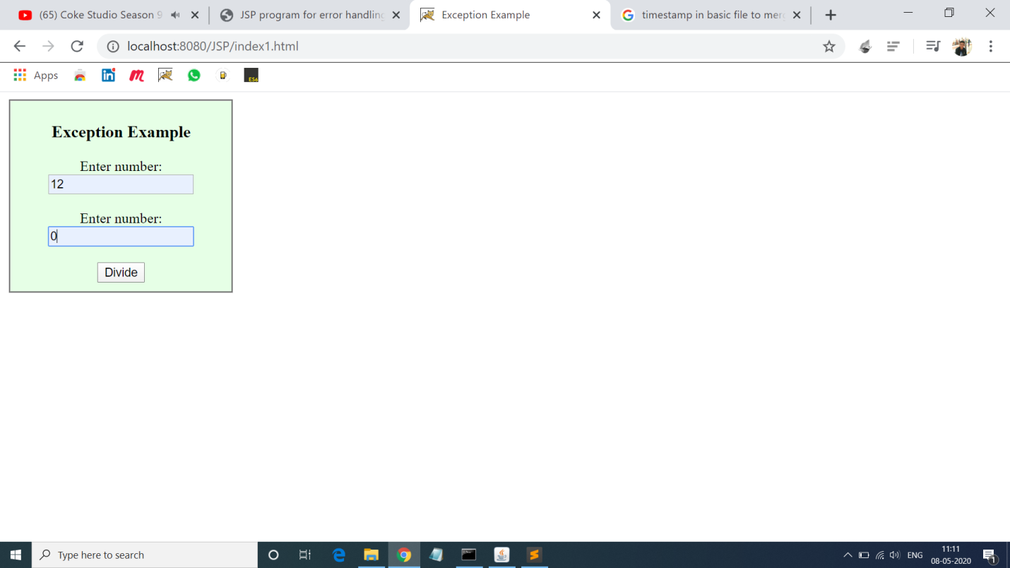

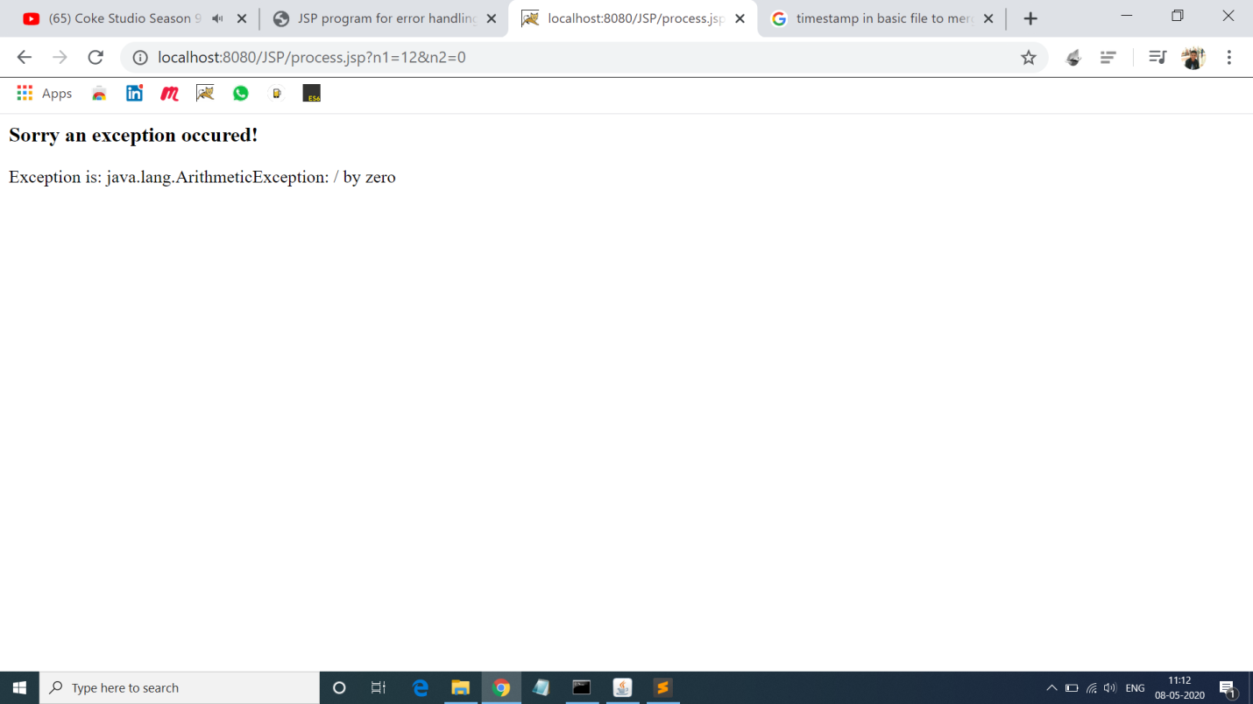

**7.Program to Demonstrate expression Tag.**

**Solution:-**

**Index.html:-**

<html>

<title>Sample Example </title>

<body>

<form method="post" action="index.jsp">

<fieldset style="width:30%; background-color:#b3d1ff">

<h2><center> Mathematical Operation</center></h2>

<hr>

<font size=5 face="Times New Roman">

<input type="radio" name="a1" value="add" checked>Addition</input><br>

<input type="radio" name="a1" value="sub">Subtraction</input><br>

<input type="radio" name="a1" value="mul" >Multiplication</input><br>

<input type="radio" name="a1" value="div" >Division</input><br>

</font>

<table>

<tr>

<td>Enter first Value:</td>

<td> <input type="text" name="t1" value=""></td>

</tr>

<tr>

<td>Enter second Value: </td>

<td><input type="text" name="t2" value=""></td>

</tr><br>

<tr>

<td></td>

<td><input type="submit" name="result" value="Check result!"></td>

</tr>

</table>

</fieldset>

</form>

</body>

</html>

**Input.jsp:-**

<%@ page errorPage="error1.jsp" %>

<html>

<body>

<H1><center>Result for <%=request.getParameter("a1")%></center></H1>

<%

String num1=request.getParameter("t1");

String num2=request.getParameter("t2");

int i=Integer.parseInt(num1);

int j=Integer.parseInt(num2);

int k=0;

String str=request.getParameter("a1");

if(str.equals("add"))

k=i+j;

if(str.equals("sub"))

k=i-j;

if(str.equals("mul"))

k=i*j;

if(str.equals("div"))

k=i/j;

%>

Result is: <%=k%>

</body>

</html>

**Error.jsp:-**

<%@ page isErrorPage="true" %>

<h3>Sorry an exception occured!</h3>

Exception is: <%= exception %>

**Output 7:-**

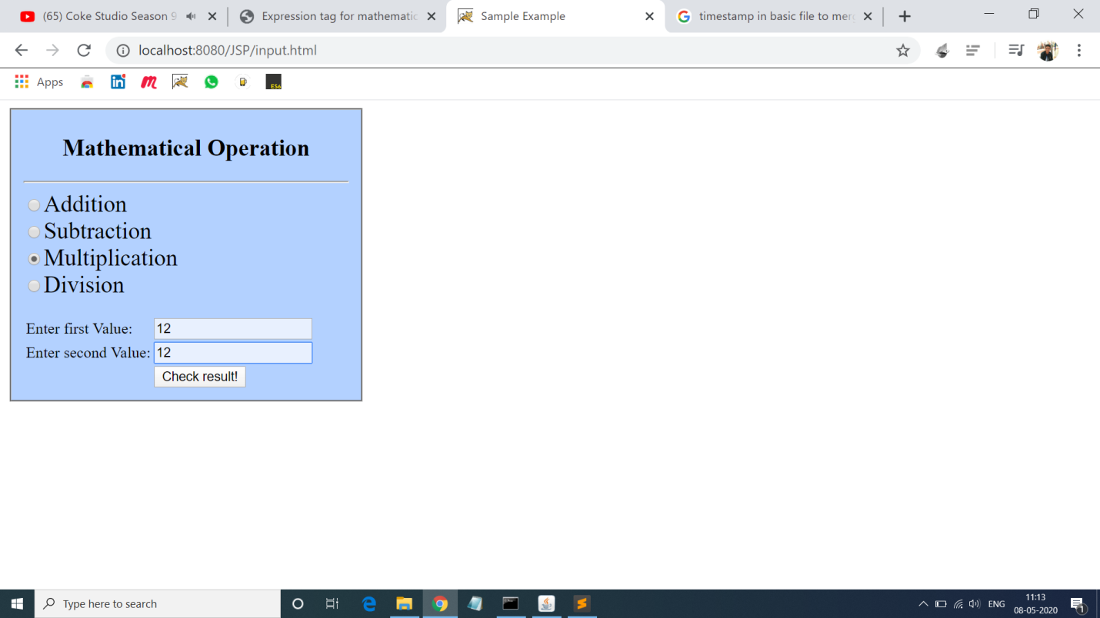

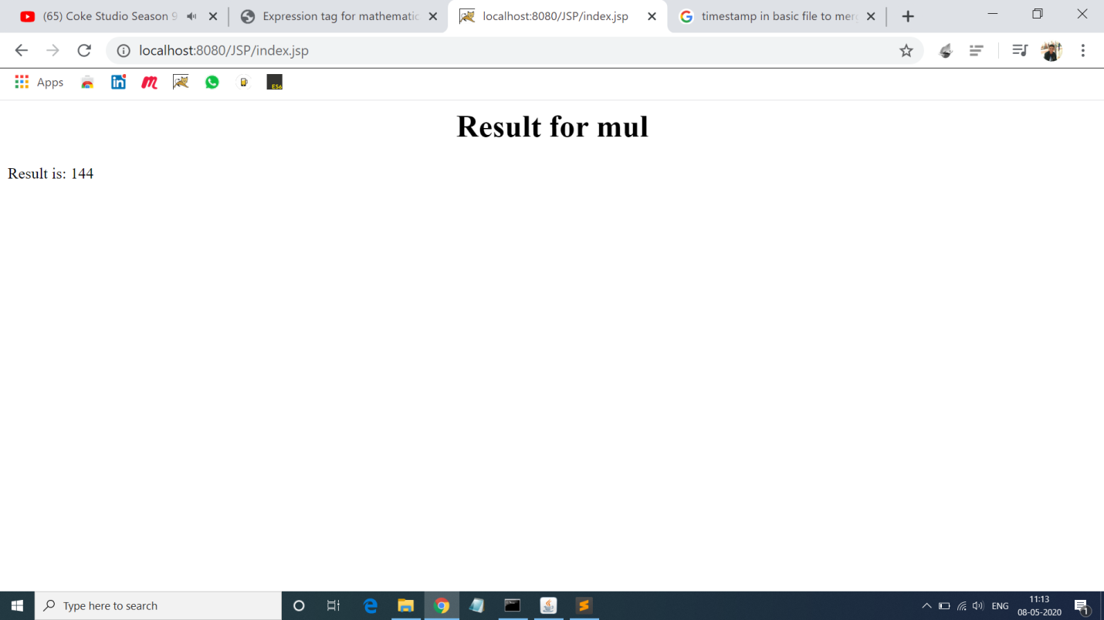

# 8.Program for Detect locale, language settings & local specific time.

# Solution:-

# <%@ page import="java.io.*,java.util.Locale" %>

# <%@ page import="javax.servlet.*,javax.servlet.http.* "%>

# <%@ page import="java.text.NumberFormat,java.util.Date" %>

# <%@ page import="java.text.DateFormat,java.util.Date" %>

# <%

# Locale locale = request.getLocale();

# String language = locale.getLanguage();

# String country = locale.getCountry();

# String title = "Locale Specific Dates";

# String date = DateFormat.getDateTimeInstance(DateFormat.FULL, DateFormat.SHORT, locale).format(new Date( ));

# NumberFormat nft = NumberFormat.getCurrencyInstance(locale);

# String formattedCurr = nft.format(500);

# %>

# <html>

# <head>

# <title>Detecting Locale</title>

# </head>

# <body>

# <form>

# <fieldset style="width:20%; background-color:#e6ffe6;">

# <center>

# <h1>Detecting Locale</h1>

# </center>

# <p align="center">

# <%

# out.println("Language : " + language + "<br />");

# out.println("Country : " + country + "<br />");

# %>

# </p>

# <div align="center">

# <h1><% out.print(title); %></h1>

# <p>Local Date: <% out.print(date); %></p>

# <p>Formatted Currency: <% out.print(formattedCurr); %></p>

# </div>

# </fieldset>

# </form>

# </body>

# </html>

# Output 8:-

# demo8.png

# 9.Program for demonstrate JSP implicit Object.

# Solution:-

# Index.jsp:-

# <%@ page language="java"%>

# <%@ page import="java.util.Date" %>

# <!DOCTYPE html>

# <head>

# <title>Index JSP Page</title>

# </head>

# <body>

# <table border="1"; style="background-color:#ffffcc; width:30%" >

# <caption><h3>JSP Implicit object</h3></caption>

# <tr><td><b>Current Time</b></td>

# <td><% out.print(new Date()); %></td></tr>

# <%response.addCookie(new Cookie("Test","Value")); %>

# <tr><td><b>User context param value</b></td>

# <td><%=application.getInitParameter("User") %></td></tr>

# <tr><td><b>User Session ID</b></td>

# <td><%=session.getId() %></td></tr>

# <% pageContext.setAttribute("Test", "Test Value"); %>

# <tr><td><b>PageContext attribute</b></td>

# <td>{Name="Test",Value="<%=pageContext.getAttribute("Test") %>"}</td></tr>

# <tr><td><b>Generated Servlet Name</b>:</td>

# <td><%=page.getClass().getName() %></td></tr>

# 

# <tr><td><b>Request User-Agent</b></td>

# <td> <%=request.getHeader("User-Agent") %></td></tr>

# </table>

# </body>

# </html>

# Output 9:-

# index(1)12.png

# 10.Program for validate username and Password.

# Solution:-

# Login.html:-

# <!doctype html>

# <html lang="en">

# <head>

# <title>Welcome </title>

# </head>

# <body>

# <form method = "post" action = "db1.jsp">

# <fieldset style="width:23%; background-color:#b3d1ff">

# <h3><center> Login Page</center></h3>

# <hr>

# <table>

# <tr>

# <td>Username:</td>

# <td> <input type = "text" name = "uname"></td>

# </tr>

# <tr>

# <td>Password:</td>

# <td><input type = "password" name = "pwd"></td>

# </tr>

# <tr>

# <td></td>

# <td><input type = "submit" value="check detail" name = "s1"></td>

# </tr>

# </table>

# </fieldset>

# </form>

# <a href="db1.jsp? s1=link">Get all user detail</a>

# </body>

# </html>

# Db.jsp:-

# <%@ page import="java.sql.*"%>

# <%@ page import="java.util.*"%>

# <%!

# Connection con;

# PreparedStatement ps1, ps2;

# public void jspInit()

# {

# try

# { Class.forName("com.mysql.jdbc.Driver");

# con = DriverManager.getConnection("jdbc:mysql://localhost:3306/firstdb","milind","root");

# ps1 = con.prepareStatement("select count(*) from userlist where username = ? and password=?");

# ps2 = con.prepareStatement("select * from userlist");

# }

# catch(Exception ex)

# {

# ex.printStackTrace();

# }

# }

# %>

# <%

# String param = request.getParameter("s1");

# if(param =="link")

# {

# ResultSet rs = ps2.executeQuery();

# out.println("<table>");

# while(rs.next())

# {

# out.println("<tr>");

# out.println("<td>"+rs.getString(1)+"</td>");

# out.println("<td>"+rs.getString(2)+"</td");

# out.println("</tr>");

# }

# out.println("</table>");

# rs.close();

# }

# else

# { String user = request.getParameter("uname");

# String pass = request.getParameter("pwd");

# ps1.setString(1,user);

# ps1.setString(2,pass);

# ResultSet rs = ps1.executeQuery();

# int cnt = 0;

# if (rs.next())

# cnt = rs.getInt(1);

# if(cnt == 0)

# out.println("<b><i><font color=red>Invalid credential</fonr></i></b>");

# else

# {

# out.println("<form><fieldset style= width:25%; >");

# out.println("<b><i><font color=red>valid credential..</fonr></i></b><br>");

# out.println("<b><i><font size=6 color=blue>Welcome to My Page</fonr></i></b>");

# out.println("</fieldset></form>");

# }

# }

# %>

# <%!

# public void jspDestroy()

# {

# try

# {

# ps1.close();

# ps2.close();

# con.close();

# }

# catch(Exception ex)

# {

# ex.printStackTrace();

# }

# }

# %>

# Output 10:-

# login13.png

# login13,1.png

# 11.Program for Select record from database.

# Solution:-

# Index.jsp:-

# <%@ page import="java.sql.*"%>

# <%@ page import="java.util.*"%>

# <html>

# <head>

# <title>SELECT Operation</title>

# </head>

# <body>

# <%!

# Connection con;

# PreparedStatement ps;

# public void jspInit()

# {

# try

# {

# Class.forName("com.mysql.jdbc.Driver");

# con = DriverManager.getConnection("jdbc:mysql://localhost/firstdb","milind","root");

# ps = con.prepareStatement("select * from users");

# }

# catch(Exception ex)

# {

# ex.printStackTrace();

# }

# }

# %>

# <%

# ResultSet rs = ps.executeQuery();

# out.println("<table border=1 >");

# out.println("<tr style='background-color:#ffffb3; color:red'>");

# out.println("<th>Name</th>");

# out.println("<th> Roll no</th>");

# while(rs.next())

# {

# out.println("<tr style='background-color:#b3ffd9;'>");

# out.println("<td>"+rs.getString(1)+"</td>");

# out.println("<td>"+rs.getInt(2)+"</td>");

# out.println("</tr>");

# }

# out.println("</table>");

# rs.close();

# %>

# </body>

# </html>

# Output 11:-

# db11.png

**12.Program for Display the given Number in words.**

**Solution:-**

**Index.html:-**

<!DOCTYPE html>

<html>

<body>

<form method=get action="test1.jsp">

Enter Any Number : <input type=text name=num><br><br>

<input type=submit value="Display">

</form>

</body>

</html>

**Word.jsp:-**

<%@page contentType="text/html" pageEncoding="UTF-8"%>

<!DOCTYPE html>

<html>

<body>

<font color=red>

<%! int i,n;

String s1;

%>

<% s1= request.getParameter("num");

n=s1.length();

i=0;

do

{

char ch=s1.charAt(i);

switch(ch)

{

case '0': out.println("Zero ");

break;

case '1': out.println("One ");

break;

case '2': out.println("Two ");

break;

case '3': out.println("Three ");

break;

case '4': out.println("Four ");

break;

case '5': out.println("Five ");

break;

case '6': out.println("Six ");

break;

case '7': out.println("Seven ");

break;

case '8': out.println("Eight ");

break;

case '9': out.println("Nine ");

break;

}

i++;

}

while(i<n);

%>

</font>

</body>

</html>

**Output 12:-**

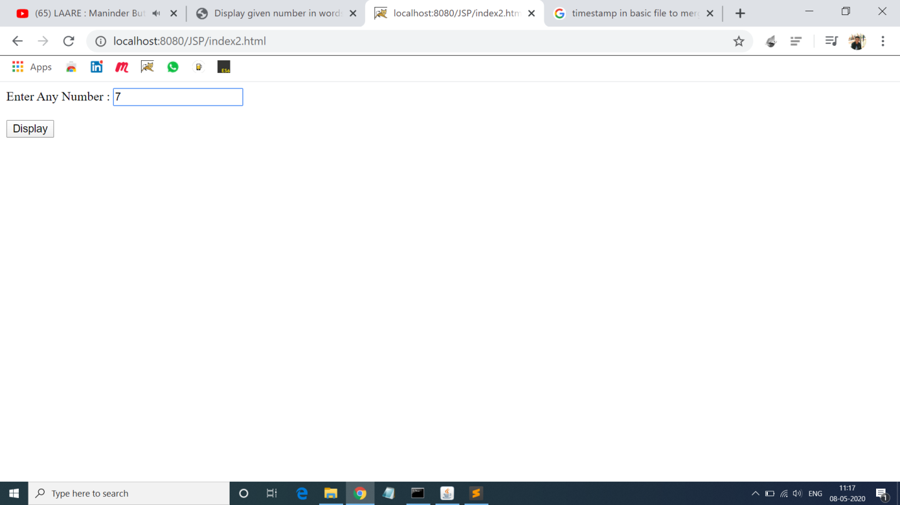

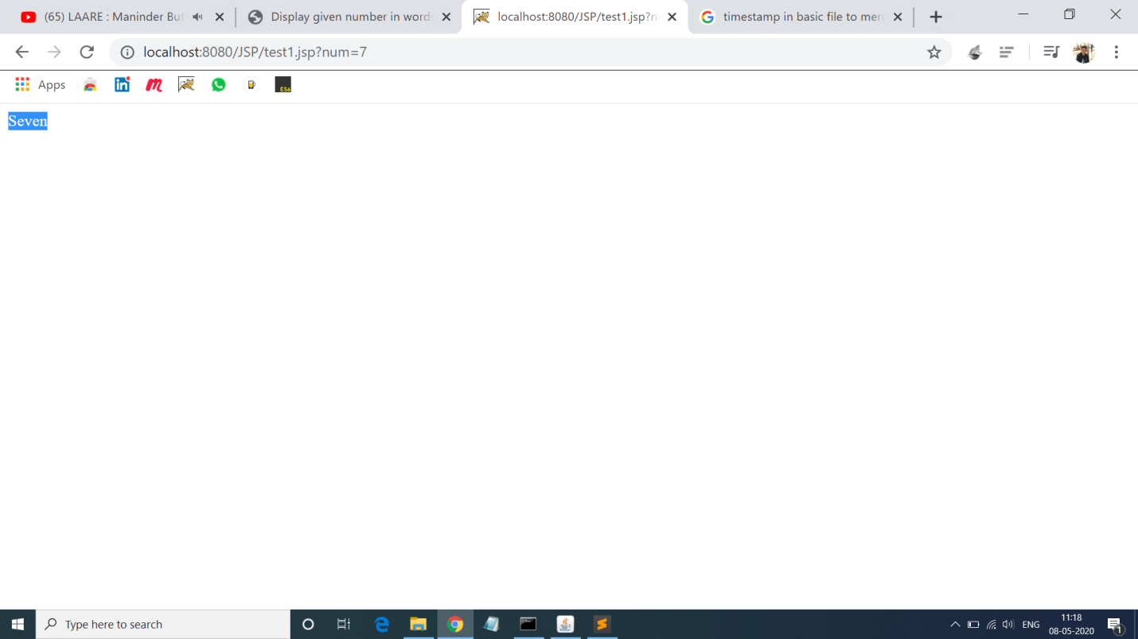

**13.Program for Generating random number in JSP.**

**Solution:-**

**Random.jsp:-**

<html>

<head><title>First JSP</title></head>

<body>

<%

double num = Math.random();

if (num > 0.95) {

%>

<h2>You'll have a luck day!</h2><p>(<%= num %>)</p>

<%

} else {

%>

<h2>Well, life goes on ... </h2><p>(<%= num %>)</p>

<%

}

%>

<a href="<%= request.getRequestURI() %>"><h3>Try Again</h3></a>

</body>

</html>

**Output 13:-**

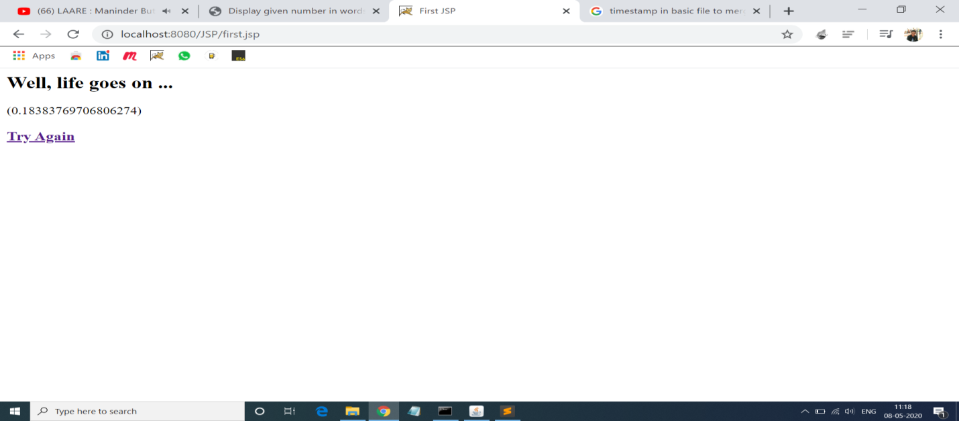

14.Program of The <jsp:include> Action.

**Solution:-**

**Date.jsp:-**

<p>Today's date: <%= (new java.util.Date()).toLocaleString()%></p>

**Main.jsp:-**

<html>

<head>

<title>The include Action Example</title>

</head>

<body>

<center>

<h2>The include action Example</h2>

<jsp:include page = "date1.jsp" flush = "true" />

</center>

</body>

</html>

**Output 14:-**

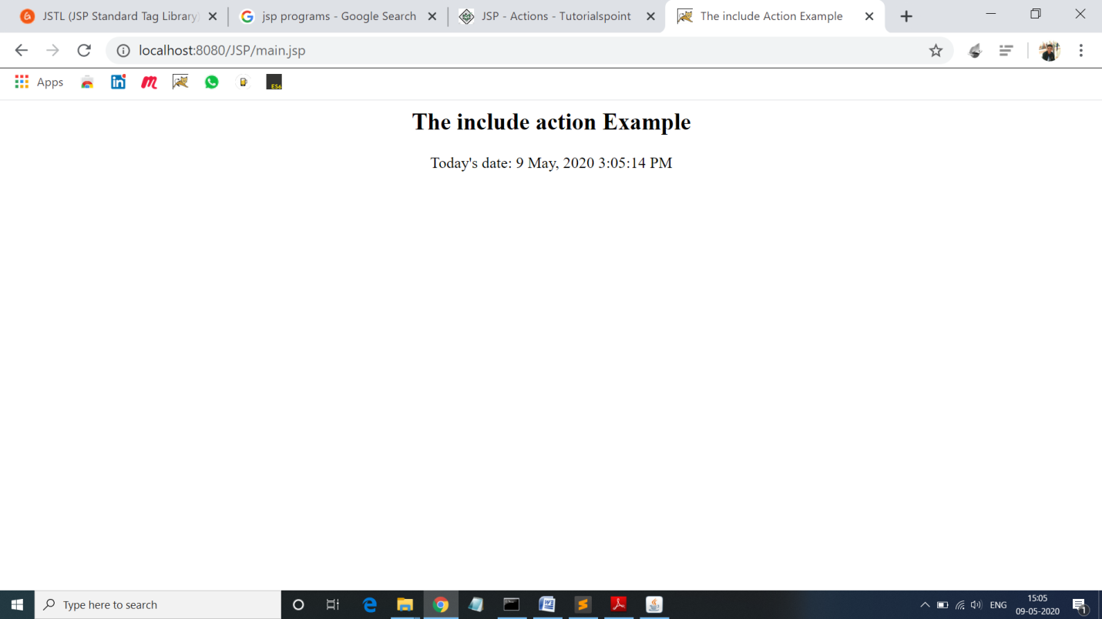

**15.Program of <jsp:forward> action.**

**Solution:-**

**Date.jsp:-**

<p>Today's date: <%= (new java.util.Date()).toLocaleString()%></p>

**Main.jsp:-**

<html>

<head>

<title>The include Action Example</title>

</head>

<body>

<center>

<h2>The include action Example</h2>

<jsp:forward page = "date2.jsp" />

</center>

</body>

</html>

**Output 15:-**

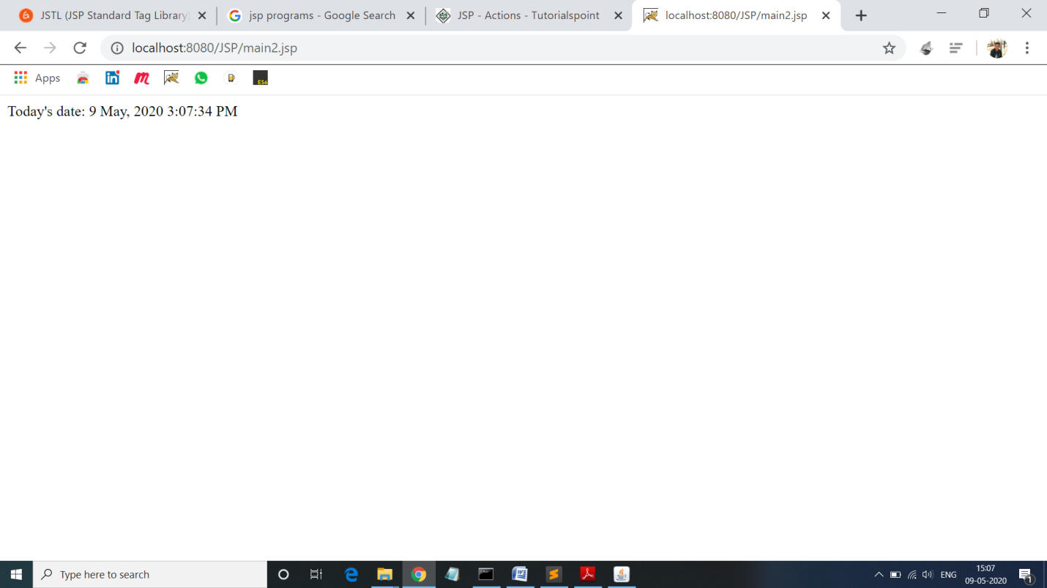

**16.Program for Catch Standard Library.**

**Solution:-**

**Catch.jsp:-**

<html>

<head>

<meta http-equiv="Content-Type" content="text/html; charset=ISO-8859-1">

<title>Core Tag JSP2</title>

</head>

<body>

<c:catch var="Exception">

<% int num = 10/0; %>

</c:catch>

The Exception is : ${Exception}

</body>

</html>

**Output 16 :-**

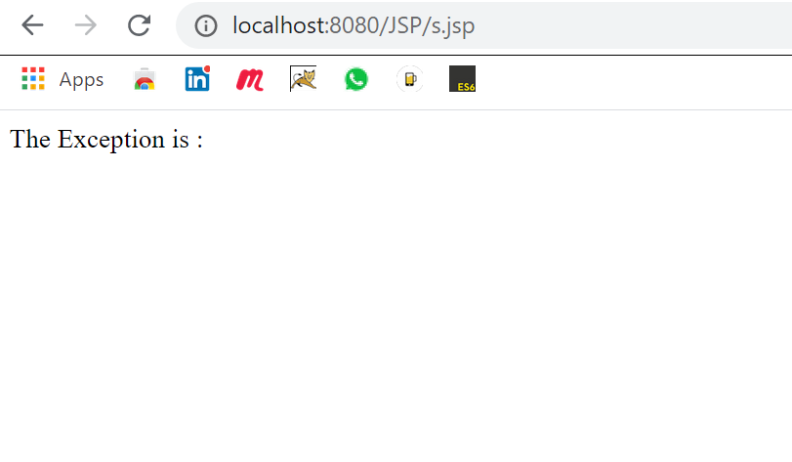

**17.Program of <c:foreach> standard Tag.**

**Solution:-**

<html>

<head>

<meta http-equiv="Content-Type" content="text/html; charset=ISO-8859-1">

<title>Core Tag JSP4</title>

</head>

<body>

<c:forEach var="count" begin="5" end="10">

<c:out value="${count}"/>

</c:forEach>

</body>

</html>

**Output 17 :-**

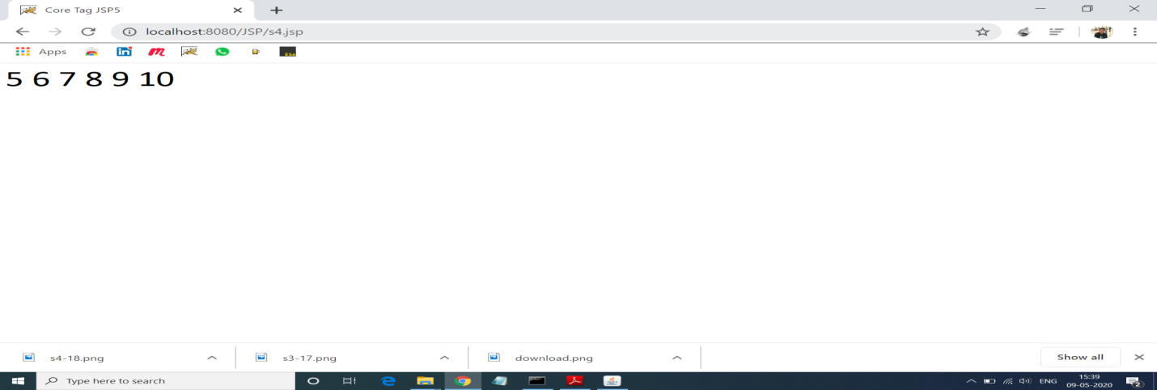

**18.Program for <c:if> standard tag.**

**Solution:-**

<html>

<head>

<meta http-equiv="Content-Type" content="text/html; charset=ISO-8859-1">

<title>Core Tag JSP5</title>

</head>

<body>

<c:set var="count" value="100"/>

<c:if test="${count == 100}">

<c:out value="The count is 100"/>

</c:if>

</body>

**Output 18:-**

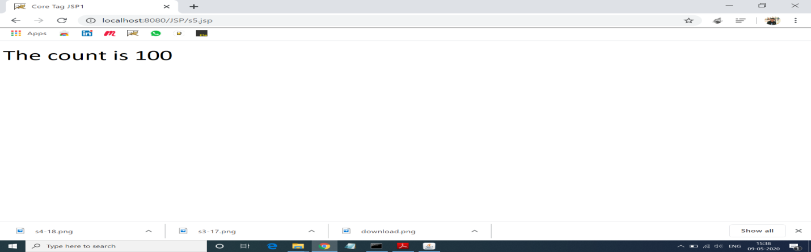

**19.Program for <c:import> standard Tag.**

**Solution:-**

<html>

<head>

<meta http-equiv="Content-Type" content="text/html; charset=ISO-8859-1">

<title>Core Tag JSP 31</title>

</head>

<body>

<c:import var="displayfile" url="download.jsp">

</c:import>

<c:out value="${displayfile}"/>

</body>

</html> **Output 19:-**

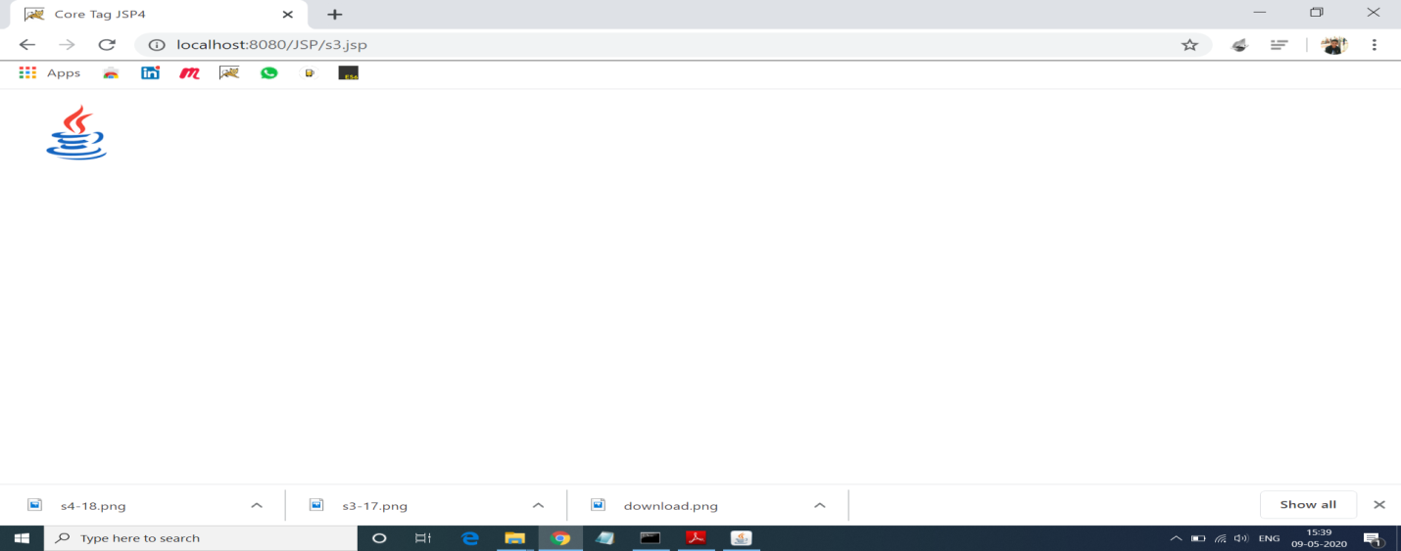

**20.Program for <c:out> standard Tag.**

**Solution:-**

<html>

<head>

<meta http-equiv="Content-Type" content="text/html; charset=ISO-8859-1">

<title>Core Tag JSP1</title>

</head>

<body>

<c:out value="name">

</c:out>

</body>

</html>**Output 20:-**

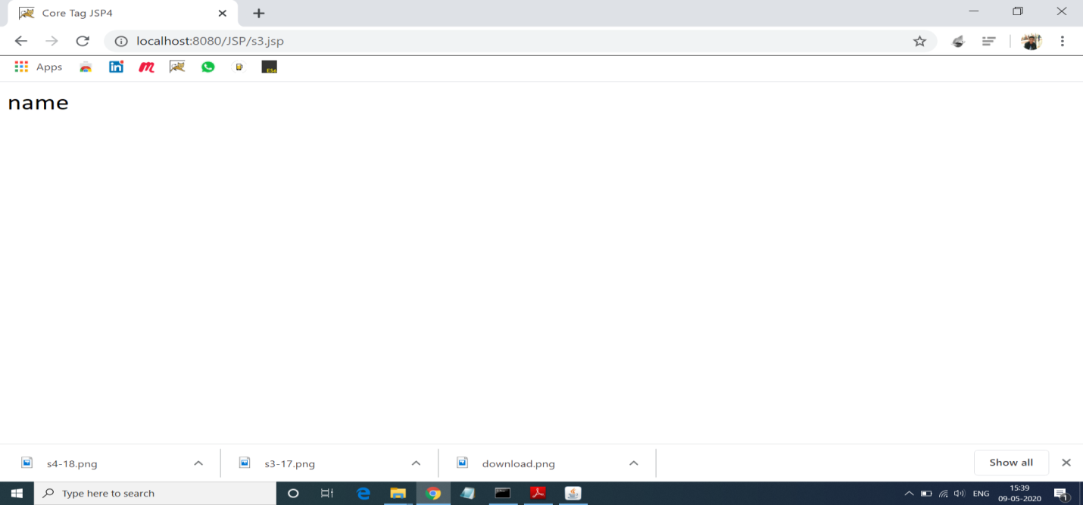

**Adv. Java Lab Assignment**

**Servlet 20 Programs**

**Name:-Milind Bajaj**

**M.Tech(5th Sem)**

**Rollno.:-IT-2k17-35**

**1.Simple Program of the doGet() runs once per HTTP GET request to servlet and showing details like URL,Path:-**

**Solution:-**

**HelloServlet.html:-**

import java.io.*;

import javax.servlet.*;

import javax.servlet.http.*;

import javax.servlet.annotation.*;

@WebServlet("/sayhello")

public class HelloServlet extends HttpServlet

@Override

public void doGet(HttpServletRequest request, HttpServletResponse response)

throws IOException, ServletException {

response.setContentType("text/html");

PrintWriter out = response.getWriter();

out.println("<!DOCTYPE html>");

out.println("<html>");

out.println("<head><title>Hello, World</title></head>");

out.println("<body>");

out.println("<h1>Hello, world!</h1>");

out.println("<p>Request URI: " + request.getRequestURI() + "</p>");

out.println("<p>Protocol: " + request.getProtocol() + "</p>");

out.println("<p>PathInfo: " + request.getPathInfo() + "</p>");

out.println("<p>Remote Address: " + request.getRemoteAddr() + "</p>");

out.println("<p>A Random Number: <strong>" + Math.random() + "</strong></p>");

out.println("</body></html>");

out.close(); }}

**Output 1:-**

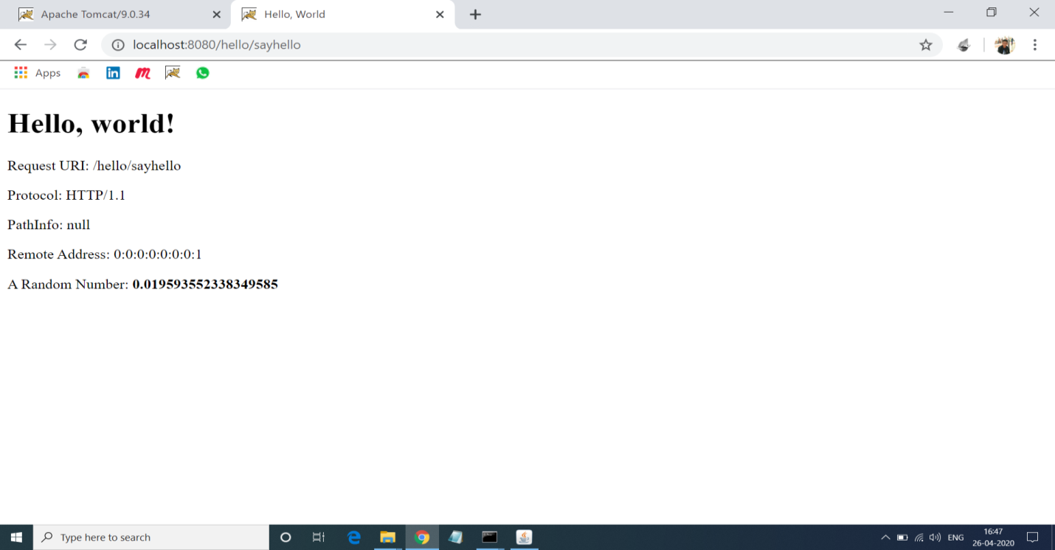

**2. Program for Adding Two Numbers With the Servlets:**

**Solution:-**

**Addnum.html:-**

<!DOCTYPE html>

<html>

<head>

<meta charset="UTF-8">

<title>Add Numbers</title>

</head>

<body>

<center>

<h1>Enters the Number For Adding:</h1>

<form action="add" method="post">

Enter 1st Number:<input type="text" name="num1"><br>

Enter 2nd Number:<input type="text" name="num2"><br>

<input type="submit">

</form>

</center>

</body>

</html>

**Addnum.java:-**

import java.io.IOException;

import java.io.PrintWriter;

import javax.servlet.annotation.WebServlet;

import javax.servlet.http.HttpServlet;

import javax.servlet.http.HttpServletRequest;

import javax.servlet.http.HttpServletResponse;

@WebServlet("/add")

public class AddNum extends HttpServlet

private static final long serialVersionUID = 1L;

public void doGet(HttpServletRequest req, HttpServletResponse res) throws IOException

{

int i = Integer.parseInt(req.getParameter("num1"));

int j = Integer.parseInt(req.getParameter("num2"));

int k= i+j;

PrintWriter out = res.getWriter();

out.println(k);

}

public void doPost(HttpServletRequest req, HttpServletResponse res) throws IOException

{

int i = Integer.parseInt(req.getParameter("num1"));

int j = Integer.parseInt(req.getParameter("num2"));

int k= i+j;

PrintWriter out = res.getWriter();

out.println(k);

}

}

**Output 2:-**

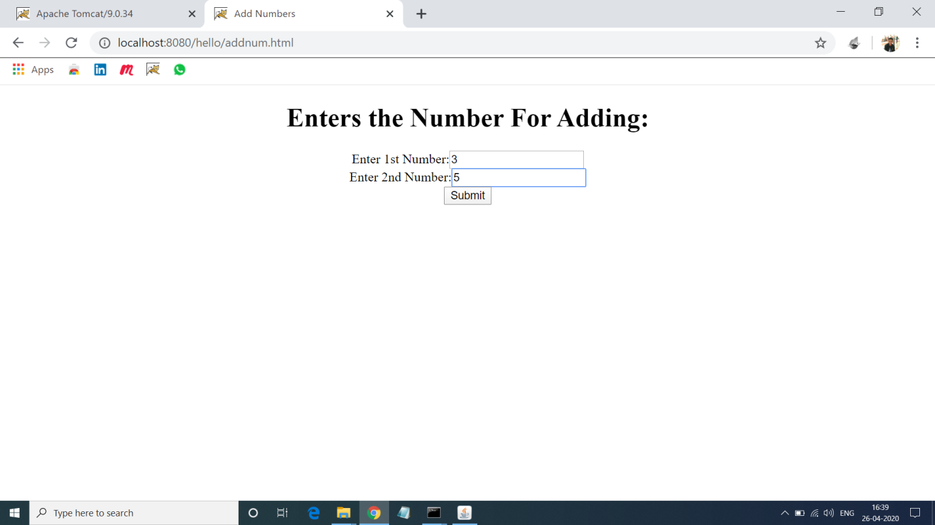

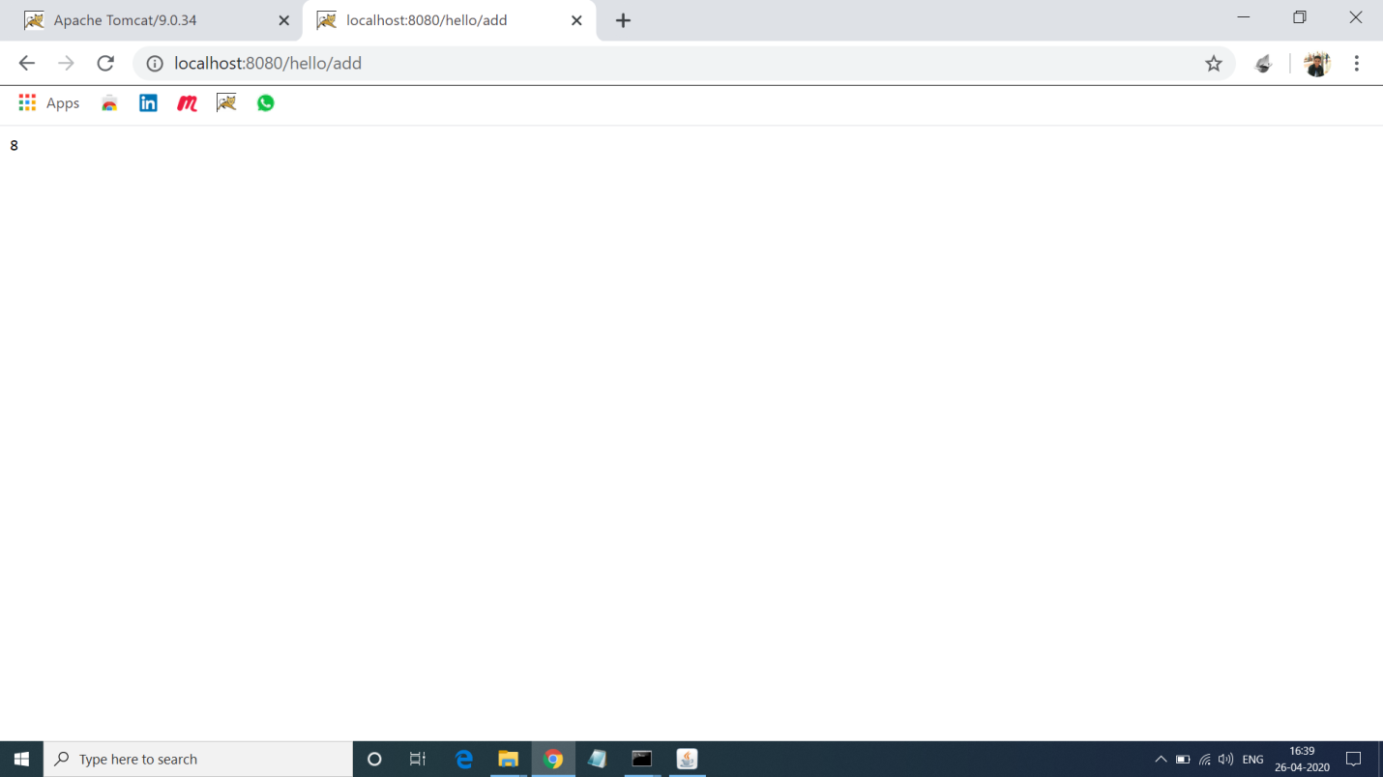

**3. Program of Displaying Entered details using Java Servlet:**

**Solution:-**

**Detail.html:-**

<html>

<head>

<title>Form</title>

<meta charset="UTF-8">

<meta name="viewport" content="width=device-width, initial-scale=1.0">

</head>

<body>

<h1>Enter Details </h1>

<form name="Form1" method="post" action="detail" bgcolor="blue">

<center>

<label>Name:</label>

<input type="text" name="name" ><br><br>

<label>Phone No.:</label>

<input type="text" name="phone" ><br>

<input type="submit" value="submit details">

</center>

</form>

</body>

</html>

**Detail.java:-**

import java.io.IOException;

import java.io.PrintWriter;

import java.util.Enumeration;

import javax.servlet.ServletException;

import javax.servlet.annotation.WebServlet;

import javax.servlet.http.HttpServlet;

import javax.servlet.http.HttpServletRequest;

import javax.servlet.http.HttpServletResponse;

@WebServlet("/detail")

public class Detail extends HttpServlet {

private static final long serialVersionUID = 1L;

protected void doPost(HttpServletRequest request, HttpServletResponse response) throws ServletException, IOException {

response.setContentType("text/html");

PrintWriter pw = response.getWriter();

Enumeration e = request.getParameterNames();

while(e.hasMoreElements())

{

String pname = (String)e.nextElement();

pw.println(pname + " = ");

String pvalue = request.getParameter(pname);

pw.println(pvalue);

}

pw.close();

}

}

**Output 3:-**

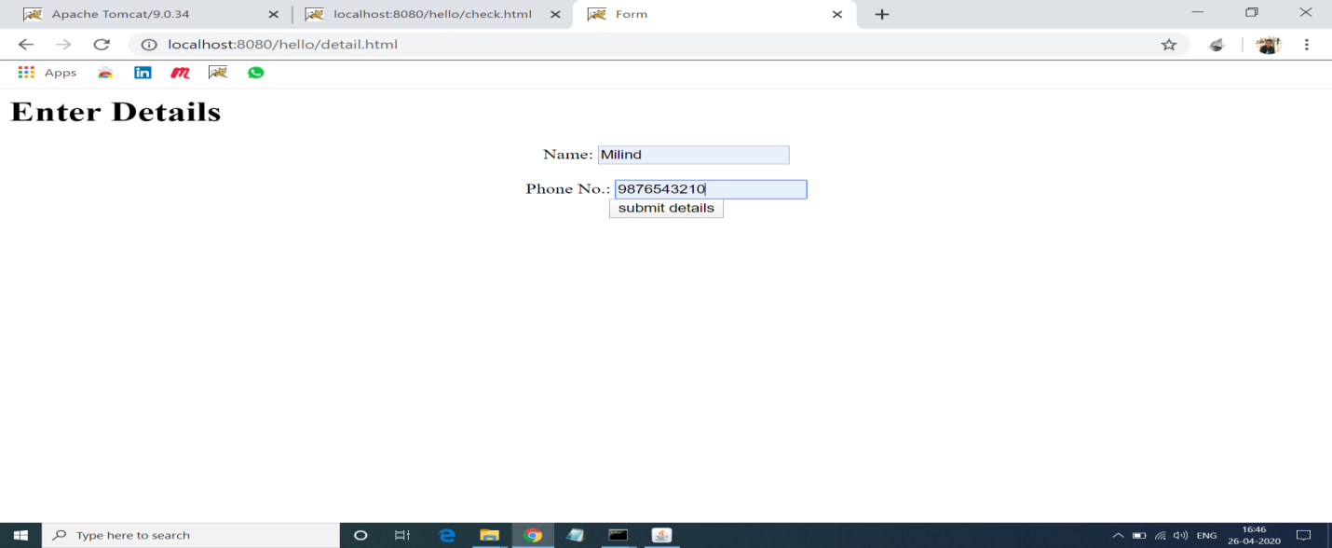

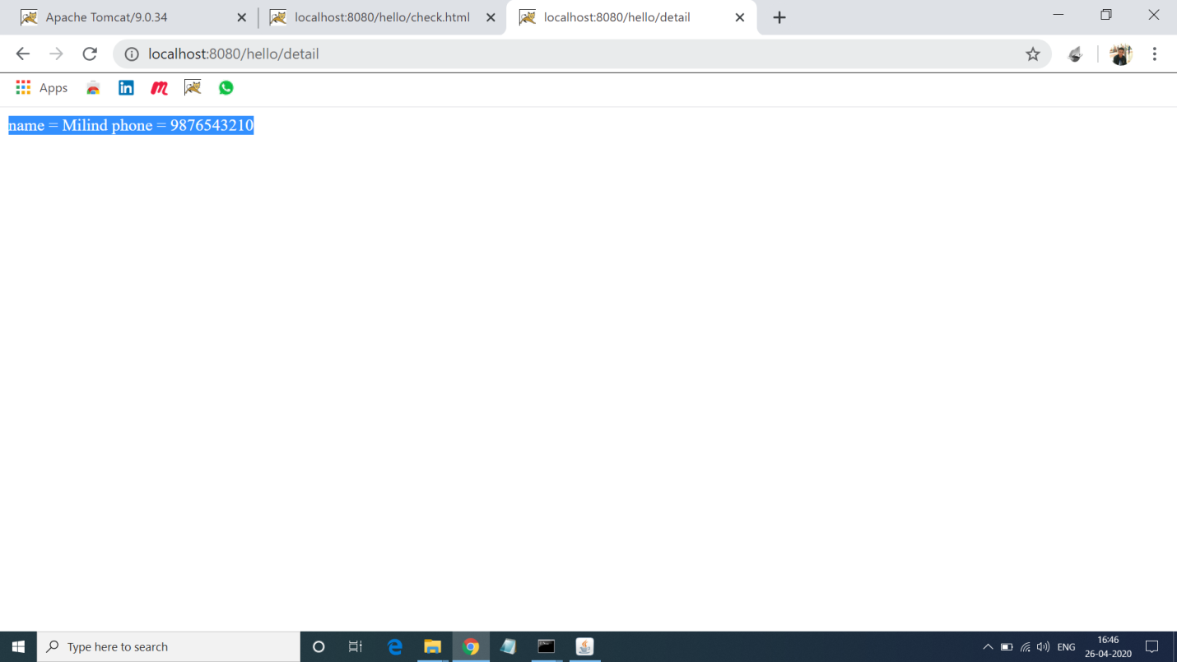

**4. Program of Reading Checkbox In Servlet:**

**Solution:-**

**Check.html:-**

<html>

<body>

<center>

<h1>See Which checkbox is checked</h1>

<form action = "Servlet" method = "POST" target = "_blank">

<input type = "checkbox" name = "Mtech" checked = "checked" /> Mtech<br>

<input type = "checkbox" name = "MCA" /> MCA<br>

<input type = "checkbox" name = "MBA" checked = "checked" />

MBA<br>

<input type = "submit" value = "Select Course" /><br>

</form>

</center>

</body>

</html>

**Check.java:-**

import java.io.IOException;

import java.io.PrintWriter;

import javax.servlet.ServletException;

import javax.servlet.annotation.WebServlet;

import javax.servlet.http.HttpServlet;

import javax.servlet.http.HttpServletRequest;

import javax.servlet.http.HttpServletResponse;

@WebServlet("/Servlet")

public class Check extends HttpServlet {

private static final long serialVersionUID = 1L;

protected void doGet(HttpServletRequest request, HttpServletResponse response) throws ServletException, IOException {

response.setContentType("text/html");

PrintWriter out = response.getWriter();

String title = "Reading Checkbox Data";

String docType =

"<!doctype html public \"-//w3c//dtd html 4.0 " + "transitional//en\">\n";

out.println(docType +

"<html>\n" +

"<head><title>" + title + "</title></head>\n" +

"<body bgcolor = \"#f0f0f0\">\n" +

"<h1 align = \"center\">" + title + "</h1>\n" +

"<ul>\n" +

" <li><b>Mtech Flag : </b>: "

+ request.getParameter("Mtech") + "\n" +

" <li><b>MCA Flag: </b>: "

+ request.getParameter("MCA") + "\n" +

" <li><b>MBA Flag: </b>: "

+ request.getParameter("MBA") + "\n" +

"</ul>\n");

out.println( "</body>");

out.println("</html>");

}

protected void doPost(HttpServletRequest request, HttpServletResponse response) throws ServletException, IOException {

doGet(request, response);

}

}

**Output 4:-**

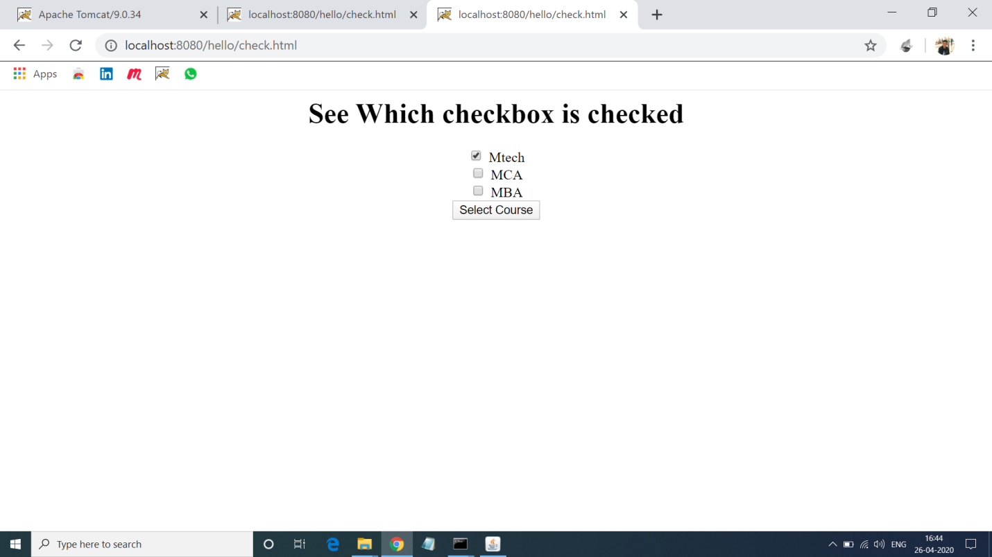

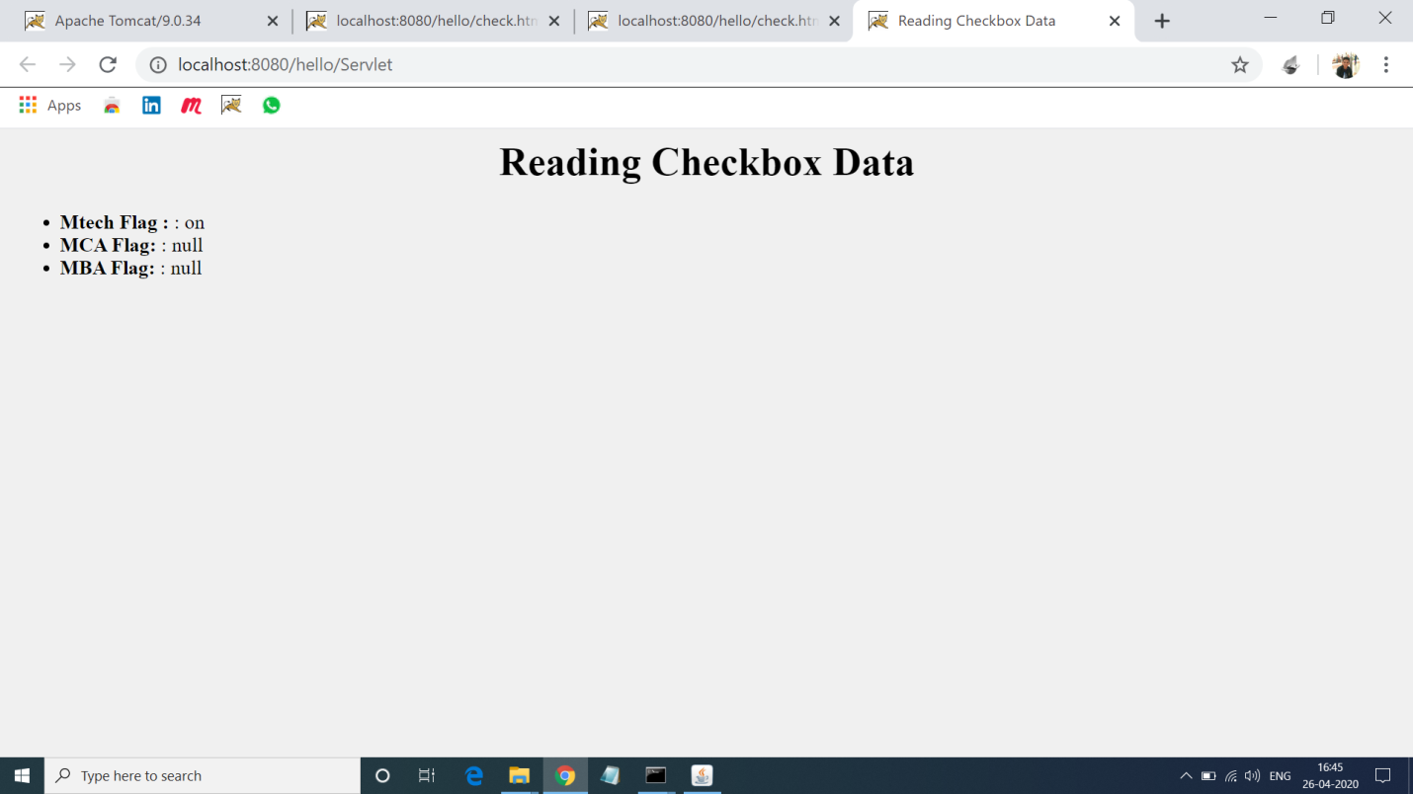

**5.Program of Adding and Getting Cookies in Java Servlets:-Solution:-**

**addCokkie.html:-**

<!DOCTYPE html>

<html>

<head>

<meta charset="ISO-8859-1">

<title>Username</title>

</head>

<body>

<cenetr>

<form action="AddCookie" method="post">

<label>Enter Username: </label><br>

<input name="unm" type="text"><br>

<input type="submit" value="Enter"><br>

</form>

</center>

</body>

</html>

**addCookie.java:-**

import java.io.IOException;

import java.io.PrintWriter;

import javax.servlet.ServletException;

import javax.servlet.annotation.WebServlet;

import javax.servlet.http.Cookie;

import javax.servlet.http.HttpServlet;

import javax.servlet.http.HttpServletRequest;

import javax.servlet.http.HttpServletResponse;

@WebServlet("/AddCookie")

public class AddCookie extends HttpServlet {

private static final long serialVersionUID = 1L;

protected void doPost(HttpServletRequest request, HttpServletResponse response) throws ServletException, IOException {

response.setContentType("text/html");

PrintWriter out=response.getWriter();

String unm=request.getParameter("unm");

out.println("<h3>Welcome</h3>"+unm);

try {

Cookie c=new Cookie("unm",unm);

response.addCookie(c);

out.println("<form action='GetCookie' method='get'>");

out.println("<input type=submit value=go>");

out.println("</form>");

}

catch(Exception e) {

}

}

}

**getCookie.java:-**

import java.io.IOException;

import java.io.PrintWriter;

import javax.servlet.ServletException;

import javax.servlet.annotation.WebServlet;

import javax.servlet.http.Cookie;

import javax.servlet.http.HttpServlet;

import javax.servlet.http.HttpServletRequest;

import javax.servlet.http.HttpServletResponse;

@WebServlet("/GetCookie")

public class GetCookie extends HttpServlet {

private static final long serialVersionUID = 1L;

protected void doGet(HttpServletRequest request, HttpServletResponse response) throws ServletException, IOException {

response.setContentType("text/html");

PrintWriter out=response.getWriter();

try {

Cookie c2[]=request.getCookies();

out.println("<h3>Hello</h3>"+c2[0].getValue());

}

catch(Exception e) {

out.println(e); }}}

**Output 5:-**

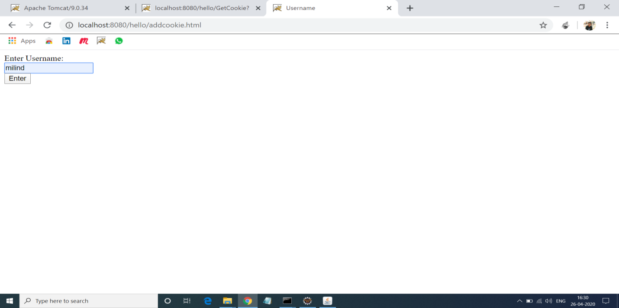

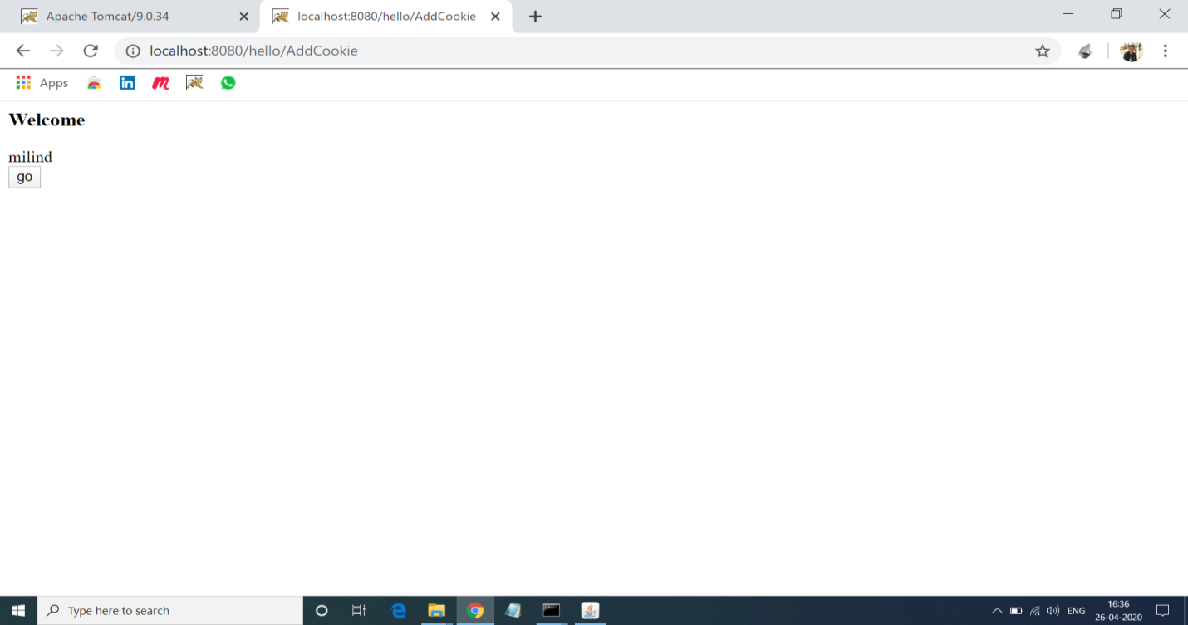

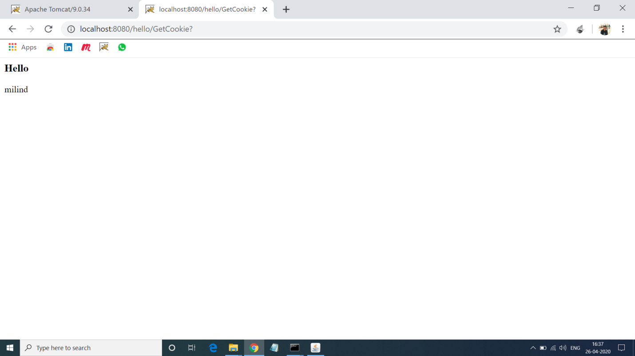

**6. Program of Retriving Data from database using Mysql and Servlet.**

**Solution:-**

**Querybook.html:-**

<!DOCTYPE html>

<html>

<head>

<title>Yet Another Bookshop</title>

</head>

<body>

<h2>Yet Another Bookshop</h2>

<form method="get" action="http://localhost:8080/hello/query">

<b>Choose an author:</b>

<input type="checkbox" name="author" value="Tan Ah Teck">Ah Teck

<input type="checkbox" name="author" value="Mohammad Ali">Ali

<input type="checkbox" name="author" value="Kumar">Kumar

<input type="submit" value="Search">

</form>

</body>

</html>

**queryServlet.java:-**

import java.io.*;

import java.sql.*;

import javax.servlet.*;

import javax.servlet.http.*;

import javax.servlet.annotation.*;

@WebServlet("/query")

public class QueryServlet extends HttpServlet {

@Override

public void doGet(HttpServletRequest request, HttpServletResponse response)

throws ServletException, IOException {

response.setContentType("text/html");

PrintWriter out = response.getWriter();

out.println("<!DOCTYPE html>");

out.println("<html>");

out.println("<head><title>Query Response</title></head>");

out.println("<body>");

try (

Connection conn = DriverManager.getConnection(

"jdbc:mysql://localhost:3306/ebookshop?allowPublicKeyRetrieval=true&useSSL=false&serverTimezone=UTC",

"milind", "vasu19@@"); // For MySQL

Statement stmt = conn.createStatement();

) {

String sqlStr = "select * from books where author = "

+ "'" + request.getParameter("author") + "'" // Single-quote SQL string

+ " and qty > 0 order by price desc";

out.println("<h3>Thank you for your query.</h3>");

out.println("<p>Your SQL statement is: " + sqlStr + "</p>");

ResultSet rset = stmt.executeQuery(sqlStr); // Send the query to the server

int count = 0;

while(rset.next()) {

out.println("<p>" + rset.getString("author")

+ ", " + rset.getString("title")

+ ", $" + rset.getDouble("price") + "</p>");

count++;

}

out.println("<p>==== " + count + " records found =====</p>");

} catch(Exception ex) {

out.println("<p>Error: " + ex.getMessage() + "</p>");

out.println("<p>Check Tomcat console for details.</p>");

ex.printStackTrace();

}

out.println("</body></html>");

out.close();

}}

**Output 6:-**

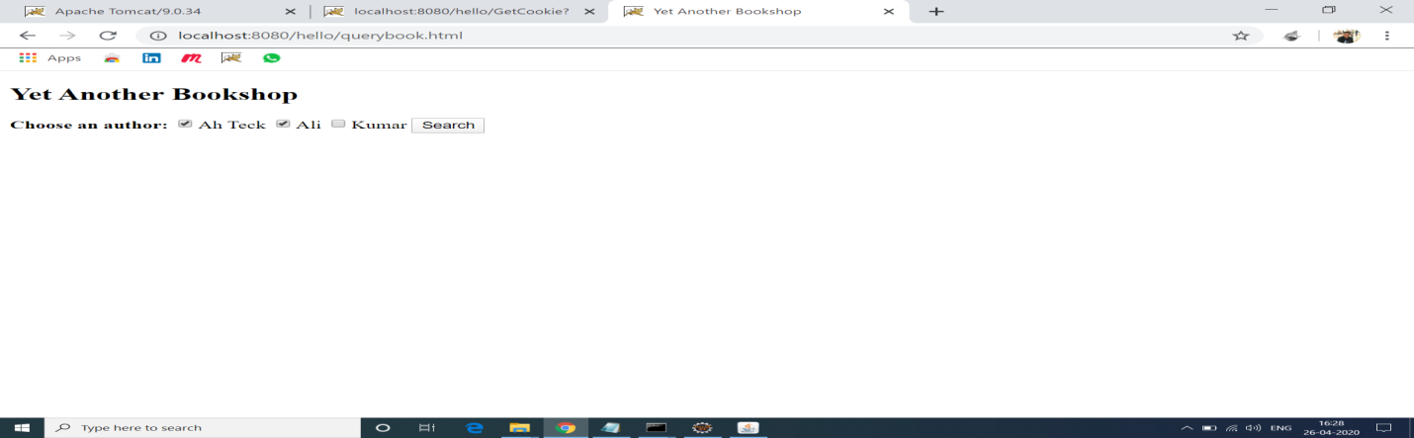

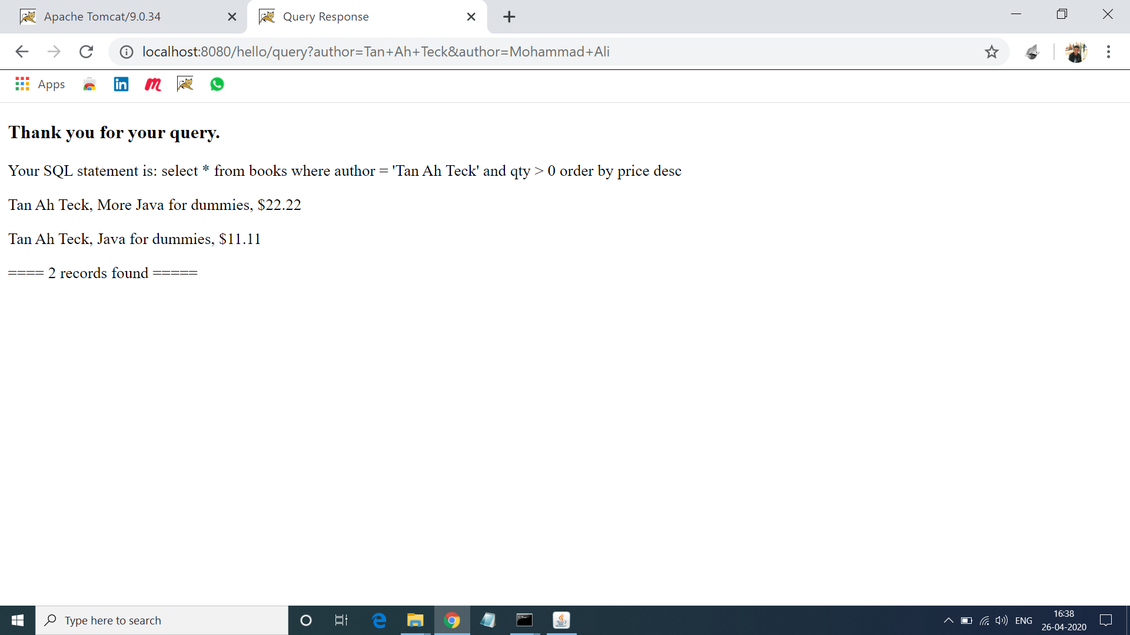

**7. Program of Storing Data in Database:**

**Solution:-**

**Addstudent.html:-**

<html>

<head>

<title>Add Student</title>

<meta charset="UTF-8">

<meta name="viewport" content="width=device-width, initial-scale=1.0">

</head>

<body>

<h1>Enter Details of Add student:</h1>

<form method="post" action="addstudent">

<label>Roll no.:</label><br>

<input type="number" name="rno" ><br>

<label>Name:</label><br>

<input type="text" name="name" ><br>

<label>Class:</label><br>

<input type="text" name="class" ><br>

<input type="submit" value="submit">

</form>

</body>

</html>

**AddStudent.java:-**

import java.io.IOException;

import java.io.PrintWriter;

import java.sql.Connection;

import java.sql.DriverManager;

import java.sql.PreparedStatement;

import javax.servlet.ServletException;

import javax.servlet.annotation.WebServlet;

import javax.servlet.http.HttpServlet;

import javax.servlet.http.HttpServletRequest;

import javax.servlet.http.HttpServletResponse;

@WebServlet("/addstudent")

public class AddStudent extends HttpServlet {

private static final long serialVersionUID = 1L;

protected void doPost(HttpServletRequest request, HttpServletResponse response) throws ServletException, IOException {

response.setContentType("text/html");

PrintWriter out=response.getWriter();

try{

Class.forName("com.mysql.jdbc.Driver");

Connection con=DriverManager.getConnection("jdbc:mysql://localhost:3306/mydb","milind","vasu19@@");

int rno=Integer.parseInt(request.getParameter("rno"));

String name=request.getParameter("name");

int cls=Integer.parseInt(request.getParameter("class"));

String section=request.getParameter("section");

String sql="INSERT INTO student(`rno`, `name`, `class`, `section`) VALUES (?,?,?,?)";

PreparedStatement stmt=con.prepareStatement(sql);

stmt.setInt(1, rno);

stmt.setString(2,name);

stmt.setInt(3, cls);

stmt.setString(4, section);

int x=stmt.executeUpdate();

if(x==1){

System.out.println("Row inserted!");

out.println("Row inserted successfully");

}

else{

System.out.println("Row could not be inserted!");

}

out.close();

}

catch(Exception ex){

System.out.println(ex);

out.println(ex);

}

}

}

**Output 7:-**

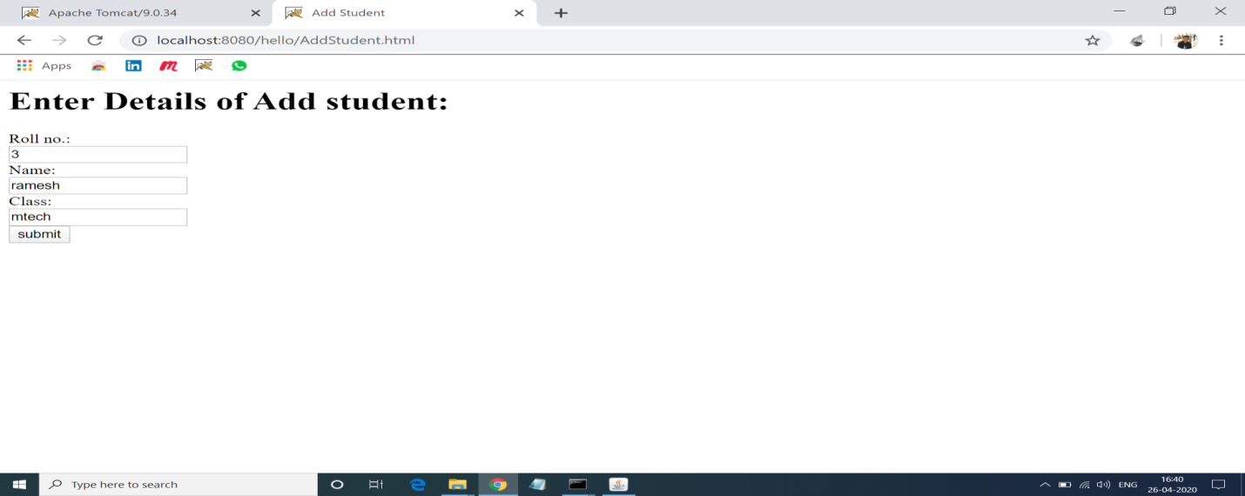

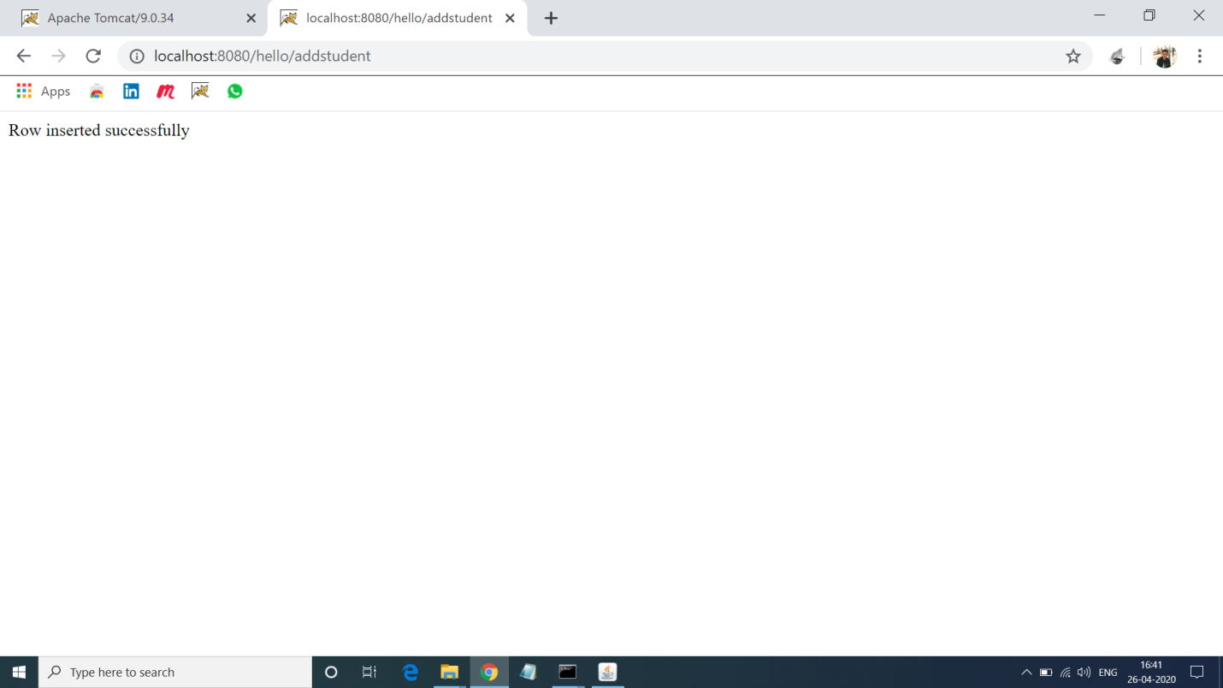

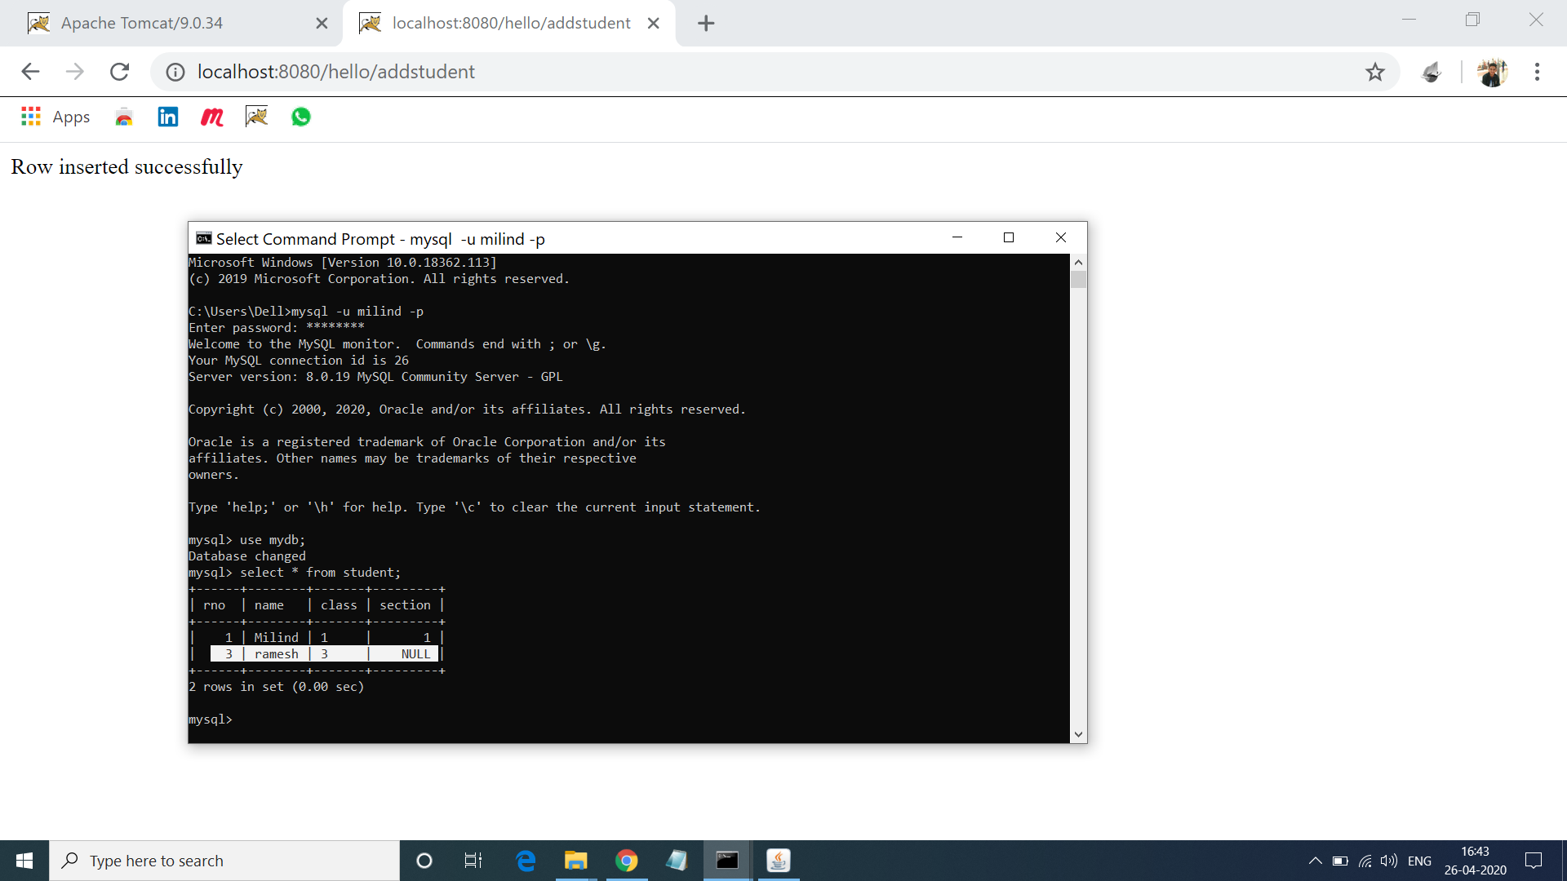

**8. Program of Simple Login and Logut Form using Cookies.**

**Solution:-**

**Login.html:-**

<!DOCTYPE html>

<html>

<head>

<meta charset="ISO-8859-1">

<title>Login using cookies</title>

</head>

<body>

<center>

<h3>Login using cookies!</h3>

<form action="Servlet1" method="post">

<input name=unm type=text placeholder= EnterUsername><br><br>

<input name=upass type=password placeholder=EnterPassword><br>

<button type=submit>Submit</button>

</form>

</center>

</body>

</html>

**Login.java:-**

import java.io.IOException;

import java.io.PrintWriter;

import javax.servlet.ServletException;

import javax.servlet.annotation.WebServlet;

import javax.servlet.http.Cookie;

import javax.servlet.http.HttpServlet;

import javax.servlet.http.HttpServletRequest;

import javax.servlet.http.HttpServletResponse;

@WebServlet("/Servlet1")

public class Login extends HttpServlet {

private static final long serialVersionUID = 1L;

protected void doPost(HttpServletRequest request, HttpServletResponse response) throws ServletException, IOException {

response.setContentType("text/html");

PrintWriter out=response.getWriter();

String unm=request.getParameter("unm");

String upass=request.getParameter("upass");

if(upass.equals("123")) {

out.println("<form action=http://localhost:8080/hello/LogoutServlet method=post>");

out.println("<button type=submit>Logout</button>");

out.println("</form>");

out.println("<center>");

out.println("<h3>Welcome "+unm+"</h3>");

out.println("<form action=http://localhost:8080/hello/ProfileServlet method=post>");

out.println("<button type=submit>View your profile</button>");

out.println("</form>");

out.println("</center>");

Cookie ck=new Cookie("unm",unm);

response.addCookie(ck);

}

else {

request.getRequestDispatcher("login.html").include(request, response);

out.println("<h3>Incorrect username or password! </h3>");

} }}

**LogoutServlet.java:-**

import java.io.IOException;

import java.io.PrintWriter;

import javax.servlet.ServletException;

import javax.servlet.annotation.WebServlet;

import javax.servlet.http.Cookie;

import javax.servlet.http.HttpServlet;

import javax.servlet.http.HttpServletRequest;

import javax.servlet.http.HttpServletResponse;

@WebServlet("/LogoutServlet")

public class LogoutServlet extends HttpServlet {

private static final long serialVersionUID = 1L;

protected void doPost(HttpServletRequest request, HttpServletResponse response) throws ServletException, IOException {

response.setContentType("text/html");

PrintWriter out=response.getWriter();

request.getRequestDispatcher("login.html").include(request, response);

Cookie ck=new Cookie("unm","");

ck.setMaxAge(0);

response.addCookie(ck);

out.print("you are successfully logged out!");

}}

**Output 8:-**

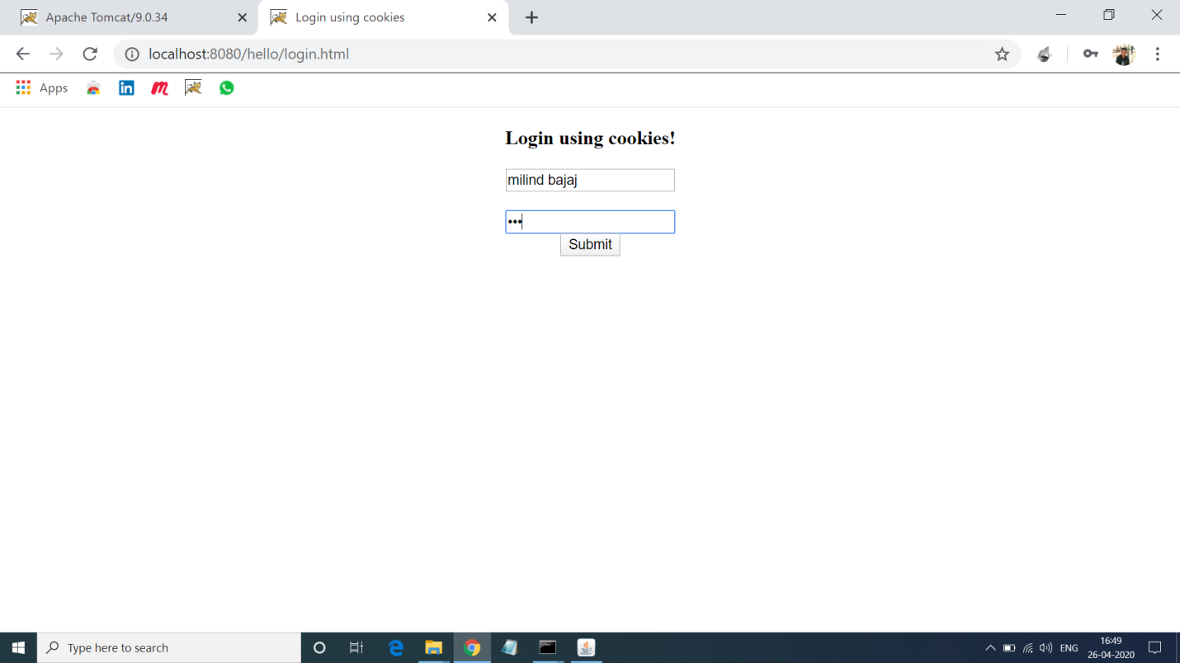

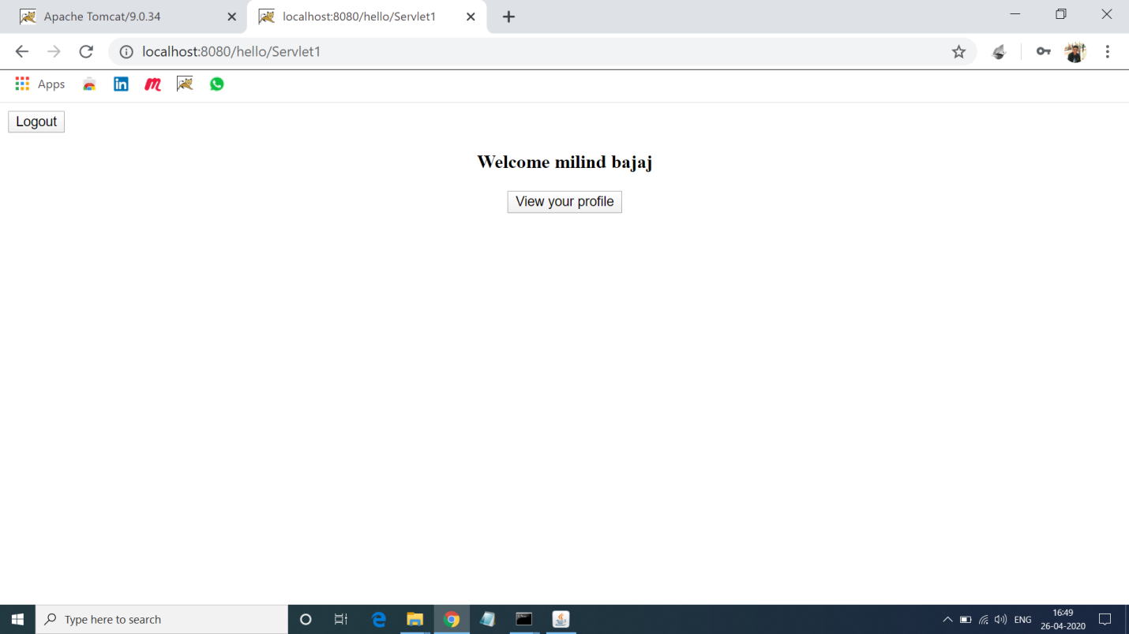

**Logout:-**

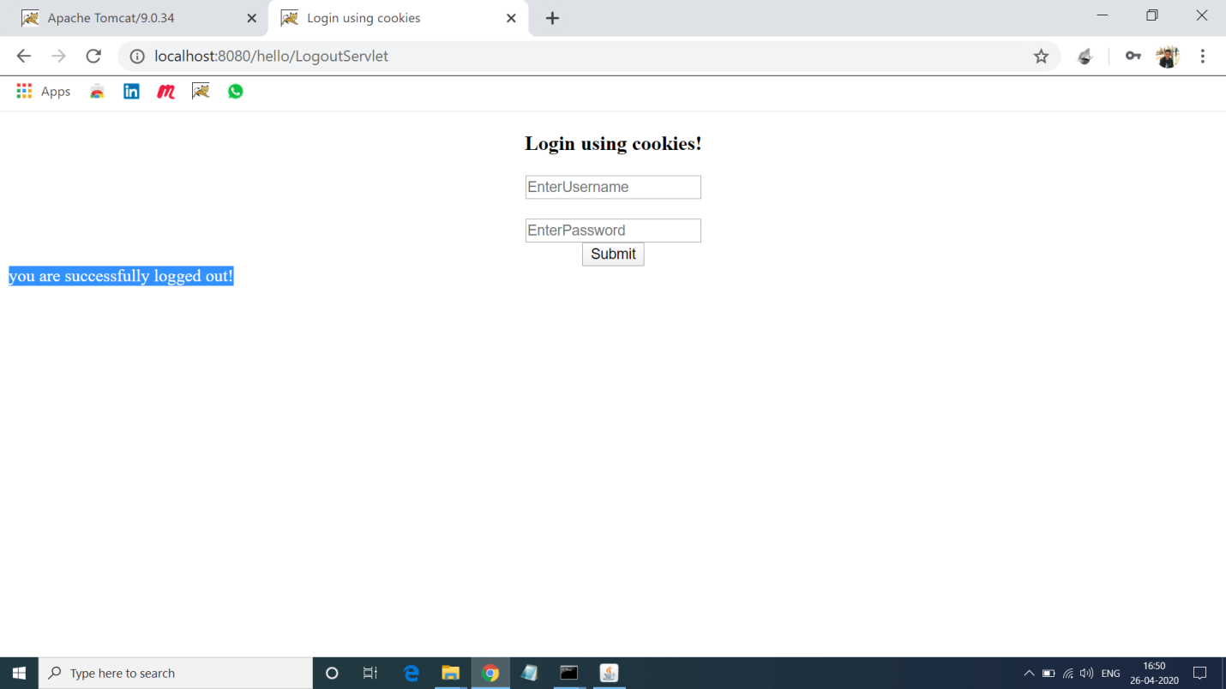

**9.Program of Auto Refeshing a Page in Servelt.**

**Solution:-**

**Auto.java:-**

import java.io.*;

import javax.servlet.*;

import javax.servlet.http.*;

import java.util.*;

import javax.servlet.annotation.*;

@WebServlet("/refresh")

public class Refresh extends HttpServlet

{

public void doGet(HttpServletRequest request, HttpServletResponse response) throws ServletException, IOException

{

response.setIntHeader("Refresh", 1);

response.setContentType("text/html");

Calendar calendar = new GregorianCalendar();

String am_pm;

int hour = calendar.get(Calendar.HOUR);

int minute = calendar.get(Calendar.MINUTE);

int second = calendar.get(Calendar.SECOND);

if(calendar.get(Calendar.AM_PM) == 0)

am_pm = "AM";

else

am_pm = "PM";

String CT = hour+":"+ minute +":"+ second +" "+ am_pm;

PrintWriter out = response.getWriter();

out.println("<h1 align='center'>Auto Refresh Page</h1><hr>");

out.println("<h3 align='center'>Current time: "+CT+"</h3>");

}

public void doPost(HttpServletRequest request, HttpServletResponse response) throws ServletException, IOException

{

doGet(request, response); }}

**Output 9:-**

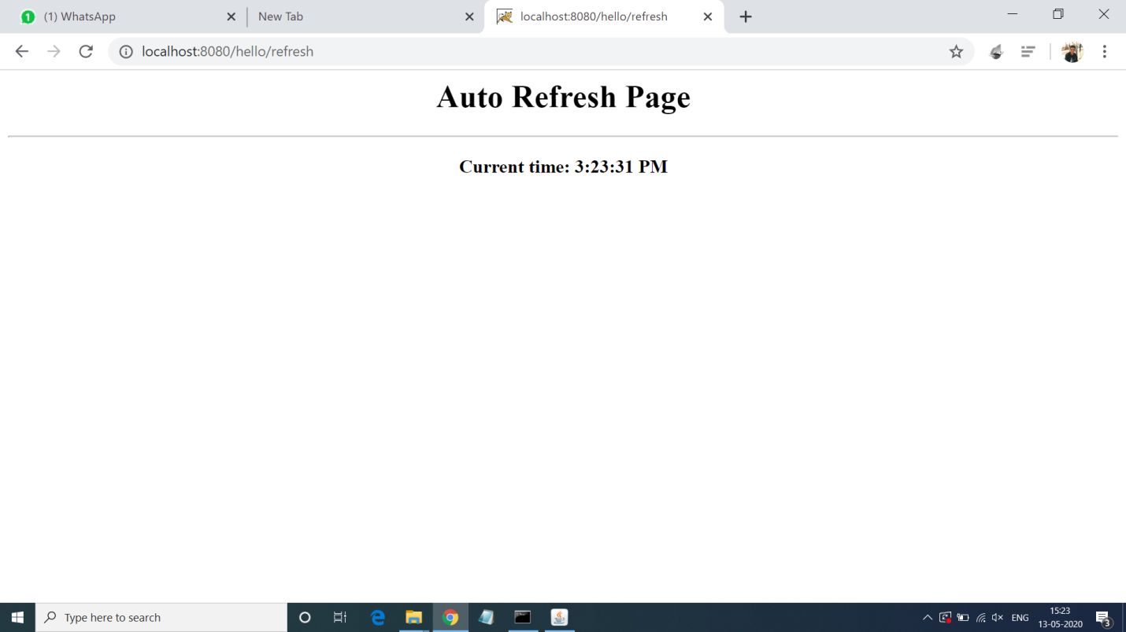

**10.Program for Checking Voting Egibilitiy using Servlet.**

**Solution:-**

**Index.html:-**

<!doctype html>

<html lang="en">

<head>

<meta charset="UTF-8">

<title>VoterApp</title>

</head>

<body>

<form action= "Voter" method="get">

<fieldset style="width:20%; background-color:#80ffcc">

<table>

<tr><td>Name</td><td><input type="text" name="name"></td></tr>

<tr><td>Age</td><td><input type="text" name="age"></td></tr>

<tr><td></td><td><input type = "submit" value="check voting eligibility"></td></tr>

</table>

</fieldset>

</form>

</body>

</html>

**Voter.java:-**

import java.io.*;

import java.util.*;

import javax.servlet.*;

import javax.servlet.http.*;

import javax.servlet.annotation.*;

@WebServlet("/Voter")

public class Voter extends HttpServlet

{

public void service(HttpServletRequest req, HttpServletResponse res) throws IOException,ServletException

{

res.setContentType("text/html");

PrintWriter pw = res.getWriter();

String name = req.getParameter("name");

int age = Integer.parseInt(req.getParameter("age"));

if (age>=18)

{

pw.println("<font color='green' size='4'>"+name+" you are eligible to vote</font>");

}

else

pw.println("<font color='red' size='4'>"+name+" you are not eligible to vote</font>");

pw.println("<br><br><a href= 'Voter.html'>Home</a>");

pw.close();

}

}

**Output 10:-**

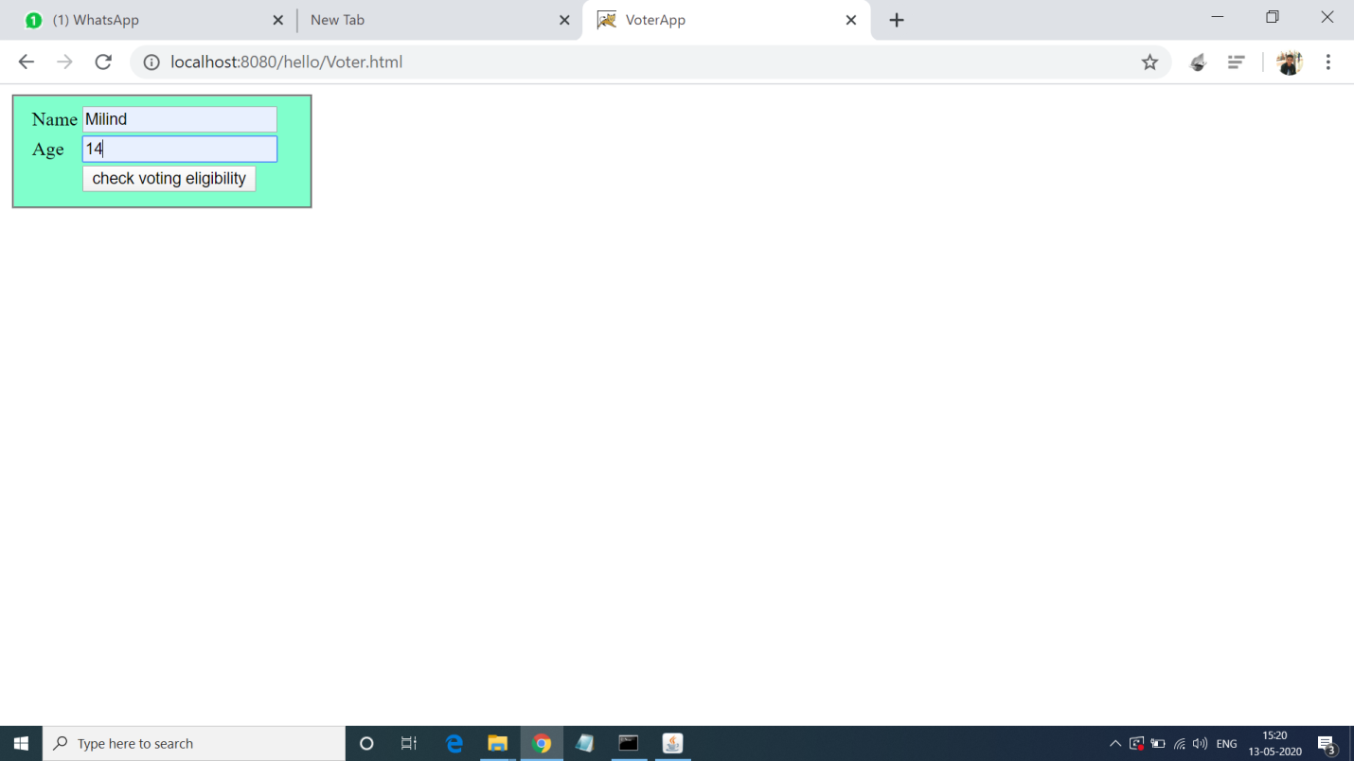

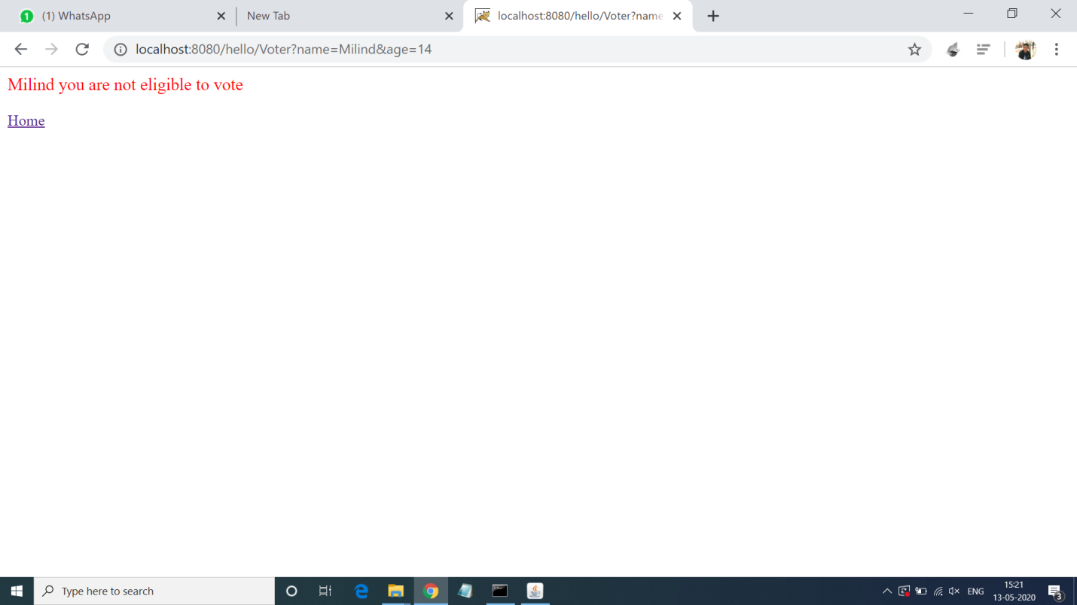

**11.Program of Session Tracking using Sevlet.**

**Solution:-**

**Session.java:-**

import java.io.*;

import javax.servlet.*;

import javax.servlet.http.*;

import java.util.*;

import java.util.Date;

import javax.servlet.annotation.*;

@WebServlet("/session")

public class SessionDemo extends HttpServlet

{

public void doGet(HttpServletRequest request, HttpServletResponse response) throws ServletException, IOException

{

HttpSession session = request.getSession(true);

Date createTime = new Date(session.getCreationTime());

Date lastAccessTime = new Date(session.getLastAccessedTime());

String title = "Welcome Back to my website";

Integer visitCount = new Integer(0);

String visitCountKey = new String("visitCount");

String userIDKey = new String("userID");

String userID = new String("Surendra");

if (session.isNew())

{

title = "Welcome to my website";

session.setAttribute(userIDKey, userID);

}

else

{

visitCount = (Integer)session.getAttribute(visitCountKey);

visitCount = visitCount + 1;

userID = (String)session.getAttribute(userIDKey);

}

session.setAttribute(visitCountKey, visitCount);

response.setContentType("text/html");

PrintWriter out = response.getWriter();

String docType =

"<!doctype html public \"-//w3c//dtd html 4.0 " +

"transitional//en\">\n";

out.println(docType +

"<html>\n" +

"<head><title>" + title + "</title></head>\n" +

"<body bgcolor=\"#e5f7c0\">\n" +

"<h1 align=\"center\">" + title + "</h1>\n" +

"<h2 align=\"center\">Session Infomation</h2>\n" +

"<table border=\"1\" align=\"center\">\n" +

"<tr bgcolor=\"#eadf8c\">\n" +

"<th>Session info</th><th>value</th></tr>\n" +

"<tr>\n" +

" <td>id</td>\n" +

" <td>" + session.getId() + "</td></tr>\n" +

"<tr>\n" +

" <td>Creation Time</td>\n" +

" <td>" + createTime +

" </td></tr>\n" +

"<tr>\n" +

" <td>Time of Last Access</td>\n" +

" <td>" + lastAccessTime +

" </td></tr>\n" +

"<tr>\n" +

" <td>User ID</td>\n" +

" <td>" + userID +

" </td></tr>\n" +

"<tr>\n" +

" <td>Number of visits</td>\n" +

" <td>" + visitCount + "</td></tr>\n" +

"</table>\n" +

"</body></html>") }}

**Output 11:-**

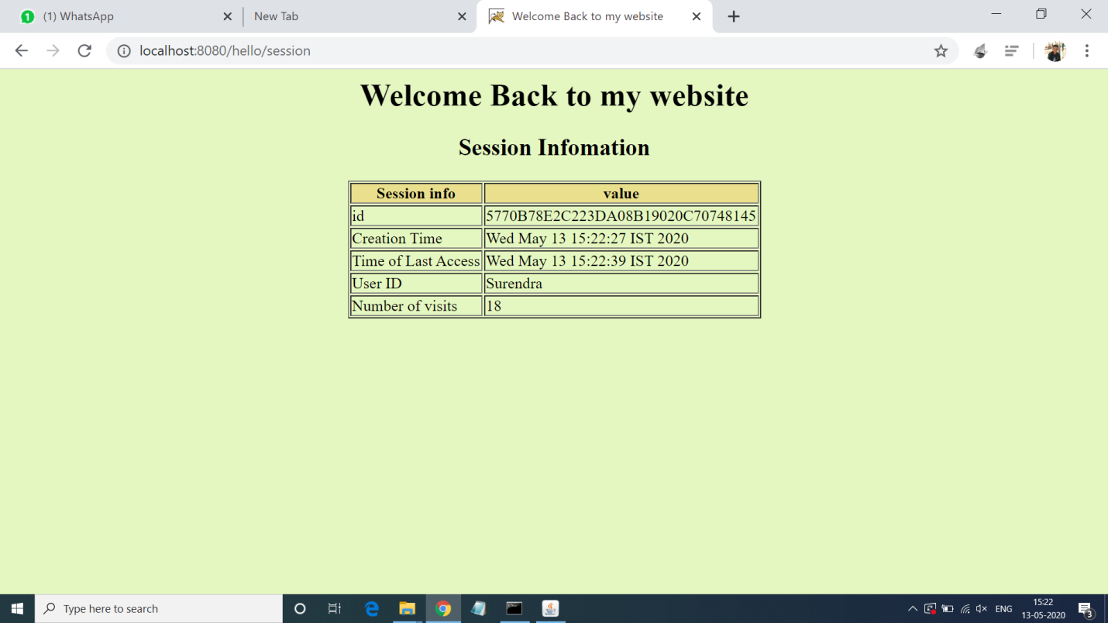

**12.Program to count number of visitor in website.**

**Solution:-**

**Counter.java:-**

import java.io.IOException;

import java.io.PrintWriter;

import javax.servlet.ServletException;

import javax.servlet.http.HttpServlet;

import javax.servlet.http.HttpServletRequest;

import javax.servlet.http.HttpServletResponse;

import javax.servlet.annotation.*;

@WebServlet("/counter")

public class CounterServlet extends HttpServlet

{

private int iHitCounter;

public void init() throws ServletException

{

iHitCounter = 0;

}

public void doGet(HttpServletRequest request, HttpServletResponse response) throws ServletException, IOException

{

PrintWriter out = response.getWriter();

Out.println("Welcome to my website !");

out.println("You are visitor number: "+ (++iHitCounter));

}

public void doPost(HttpServletRequest request, HttpServletResponse response) throws ServletException, IOException

{

doGet(request, response); }}

**Output 12:-**

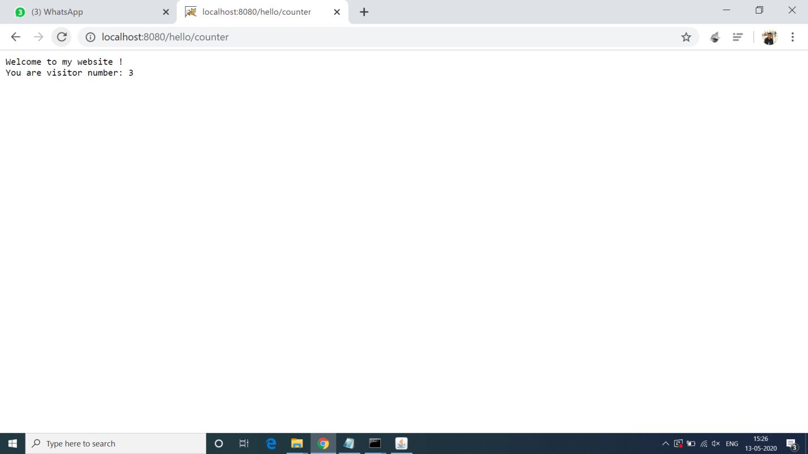

**13.Program to get current time and date using Servlet.**

**Solution:-**

**Date.java:-**

import javax.servlet.*;

import javax.servlet.annotation.*;

import java.io.*;

import javax.servlet.*;

import javax.servlet.http.*;

import java.util.*;

@WebServlet("/date")

public class Date extends GenericServlet

{

public void service(ServletRequest req, ServletResponse res) throws IOException, ServletException

{

res.setContentType("text/html");

PrintWriter pw = res.getWriter();

java.util.Date date = new java.util.Date();

pw.println("<h2>"+"Current Date & Time: " +date.toString()+"</h2>");

pw.close(); }}

**Output 13:-**

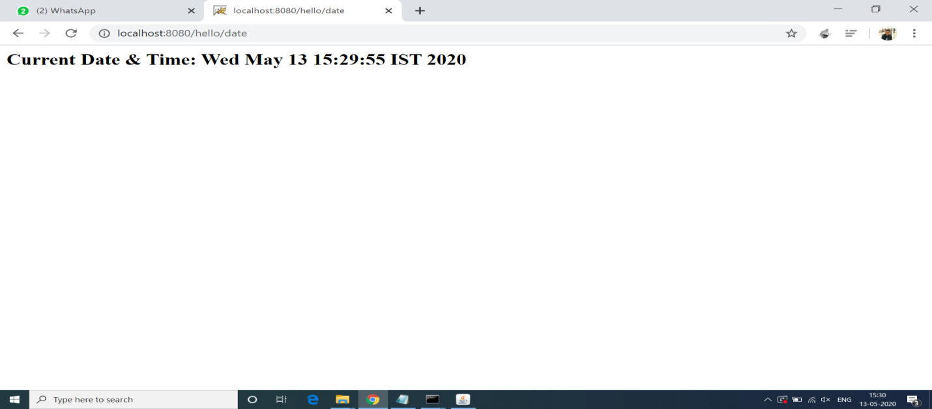

**14.Program for Adding Cookie at selected Value.**

**Solution:-**

**Index.html:-**

<!doctype html>

<head>

<title>CookiesExample</title>

</head>

<body>

<form method='post' action='ACookie'>

<fieldset style="width:14%; background-color:#ccffcc">

<h2>Select Course</h2> <hr>

<input type='radio' name='course' value='Java'>Java<br>

<input type='radio' name='course' value='UNIX'>UNIX<br>

<input type='radio' name='course' value='MCA'>DBMS<br>

<input type='radio' name='course' value='OOSE '>OOSE<br><br>

<input type='submit'> <input type='reset'><br>

</fieldset>

</form>

</body>

</html>

**Cookie.java:-**

import java.io.*;

import javax.servlet.*;

import javax.servlet.http.*;

import javax.servlet.annotation.*;

import javax.servlet.http.Cookie;

@WebServlet("/ACookie")

public class ACookie extends HttpServlet

{

public void doPost(HttpServletRequest req, HttpServletResponse res) throws ServletException,IOException

{

res.setContentType("text/html");

PrintWriter pw = res.getWriter();

Cookie []c = req.getCookies();

int id=1;

if(c!=null) id = c.length+1;

String value = req.getParameter("course");

Cookie newCookie = new Cookie("course:"+id,value);

res.addCookie(newCookie);

pw.println("<h4>Cookie added with value "+value+"</h4>");

}

}

**Output 14:-**

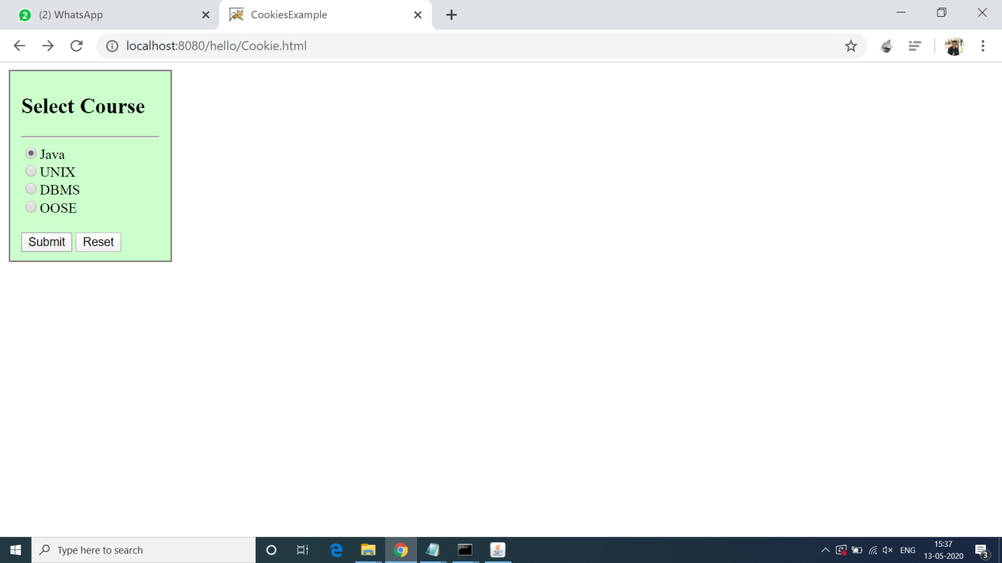

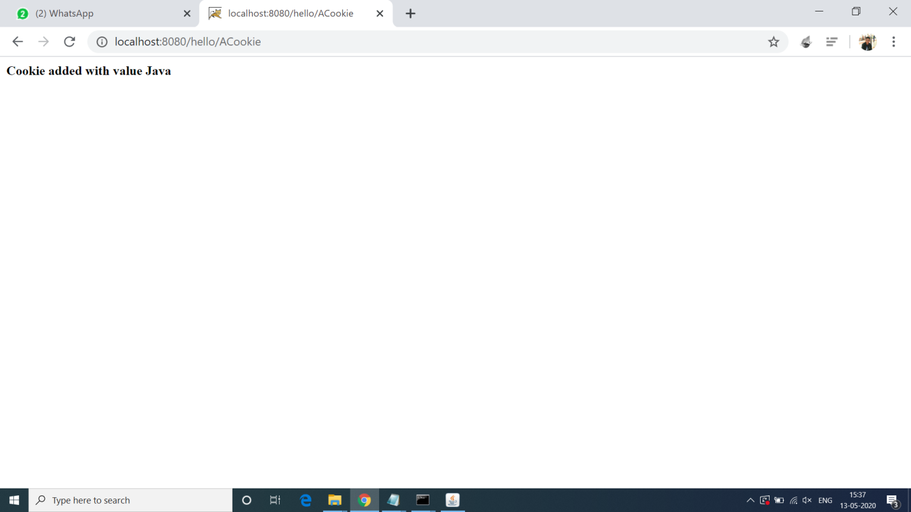

**15.Program of inserting Image in page using Servlet.**

**Solution:-**

**Image.java:-**

import java.io.*;

import javax.servlet.*;

import javax.servlet.http.*;

import javax.servlet.annotation.*;

@WebServlet("/image")

public class DisplayImage extends HttpServlet {

public void doGet(HttpServletRequest request,HttpServletResponse response)

throws IOException

{

response.setContentType("image/jpeg");

ServletOutputStream out;

out = response.getOutputStream();

FileInputStream fin = new FileInputStream("c:\\java.jpg");

BufferedInputStream bin = new BufferedInputStream(fin);

BufferedOutputStream bout = new BufferedOutputStream(out);

int ch =0; ;

while((ch=bin.read())!=-1)

{

bout.write(ch);

}

bin.close();

fin.close();

bout.close();

out.close(); } }

**Output 15:-**

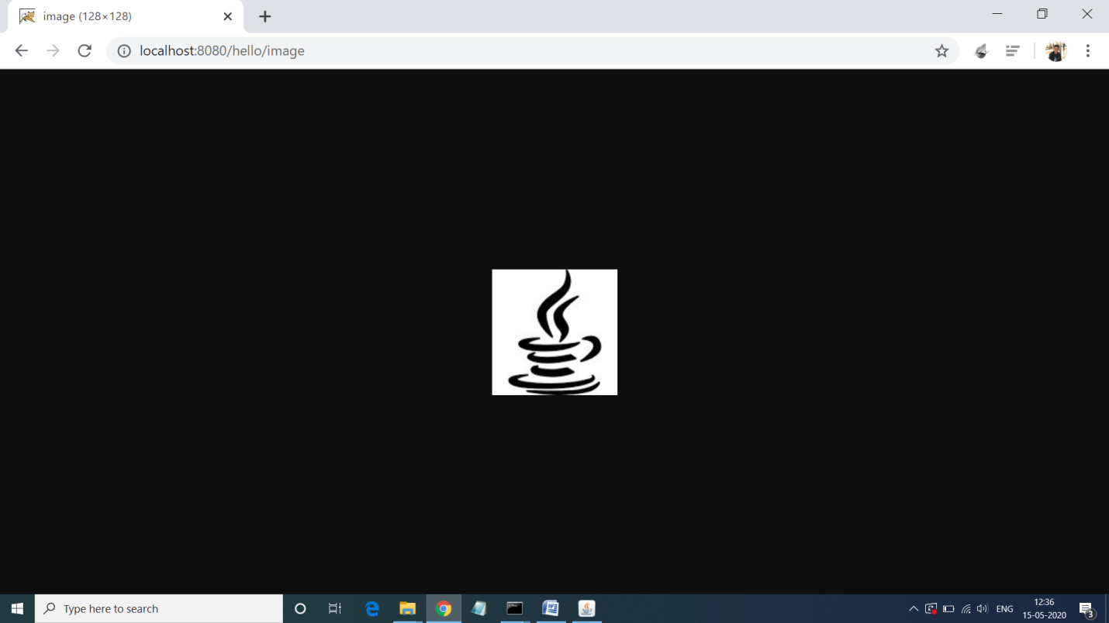

**16.Program of Downloading File using Servlet.**

**Solution:-**

**index.html:-**

<a href="Download">download the html file</a>

**Download.java:-**

import java.io.*;

import javax.servlet.ServletException;

import javax.servlet.http.*;

import javax.servlet.annotation.*;

@WebServlet("/Download")

public class DownloadServlet extends HttpServlet {

public void doGet(HttpServletRequest request, HttpServletResponse response)

throws ServletException, IOException {

response.setContentType("text/html");

PrintWriter out = response.getWriter();

String filename = "home.html";

String filepath = "e:\\";

response.setContentType("APPLICATION/OCTET-STREAM");

response.setHeader("Content-Disposition","attachment; filename=\"" + filename + "\"");

FileInputStream fileInputStream = new FileInputStream(filepath + filename);

int i;

while ((i=fileInputStream.read()) != -1) {

out.write(i);

}

fileInputStream.close();

out.close(); }}

**Output 16:-**

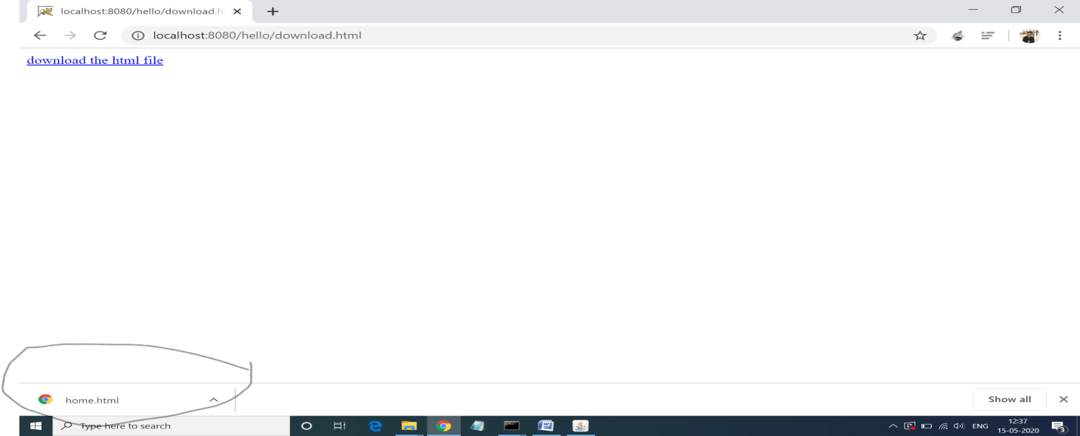

**17.Program of Uploading File using Servlet.**

**Solution:-**

**Index.html:-**

<html>

<body>

<form action="upload" method="post" enctype="multipart/form-data">

Select File:<input type="file" name="fname"/><br/>

<input type="submit" value="upload"/>

</form>

</body>

</html>

**Upload.java:-**

import java.io.*;

import javax.servlet.ServletException;

import javax.servlet.http.*;

import com.oreilly.servlet.MultipartRequest;

import javax.servlet.annotation.*;

@WebServlet("/upload")

public class UploadServlet extends HttpServlet {

public void doPost(HttpServletRequest request, HttpServletResponse response)

throws ServletException, IOException {

response.setContentType("text/html");

PrintWriter out = response.getWriter();

MultipartRequest m=new MultipartRequest(request,"d://");

out.print("successfully uploaded");

}

}

**Output 17:-**

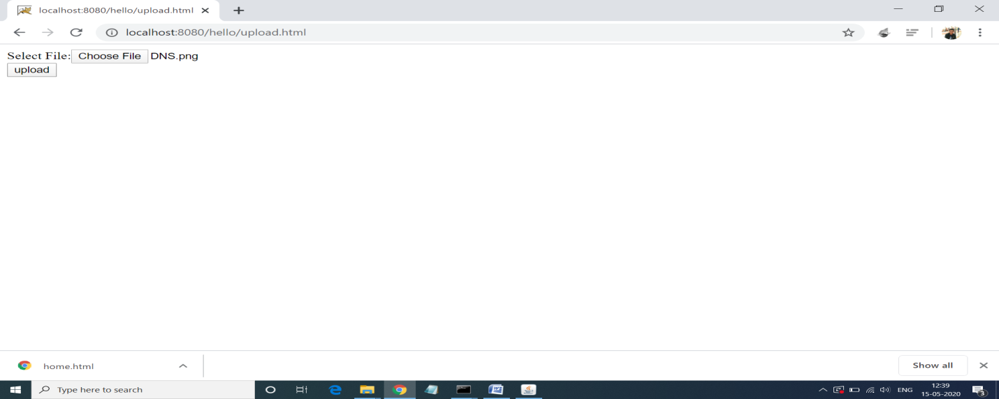

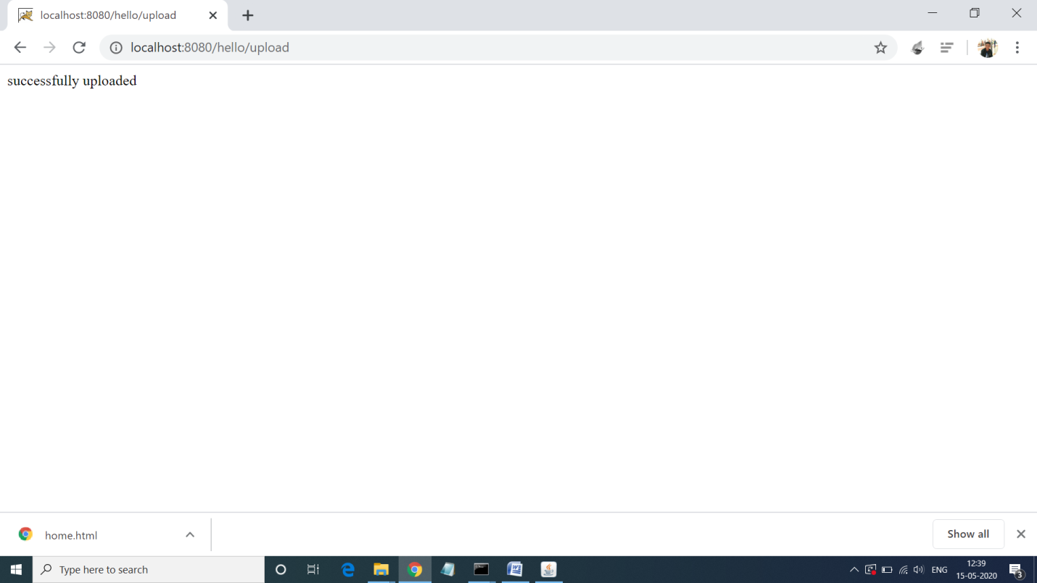

**19.Program of Request Dispatcher.**

**Solution:-**

**Request.java:-**

import java.io.IOException;

import java.io.PrintWriter;

import javax.servlet.RequestDispatcher;

import javax.servlet.ServletException;

import javax.servlet.annotation.WebServlet;

import javax.servlet.http.HttpServlet;

import javax.servlet.http.HttpServletRequest;

import javax.servlet.http.HttpServletResponse;

@WebServlet("/request")

public class Example extends HttpServlet {

private static final long serialVersionUID = 1L;

public Example() {

super();

}

protected void doPost(HttpServletRequest request, HttpServletResponse response) throws ServletException, IOException

{

String name=request.getParameter("username");

String pass=request.getParameter("password");

PrintWriter pw = response.getWriter();

if(name.equals("milind") && pass.equals("milind123"))

{

RequestDispatcher dis = request.getRequestDispatcher("WelcomeUser");

dis.forward(request, response);

}

else

{

RequestDispatcher dis = request.getRequestDispatcher("userrequest.html");

dis.include(request, response);

pw.print("User name or password is incorrect!");

}

}

}

**Output 19:-**

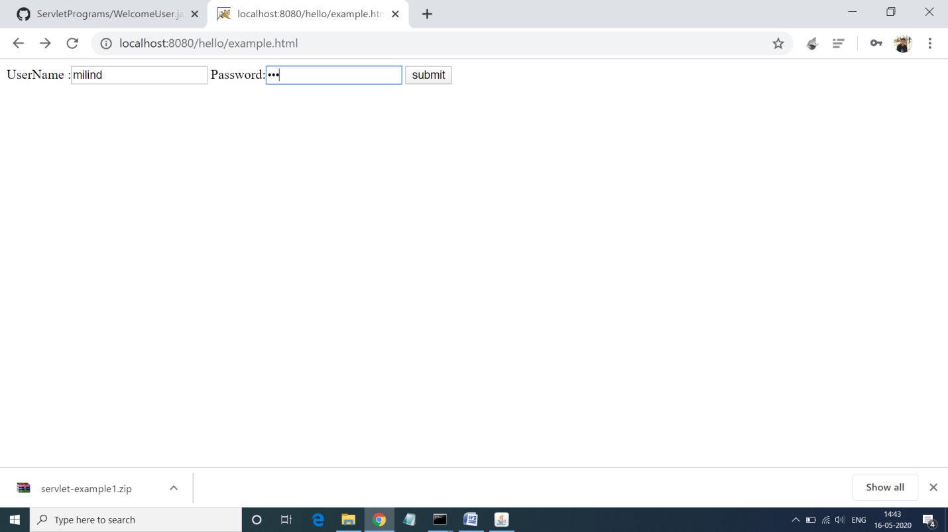

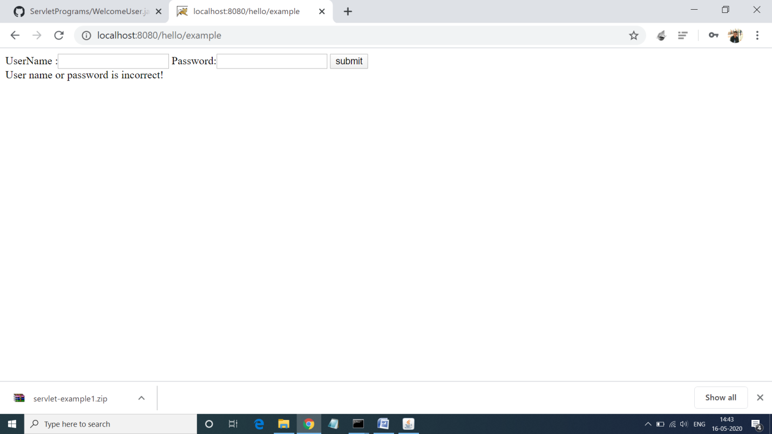

**20.Program for Header Information.**

**Solution:-**

**Header.java:-**

import java.io.IOException;

import java.io.PrintWriter;

import java.util.Enumeration;

import javax.servlet.ServletException;

import javax.servlet.annotation.WebServlet;

import javax.servlet.http.HttpServlet;

import javax.servlet.http.HttpServletRequest;

import javax.servlet.http.HttpServletResponse;

@WebServlet("/HeaderInformation")

public class HeaderInformation extends HttpServlet {

private static final long serialVersionUID = 1L;

public HeaderInformation() {

super();

}

protected void doGet(HttpServletRequest request, HttpServletResponse response) throws ServletException, IOException

{

PrintWriter pw = response.getWriter();

pw.println("HTTP header Information:<br>");

Enumeration en = request.getHeaderNames();

while(en.hasMoreElements())

{

String hName = (String)en.nextElement();

String hValue = request.getHeader(hName);

pw.println("<br>"+hName+":"+hValue + "<br>");

}

}

}

**Output 20:-**

